

AVoided Emissions and geneRation Tool (AVERT)

**User Manual**

PROVISIONAL Version 4.4

Provisional draft May 2025, not approved for final release

U.S. Environmental Protection Agency

Office of Air and Radiation

Climate Protection Partnerships Division

EPA logo

**Acknowledgments**

AVERT was developed by Synapse Energy Economics, Inc., under contract to EPA’s Climate Protection Partnerships Division, State and Local Climate and Energy Program and under the direction of Robyn DeYoung and Colby Tucker of EPA.

EPA thanks the staff at Synapse who developed AVERT and the user manual, particularly Jeremy Fisher, Ph.D., Patrick Knight, Ariel Horowitz, Ph.D., Caitlin Odom, Avi Allison, Jamie Hall, Erin Camp, Jackie Litynski, Elise Ashley, Elizabeth A. Stanton, Ph.D., and Bruce Biewald. Eastern Research Group, Inc. (ERG) provided production and logistical support and developed the web-based version of AVERT, with thanks to Chris Lamie, Courtney Myers, Bryan Neva, Emma Borjigin-Wang, Beverly Ge, Sydney Merrill, and several ERG colleagues. ERG and Synapse provided these services under EPA contracts #EP-BPA-12-H-0025, #EP-BPA-12-H0036, #68HERH19D0028, and #47QFHA20A0005 (GSA). EPA also thanks Abt Associates staff David Cooley, Kait Siegel, Jonathan Dorn, Ph.D., and Anna Belova, Ph.D., currently with Cognistx, who provided support for developing the PM2.5 emission rates under contracts #EP-W-11-003 and #EP-W-17-009.

EPA thanks the following individuals for participating in a formal peer review of the new functionality and associated materials found in AVERT v4.0: T. Donna Chen, Ph.D., University of Virginia; Stephen Holland, University of North Carolina; Avi Mersky, Ph.D., American Council for an Energy-Efficient Economy; Jeremy Michalek, Ph.D., Carnegie Mellon University; and Shawn Midlam-Mohler, Ph.D., The Ohio State University. The information and views expressed in AVERT v4.4, the user manual, and associated materials do not necessarily represent those of the reviewers, who also bear no responsibility for any errors or omissions. In addition, EPA thanks staff members at the United States Department of Energy, National Renewable Energy Laboratory, and our colleagues in the Office of Air Quality Planning and Standards and Office of Transportation and Air Quality for their collaboration, assistance, and guidance.

**Please contact** [**avert@epa.gov**](mailto:avert@epa.gov) **with any inquires or requests for technical assistance.**

Contents

What’s New in AVERT v4.4? 1

Key Abbreviations 2

1. Introduction 4

The Challenge of Estimating Changes in Emissions 5

Basic Method: eGRID Non-baseload Method 6

Basic Method: Capacity Factor Approach 7

Intermediate Method: Historical Hourly Method 7

Sophisticated Method: Energy Modeling 7

Short-run and Long-run Power Sector Analysis 8

Using AVERT 8

Example Use A: Air Quality Planner Quantification of Changes in Emissions Resulting from an Energy Efficiency Program for State Implementation Plan Compliance 10

Example Use B: Stakeholder Review of Multiple Energy Efficiency Options for Changing Emissions 10

Cautionary Note 10

Benefits of Using AVERT 11

2. The AVERT Analysis Structure 13

3. AVERT Main Module: An Overview 16

AVERT Regions 16

Energy Policy Characteristics 18

Scenario Results 20

4. AVERT Main Module: Step-by-Step Instructions 23

AVERT Welcome Page 23

Step 1: Load Regional Data File 25

Step 2: Set Energy Scenario 27

Manual User Input 29

Reduce Generation by a Percent in Some or All Hours 30

Reduce Generation by Annual GWh 32

Reduce Each Hour by Constant MW 32

Renewable Energy 32

Electric Vehicles 33

Energy Storage 35

Step 3: Run Scenario 36

Step 4: Display Results 38

Summary Tables 39

Charts and Figures 44

Summary Tables, Charts, and Figures: Power Sector and Avoided Vehicle Emissions Data 50

COBRA Text File 55

SMOKE Text File 56

Advanced Outputs 56

Appendix A: Installation Instructions 57

Main Module 57

System Requirements 57

Installation 57

Launching AVERT’s Main Module 58

Technical Assistance 58

Statistical Module 58

System Requirements 58

Installation and Launching 58

Technical Assistance 58

Future Year Scenario Template 59

System Requirements 59

Installation 59

Launching and Working with the Future Year Scenario Template 59

Technical Assistance 59

Appendix B: Power Sector Data 60

Data from CAMD 60

Data from the National Emissions Inventory 64

Appendix C: Renewable Energy Hourly Profiles 66

Rooftop and Utility-Scale Photovoltaic 66

Onshore Wind 66

Offshore Wind 67

Appendix D: Overview of AVERT’s Statistical Module 69

Parsing Generation Demand into Fossil-Fuel Load Bins 69

Collecting Statistical Information 72

Frequency of Operation by Fossil-Fuel Load Bin 72

Generation Level by Fossil-Fuel Load Bin 72

Heat Input and Emissions by Generation Level 75

Extrapolation to Higher and Lower Fossil-Fuel Loads 75

Extrapolating the Probability of Operation 76

Extrapolating the Generation Level 77

Statistical Analysis 79

Statistical Output 81

Appendix E: AVERT’s Statistical Module: Step-by-Step Instructions 83

Step 1: Determine Your Windows Operating Environment 83

Step 2: Download the Statistical Module Executable 83

Step 3: Download the CAMD Database 84

Step 4: Install the MATLAB Compiler Runtime 84

Step 5: If Desired, Complete a Future Year Scenario Template 84

Step 6: Launch the AVERT Executable 84

Step 7: Choose a Base Year for Analysis 85

Step 8: Choose a Base- or Future Year Scenario 85

Step 9: Choose Region(s) of Interest 86

Appendix F: AVERT’s Future Year Scenario Template 87

Retirement of Existing EGUs 87

Addition of Proxy EGUs 87

Pollution-Control Retrofits 89

Running Future Year Scenarios in AVERT 89

Appendix G: AVERT Regions and Instructions for States that Cross Regional Boundaries 90

Appendix H: Frequently Asked Questions 93

AVERT Inputs 93

AVERT Results 98

AVERT Statistical Module 102

Future Year Scenarios 104

Electric Vehicles 105

Energy Storage 109

Appendix I: Web-Based AVERT 111

Differences Between the Web Edition and the Excel Main Module 111

Web AVERT State Analysis 112

Input Validation 113

Appendix J: Electric Vehicles in AVERT 114

Inputs and Assumptions 114

EV Detailed Inputs – Excel Main Module Only 114

Background Assumptions 118

Calculations 121

Power Sector 121

Vehicles 123

How to: Analyzing Emissions Impacts of Electric Vehicles 124

Example 1: What is the impact of deploying 39,000 new battery-powered electric vehicles in 2022 in North Carolina? 126

Example 2: What if Florida were evaluating the impacts of a proposed policy that increased the sales of electric vehicles by 5 percent each year from 2022 to 2024? 128

Example 3: How might different charging profiles for transit buses affect emissions from additional electric vehicles in New York? 130

Appendix K: Energy Storage in AVERT 133

Inputs and Assumptions 133

Energy Storage Detailed Inputs – Excel Main Module Only 133

Background Assumptions 135

Calculations 136

Energy Storage with No Paired Solar 136

Energy Storage with Paired Solar (PV-Plus-Storage) 137

Appendix L: Caveats and Limitations 139

Caveats and Limitations: Power Sector 139

Caveats and Limitations: Modeling Electric Vehicles 142

Appendix M: Version History 144

# What’s New in AVERT v4.4?

AVERT v4.4 is the latest version of AVERT. Key updates in AVERT v4.4 include:

* **2024 data.** This version includes 2024 power sector data, including the release of 2024 Regional Data Files (RDFs) and updated transmission and distribution losses.
* **Updated electric vehicle module.** This version updates the parameters associated with electric vehicles, including emission rates, vehicle efficiency, charging profiles, and fleet comparisons. This version also incorporates new options for modeling medium- and heavy-duty electric vehicles. More information can be found in Appendix J.

To see changes and updates from previous versions of AVERT, refer to the version history in Appendix M.

Key Abbreviations

**AVERT** AVoided Emissions and geneRation Tool

**BEV** battery-powered electric vehicle

**BOEM** Bureau of Ocean Energy Management

**CAMD** EPA Clean Air Markets Division

**CHP** combined heat and power

**CO2** carbon dioxide

**COBRA** CO-Benefits Risk Assessment Health Impacts Screening and Mapping Tool

**DoD** depth of discharge

**DOE** U.S. Department of Energy

**EE** energy efficiency

**EGU** electric generating unit

**EIA** Energy Information Administration

**EPA** U.S. Environmental Protection Agency

**EV**  electric vehicle

**GWh** gigawatt-hour

**HDV** heavy-duty vehicle

**ICE** internal combustion engine

**ISO** Independent System Operator

**lb** pound

**LDV** light-duty vehicle

**LRMER** long-run marginal emission rate

**MDV** medium-duty vehicle

**MMBtu** million British thermal units

**MOVES** MOtor Vehicle Emission Simulator

**MW** megawatt

**MWh** megawatt-hour

**NEI** National Emissions Inventory

**NAAQS** National Ambient Air Quality Standards

**NH3** ammonia

**NOx** nitrogen oxides

**PHEV** plug-in hybrid vehicle

**PM2.5** particulate matter with a diameter of 2.5 microns or less

**PV** photovoltaic

**RDF** Regional Data File

**RE** renewable energy

**RTE** round-trip efficiency

**RTO** Regional Transmission Organization

**SIP** State Implementation Plan

**SRMER** short-run marginal emission rate

**SMOKE** Sparse Matrix Operator Kernel Emissions Model

**SO2** sulfur dioxide

**TWh** terawatt-hour

**VOCs** volatile organic compounds

# Introduction

The U.S. Environmental Protection Agency (EPA) recognizes that many state and local governments are adopting, implementing, and expanding cost-effective energy efficiency (EE), renewable energy (RE), electric vehicle (EV), and energy storage policies and programs. States are investing in policies and programs to achieve benefits including lowered customer costs, improved electric supply reliability, and diversified energy supply portfolios.[1] Certain energy policies can also reduce pollution of criteria air pollutants and greenhouse gases, especially on high-electricity-demand days that typically coincide with poor air quality.

EPA’s *Roadmap for Incorporating Energy Efficiency/Renewable Energy Policies and Programs in State and Tribal Implementation Plans* describes basic, intermediate, and sophisticated methods for quantifying the emissions changes resulting from energy policies.[2] Basic methods entail a simple calculation: multiplying the amount of generation or electricity consumption changed by the policy or program by the “non-baseload” emission rate indicated for a specific pollutant in a region (e.g., eGRID subregion or electricity market area). Intermediate methods, like the AVERT tool described in this manual, offer more temporal resolution and greater functionality than basic methods, while being transparent, credible, free, and accessible. Sophisticated methods offer the highest level of detail, but cannot be implemented without a detailed understanding of the electricity grid and electric generator dispatch dynamics, and/or energy modeling expertise. EPA is committed to helping state and local air quality planners and other agencies calculate the emissions impacts of energy policies and programs so that these emissions reductions can be incorporated in Clean Air Act plans to meet National Ambient Air Quality Standards (NAAQS) and other clean air goals.

AVERT estimates the change in generation from one or more energy policy scenarios. These scenarios could be EE savings or RE deployments that reduce the amount of generation needed, policies and programs that increase the amount of generation needed (e.g., EVs), or policies and programs that shift when generation is needed (e.g., energy storage). AVERT applies this change in generation and predicts changes in hour-by-hour generation and emissions for individual power plants, called electric generating units (EGUs). AVERT is therefore indirectly estimating the change in emissions from these interventions, which is in contrast to direct measurements, like emissions reductions resulting from stack controls in an EGU’s smokestack.

Energy policies may be implemented though specific programs and technologies that have hourly load[3] profiles, which are hour-by-hour schedules of expected reductions or increases in electricity demand or electricity production for a year. Understanding the hour-by-hour relationship between specific energy programs and the dispatch of fossil fuel EGUs is essential to the estimation of the magnitude and location of changes in emissions resulting from energy policies.

EPA has developed a credible, free, user-friendly, and accessible tool to estimate emissions changes resulting from energy policies and programs so that air quality planners can incorporate those impacts into their NAAQS State Implementation Plans (SIPs).[4] The AVoided Emissions and geneRation Tool (AVERT) quantifies the changes in emissions of sulfur dioxide (SO2), nitrogen oxides (NOx), carbon dioxide (CO2), particulate matter with diameter of 2.5 microns or less (PM2.5), volatile organic compounds (VOCs), and ammonia (NH3) associated with energy policies and programs within the contiguous United States (Alaska, Hawaii, and U.S. territories are not modeled). AVERT captures the actual historical behavior of EGUs’ operation on an hourly basis to predict how EGUs will operate with these energy changes in place.

AVERT users can analyze how different types of EE, RE, EV, and energy storage policies and programs affect the magnitude and location—at the county, state, and regional level—of emissions. AVERT is a flexible modeling framework with a simple user interface designed specifically to meet the needs of state air quality planners and other interested stakeholders.

## The Challenge of Estimating Changes in Emissions

Estimating the location of changes in generation and associated changes in emissions presents several challenges:

* The balance of electricity supply and demand varies by hour and by season.
* Multiple EGUs are dispatched to supply demand for electricity over a broad region.
* Different programs and technologies save or generate energy at varying times throughout the day and seasonally.

Within each region across the country, system operators decide when, how, and in what order to dispatch generation from each power plant in response to customer demand for electricity in each moment and the variable cost of production at each plant.[5] Electricity from the power plants that are least expensive to operate is dispatched first, and the most expensive plants are dispatched last. That is, given a cohort of EGUs, the lowest-variable-cost units are brought online first; as the load increases through peak (high-demand) hours, increasingly expensive units are brought online. (Ideally, given no other constraints—e.g., transmission, voltage support, ramp rates, maintenance outages—EGUs will dispatch into an electric system in a regular economic order based on the cost of fuel, the units’ heat rates, and other variable costs of production.) In this “economic dispatch” decision-making process, EE and RE resources generally have low variable costs or are considered “must-take” resources, the operation of which is determined by sun, wind, the flow of a river, or efficiency program designs.[6] EE and RE resources typically displace higher-variable-cost, higher-emission-producing fossil-fuel generation. While electricity planners typically think about a single marginal resource,[7] there are often several EGUs with similar variable costs that are simultaneously on or near the margin. EE load reductions and low-variable-cost RE generation can change the level of generation dispatched at multiple marginal EGUs at the same time across state boundaries.

Different resources impact different generation in different hours or seasons. Hourly energy profiles describe the hourly changes in customer demand resulting from a program or measure, or the combined impact of a set of programs or measures. For example, hourly energy profiles can represent a portfolio of programs used to meet a policy target, such as the Energy Efficiency Resource Standards adopted by 27 states.[8] Generation profiles for RE technologies, such as wind or solar photovoltaic (PV), also vary by hour and season.

Determining which cohorts of EGUs are most likely to be impacted during particular hours or under certain conditions is a complex endeavor. It is not possible to definitively predict how resources from an energy policy will affect any given power plant. There are, however, several ways to estimate which EGUs would be impacted when and by how much based on new resources’ hourly energy profiles, EGUs’ historical operational behavior, projected information on cost, and other factors affecting dispatch in each regional electricity market.

As noted above, methods for estimating projected changes to emissions range from basic to sophisticated (see Figure 1). The first three methods (two basic methods and the AVERT intermediate-complexity method described in this manual) use historical operations and profiles to estimate likely changes to emissions. The more sophisticated fourth approach predicts future electricity market conditions and emissions changes. Each method attempts to identify the group of EGUs whose generation activity would change as a result of new programs or measures that vary in terms of their sizes, geographic areas, and timing during the day and the year.

Figure 1. Emissions quantification methods.

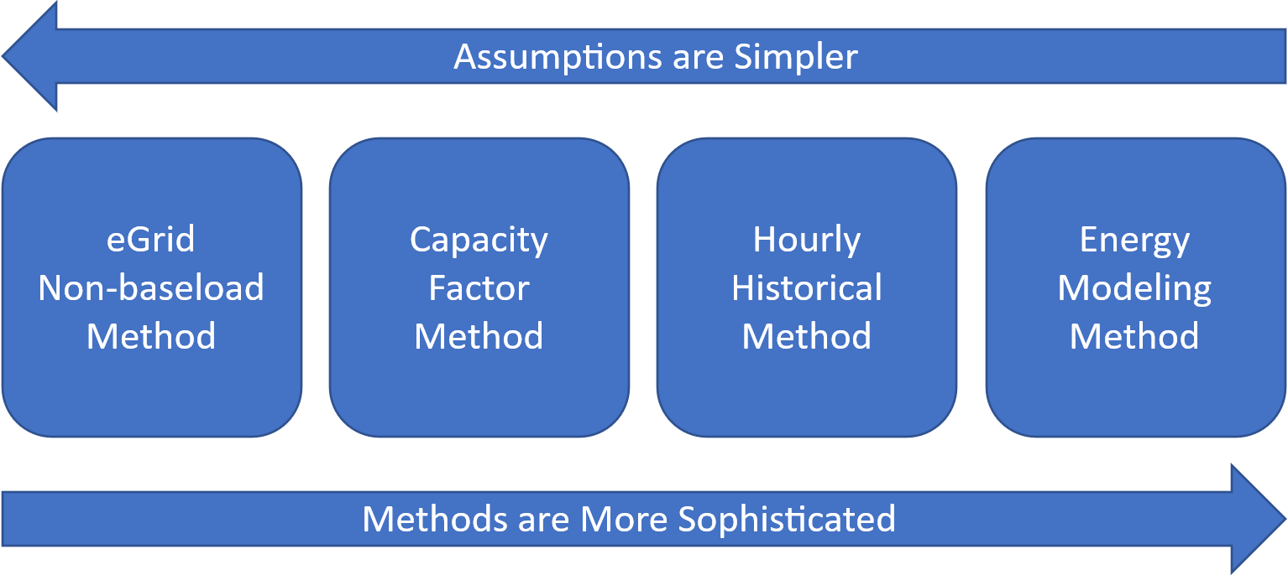

### Basic Method: eGRID Non-baseload Method

This basic method calculates the average non-baseload changes in emissions resulting from energy policies and programs in one of EPA’s “eGRID” subregions.[9] Annual electricity generation or sales increased or displaced by a program or measure are multiplied by the “non-baseload” emission rate for each pollutant in each eGRID subregion.[10] The non-baseload emission rates for an eGRID subregion are appropriate to represent the average emission rate for the EGUs most likely to be impacted by EE or RE.

### Basic Method: Capacity Factor Approach

The capacity factor approach estimates emissions impacts for an EGU based on its current capacity factor (i.e., its production of electricity in the most recent year as a percentage of the maximum energy that it can produce).[11] The capacity factor is used as a proxy for the likelihood that any given EGU will be impacted by new resources resulting from energy policies. Infrequently dispatched EGUs with low capacity factors are more likely to be impacted than EGUs with higher capacity factors.

### Intermediate Method: Historical Hourly Method

The AVERT method described here uses historical hourly emission rates based on recent EPA data on EGUs’ hourly generation and emissions reported through EPA’s Acid Rain Program.[12] This method couples historical hourly generation and emissions with the hourly load profiles of energy resources to determine hourly marginal emission rates and hourly changes in emissions. AVERT can be used to predict emissions changes in a current or near-future year—though it is based on historical behavior rather than predicted economic behavior and, therefore, does not use projections of future fuel or electricity market prices.

### Sophisticated Method: Energy Modeling

The most sophisticated method, energy modeling, is the use of highly complex simulation models that predict individual EGU dispatch, commitment, and emissions based on economic dispatch.[13] Energy models that simulate unit-by-unit dispatch and attempt to replicate decisions made by controllers and operators are called “production-cost” models, and will often include operational and transmission constraints. Operating economic dispatch models require the modification and validation of extensive input datasets, significant expertise to operate proprietary models, and ultimately a fairly high cost to evaluate individual scenarios. Other models called “capacity expansion” models are designed to optimize resource build-out (i.e., new capacity additions), and may be appropriate for examining long-term impacts of specific new resources.[14]

### Short-run and Long-run Power Sector Analysis

Electric sector interventions can have both operational as well as structural impacts on the electric grid. For example, the charging of new EVs might initially come from existing generators (i.e., operational impacts only), but after time, the existence of the new load may influence the deployment or retirement of generators (a structural change). Methodologies for estimating emissions changes can be classified as short-run (operational only, holding the structure of the grid fixed) or long-run (incorporating both operational as well as structural responses to an intervention).

Each approach is appropriate for distinct purposes. As structural impacts often take time to materialize, short-run approaches are appropriate for characterizing the near-term impacts of an intervention prior to the point where structural impacts are expected to occur. As a guiding principle, users can consider that it takes five years for an intervention to create structural impacts (although it can be shorter if the intervention was anticipated, such as a large EE campaign that the local utility was involved in and incorporated into their resource plans).

Depending on the interests of the analyst, short-run approaches may be sufficient. However, they are generally inappropriate for characterizing the long-term impacts of interventions due to the fact that they omit the intervention's impact on the structure of the grid.[15] AVERT is considered a short-run model, and it produces estimates of emission changes of scenarios representing the near-future and estimates of short-run marginal emission rates (SRMER).

## Using AVERT

AVERT is a free tool that allows users with minimal electricity-system expertise to easily evaluate county-level changes in emissions resulting from energy policies. AVERT is primarily designed to estimate the impact of new energy policies and programs on emissions from large (greater than 25-megawatt [MW]), stationary fossil-fired EGUs. It uses public data, is accessible and auditable, and can be used for quantifying emissions impacts in NAAQS SIPs.[16] Of the six criteria pollutants governed by NAAQS, AVERT provides analytical capability for three pollutants from direct emissions (NOx, SO2, and PM2.5) and two from a precursor basis (ozone and PM2.5).[17],[18]

To estimate changes in emissions using AVERT, users will need to know the type of program or measure to be analyzed or the program’s energy profile. An annual energy profile can be presented in 8,760 hourly intervals, or more coarsely in a few intervals (for example, peak, off-peak, and shoulder periods). For EE policies and programs, users will need the expected annual load reduction and an understanding of the temporal profile (e.g., would the EE program save energy throughout the year or primarily during peak periods). For RE programs, users will need to know the capacity of the solar or wind resource they are analyzing. These annual profiles are used to identify more precisely what specific generation resources will experience a change in output as a result of specific programs or measures.[19] In the absence of specific data on energy changes, planners need to use their judgement to approximate the timing of these changes.

Using these inputs, AVERT automatically estimates emission changes in a region. The user then can view various outputs, maps, charts, and tables useful for many different types of analysis. Users can choose outputs that show regional-, state-, and county-level changes in emissions, with the option of highlighting high-electric-demand days. Expert air quality modelers assessing changes in PM2.5,NOx, and SO2 emissions can use the SMOKE (Sparse Matrix Operator Kernel Emissions) output function to produce hourly, EGU-specific air-dispersion-model-ready data. AVERT users assessing the public health impacts of the criteria pollutant reductions can use the COBRA (CO-Benefits Risk Assessment Health Impacts Screening and Mapping Tool) output function to produce model-ready county-level emissions impact data.[20]

AVERT is best suited to analyze the emissions changes resulting from state-wide or multi-state energy policies and programs. Since AVERT modeling is conducted in one of 14 large regions that represent electricity markets and does not account for transmission constraints within each region, this tool is not recommended for estimating the change in emissions under small local programs. Smaller programs can use AVERT-generated emission rates to estimate emission changes within an AVERT region; these rates are available at [www.epa.gov/avert](https://www.epa.gov/avert). (See Appendix H for more details on determining the upper and lower bounds for load changes to be modeled in AVERT.) In addition, the tool is equipped to predict changes in near-term future years by estimating each unit’s generation, heat input, and emissions in the event that other EGUs are retired, newly brought online, or retrofitted with pollution controls.

AVERT provides useful information to expert energy or air quality planners, and also to interested stakeholders. In 2018, EPA released a web-based version of the AVERT Main Module on EPA’s website ([www.epa.gov/avert](https://www.epa.gov/avert)). It provides a streamlined interface with much of the same functionality as the downloadable Excel-based Main Module, without the need to use Excel software or upload separate Regional Data Files (RDFs). The Web Edition relies on the most recent year of input data. Refer to Appendix I for a comparison between the Excel- and web-based Main Modules’ functionality and available display outputs.

### Example Use A: Air Quality Planner Quantification of Changes in Emissions Resulting from an Energy Efficiency Program for State Implementation Plan Compliance

Air quality planners can use AVERT to quantify the expected emissions of a new wind farm, solar initiative, or EE program for the purposes of Regional Haze Rule or NAAQS SIP/Tribal Implementation Plan compliance. For example, planners can evaluate a program that could displace NOx during the summer ozone season, efforts to bolster a state wind energy program, or proposed additional incentives for an EE program that targets peak energy usage (e.g., high-efficiency air conditioner replacement).

Using AVERT, planners can input estimates for the amount of energy a wind farm of a particular size and output typical of the region can produce or the amount of energy that could be avoided from an EE program. Among other outputs, AVERT can estimate annual SO2, PM2.5, and VOCs emissions as well as ozone-season NOx emissions reductions or a pounds (lb)-per-day 10-day average of NOx emissions in counties selected, allowing a comparison of the effectiveness of these programs against other SIP measures. Advanced AVERT users can incorporate expected retirements and changes in emission rates expected in future years, and establish new baseline conditions. Because AVERT can output SMOKE-formatted emissions estimates for each EGU in the region in each hour of the year, planners can also assess the air quality improvements using an air dispersion model. Following EPA guidance, this information could be incorporated into a SIP.[21]

### Example Use B: Stakeholder Review of Multiple Energy Efficiency Options for Changing Emissions

Stakeholders can use AVERT to develop and test multiple types of EE programs in a state or group of states within an AVERT region to compare potential reductions in PM2.5, NOx, SO2, VOC, NH3, or CO2 emissions. Using AVERT, they can quickly test different types of EE load profiles and estimate the resulting displaced emissions. Users would modify input parameters to simulate baseload, peak load, or total EE portfolio reductions, or hour-by-hour load reduction profiles. This type of analysis allows stakeholders to review estimated emissions benefits from a wide variety of programs, which can help them consider adopting and/or implementing programs with the greatest improvements to air quality.

### Cautionary Note

AVERT should only be used to assess changes to emissions resulting from energy programs—not to assess changes to an EGU fleet. For example, AVERT is not equipped to examine the changes in emissions that result from retirements, changes to heat rates, or specific fuel changes. AVERT uses data based on historical dispatch patterns and cannot credibly estimate changes in emissions resulting from changes to the overall pattern of dispatch.

## Benefits of Using AVERT

AVERT combines historical hourly generation data with energy profiles, making it possible for users to:

* Compare the emissions impacts of different types of energy polices, programs, or technologies.
* Incorporate energy policies and programs into air quality models and public health impact tools, such as EPA’s COBRA Screening Model; and identify opportunities within the power sector for SIPs to demonstrate Clean Air Act compliance.[22]
* Estimate emission changes during peak energy demand periods in a historical year or near-term future year.

For example, wind and solar power have different hourly and seasonal operational profiles. AVERT can compare the change in emissions between these two RE technologies at different times of the year. Similarly, various EE programs have different hourly load profiles. AVERT can also help users analyze different EE programs or portfolios of programs that offer different energy savings and emissions changes throughout the year. Using this information, air quality planners could, for example, assess which EE programs provide the greatest air quality improvement on high ozone days. For smaller programs, users can use AVERT-generated emission rates to get a general estimate within an AVERT region. (See Appendix H for more details on determining the upper and lower bounds for load changes to be modeled in AVERT.)

**Emission Rates from AVERT**

EPA has used AVERT to produce approximations of marginal emission rates for each AVERT region and for a national weighted average. Current and historical emission rates are available at <https://www.epa.gov/avert/avoided-emission-rates-generated-avert>. These emission rates were calculated by assuming a 0.5% reduction in the regional fossil generation and are divided into eight categories: onshore wind, offshore wind, utility PV, utility PV-plus-storage, distributed PV, distributed PV-plus-storage, portfolio EE, and uniform EE. These emission rates can be used for quick estimates of avoided emissions under specific scenarios, especially for very small energy policies.

AVERT is driven entirely by historical, publicly available data reported to EPA and the U.S. Department of Energy’s (DOE’s) Energy Information Administration (EIA). It uses statistically driven “behavior simulation” to estimate near-term future emissions changes based on the recorded historical behavior of existing EGUs in the recent past. Using this dataset alone, the model derives unit generation behaviors (i.e., how these EGUs respond to load requirements), EGUs that have a must-run designation,[23] and forced and maintenance outages. In addition, AVERT accurately represents the recent historical relationship between unit generation and emissions, with characteristics such as a decreasing heat rate (i.e., increasing efficiency) at higher levels of output, higher emissions from EGUs that are just warming up, and seasonally changing emissions for EGUs with seasonal environmental controls. The derivation of unit behavior and its application to AVERT is described in detail in Appendix D of this user manual.

AVERT has many advantages but requires several simplifying assumptions. Unlike traditional electricity system simulation dispatch or production cost models, AVERT does not use operating costs to estimate how and when an EGU dispatches to meet load requirements. As a result, there are important electric system dynamics that AVERT cannot capture: temporal characteristics (i.e., EGU minimum maintenance downtime and ramp-rates), changing economic conditions (i.e., rising or falling fuel or emissions prices), and explicit relationships between EGUs (i.e., units that substitute for one another). AVERT should not be used to assess these types of changes in the electric system or overall dispatch. These limitations are discussed in more depth in Appendix L.

AVERT operates in a basic computer environment and leads users through the process step-by-step. Detailed instructions for the Excel version of the Main Module can be found in Section 4 of this manual or EPA’s AVERT online tutorial.[24] In 2018, EPA launched a simplified web-based version of the Main Module. Refer to Appendix I for a comparison between the web and Excel versions.

.

# The AVERT Analysis Structure

AVERT has three components:

* An Excel- and web-based **Main Module** allows users to estimate the changes in emissions likely to result from new energy programs, policies, or projects. The Excel-based version requires users to select RDFs generated by the Statistical Module to analyze scenarios in reference to either a historical base year or a future year. (See Sections 3 and 4 for a detailed description of the Main Module.) The web-based version of the Main Module provides a streamlined interface with much of the same functionality as the downloadable Excel tool, without the need for Excel software or separate RDFs. The Web Edition relies on a single year of data and generates a subset of display outputs of state and county level emission changes. Refer to Appendix I for a full comparison of the Excel- and web-based Main Modules. Except for this appendix and where noted otherwise, this user manual describes features available in the Excel version.
* The MATLAB®-based **Statistical Module** performs statistical analysis on historical generation, heat input, and emissions data collected by the EPA Clean Air Markets Division (CAMD)[25] to produce the statistical data files used by AVERT’s Main Module. The Statistical Module is available to users as a stand-alone executable. (See Appendices D and E for a detailed description of the Statistical Module.)
* The Excel-based **Future Year Scenario Template** allows users to modify base-year CAMD data with specified retirements and additions of power plants, as well as changes in emission rates due to pollution controls. This modified data can be input into AVERT’s Statistical Module to produce scenario-specific statistical data files, which are then fed into the Main Module. (See Appendix F for a detailed description of the Future Year Scenario Template.)

AVERT analyzes how hourly changes in demand in a user-selected historical base year change the output of fossil EGU.[26] Using detailed hourly data from CAMD, AVERT probabilistically estimates the operation and output of each EGU in a region based on a region’s hourly demand for fossil-fired generation. This statistical information is used to predict EGUs’ likely operation in response to energy changes from modeled resources. Figure 2, below, shows the flow of data from its source, through various processing tools, to its end-use in the Main Module.

In general, hourly “prepackaged” CAMD data are input into AVERT’s Statistical Module. Hourly generation, heat input, and emissions of SO2, NOx, and CO2 from each EGU reporting to CAMD (a requirement for fossil-fuel EGUs 25 MW and greater) are read from monthly or quarterly files.

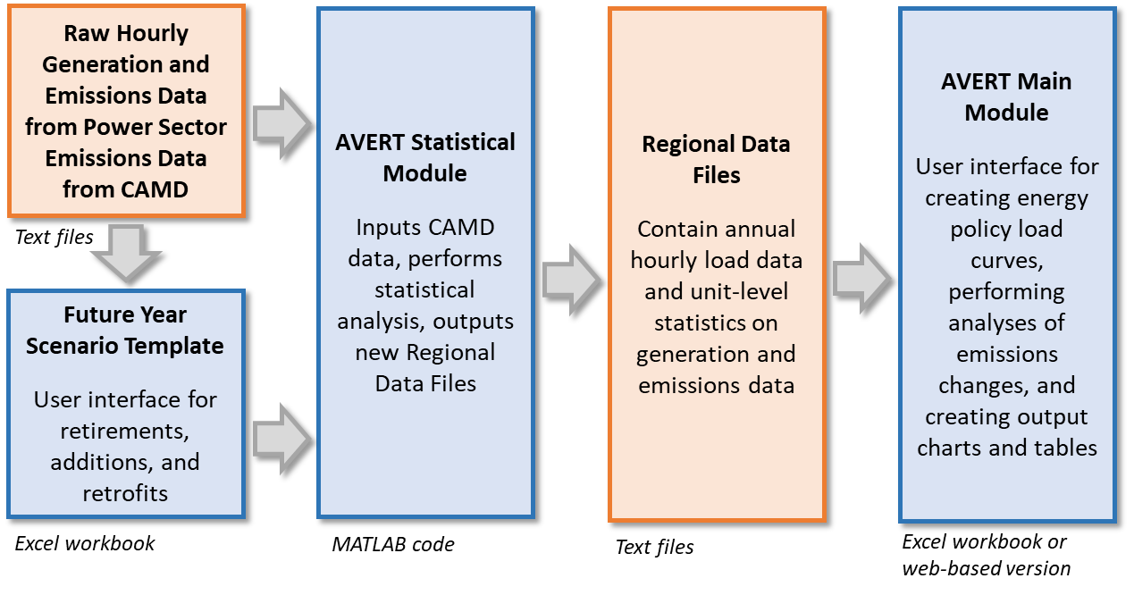Figure 2. Schematic of AVERT.

AVERT’s Statistical Module can analyze either raw data for a base year or modified data created in the AVERT’s Future Year Scenario Template.[27] AVERT’s Future Year Scenario Template allows users to create a scenario for a year in the near future[28] by modifying data representing a historical year. Users designate existing fossil-fuel EGUs that will no longer be in operation or will have different emission rates as a result of pollution-control retrofits, and add new fossil-fuel EGUs based on the characteristics of proxy existing EGUs. (See Appendix F for a more detailed description of AVERT’s Future Year Scenario Template.)

After receiving either base- or future year scenario data, AVERT’s Statistical Module performs a statistical analysis of how each EGU responds to variations in regional fossil load, and simulates the average generation, heat input, and emissions of each EGU across a range of possible load levels, from zero to the maximum coincident fossil capacity.[29] These EGU and load-level-specific averages are stored in the AVERT RDFs, which are the input files used into AVERT’s Main Module. (See Appendix D and Appendix E for a more detailed description of AVERT’s Statistical Module.)

AVERT’s Main Module is accessible as an online tool or a downloadable Excel workbook. It allows users, regardless of their level of electricity modeling expertise, to quickly estimate the changes in emissions likely to result from energy policies in a chosen year.[30] AVERT’s Main Module provides a simple interface that guides users through inputting an hourly energy profile depicting electricity demand in every hour of a year. The user is then prompted to launch automatic calculations that result in final results tables and charts for one of the 14 AVERT regions and, if desired, smaller areas within the region. In addition, AVERT’s Excel-based Main Module also outputs SMOKE-formatted data for advanced air modeling applications. Both the Excel and web versions output COBRA-formatted data for public health modeling applications. (See Sections 3 and 4 for a more detailed description of AVERT’s Main Module and instructions for its use.)

# AVERT Main Module: An Overview

This section provides a simplified overview of user inputs and model results. See Section 4 for detailed, step-by-step instructions and Appendix A for detailed installation instructions. Appendix D describes, in detail, how AVERT performs its calculations. Appendix I provides a comparison between the web- and Excel-based versions of AVERT’s Main Module.

AVERT’s Excel-based Main Module estimates the emission changes resulting from user-entered energy policy scenarios. AVERT predicts emissions changes for every individual fossil-fuel EGU in a region and aggregates these changes to the county level.[31] The Main Module uses two key pieces of information:

* **Expected emissions at every load level**—the likely generation level and emissions of all but the smallest fossil-fuel EGUs in a region in a base- or future year scenario (as modeled in AVERT’s Statistical Module and input automatically into the Main Module).
* **A change in load level for every hour of the year**—a user-created energy profile depicting user-created changes in the regional fossil-fuel load for every hour of the year.

The Main Module estimates how much each fossil-fuel EGU changes its generation output and emissions in response to an energy policy (e.g. a scenario) as compared to the base- or future year without the program (e.g. the baseline). The Main Module presents emissions changes between the scenario and the baseline in summary tables for quick comparison, and in graphs and maps for rapid visual assessment.

Section 4 presents detailed, step-by-step instructions on the process of identifying a region for analysis; obtaining and importing data; designing an energy profile; calculating the changes resulting from this profile; and accessing tables, graphs, and maps summarizing the results. Once an energy profile has been designed, typical processing takes 1 to 10 minutes depending on the size of the region of interest and the processing speed of the computer.

## AVERT Regions

Because customers’ electricity demand is met jointly by generation resources throughout a region, emissions changes from energy policies occur region-wide. All AVERT analysis, therefore, is conducted at a regional level. For users, designating one of the 14 AVERT regions for analysis is “Step 1” in using AVERT’s Main Module. A map of these regions is shown in Figure 3.

Twenty-four of the contiguous U.S. states are split between two or more regions each; the other 24, and the District of Columbia, are not split. Table 1 describes each region in detail.

Generally, air quality managers for states that are split between more than one AVERT region should evaluate the emission changes for all regions that state is a part of. Appendix G includes further discussion of the regions and more complete instructions for users analyzing expected changes from energy policies in split states.

Figure 3. Map of AVERT’s regions.

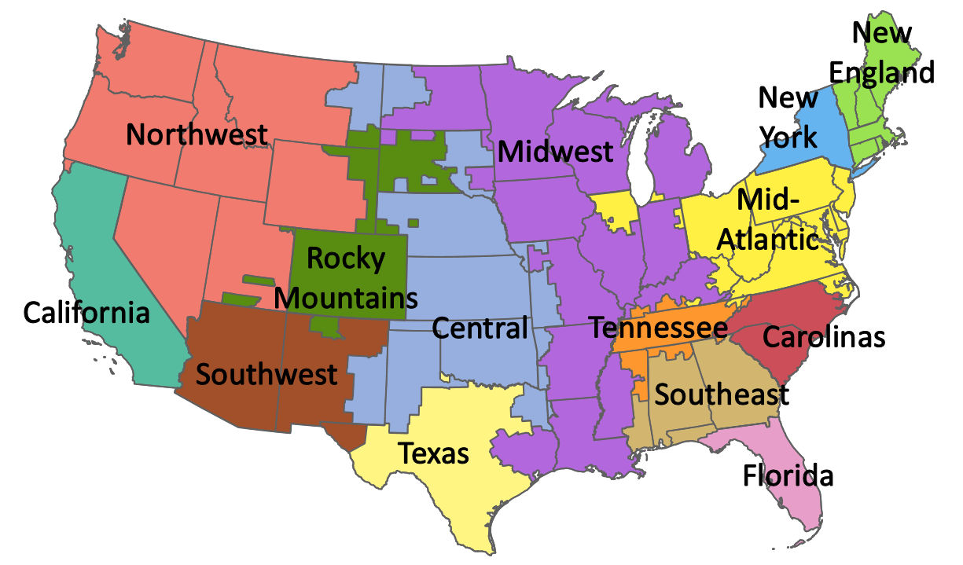

Table 1. AVERT regions, abbreviations, and states.

| **AVERT region** | **Full states** | **Partial states** |
| --- | --- | --- |
| California | California | — |
| Carolinas | South Carolina | North Carolina |
| Central | Kansas | Arkansas, Iowa, Louisiana, Minnesota, Missouri, Montana, North Dakota, Nebraska, New Mexico, Oklahoma, South Dakota, Texas |
| Florida | — | Florida |
| Mid-Atlantic | District of Columbia, Delaware, Maryland, New Jersey, Ohio, Pennsylvania, Virginia, West Virginia | Illinois, Indiana, Kentucky, Michigan, North Carolina, Tennessee |
| Midwest | Wisconsin | Arkansas, Iowa, Illinois, Indiana, Kentucky, Louisiana, Michigan, Minnesota, Missouri, Mississippi, North Dakota, Oklahoma, South Dakota, Texas |
| New England | Connecticut, Massachusetts, Maine, New Hampshire, Rhode Island, Vermont | — |
| New York | New York | — |
| Northwest | Idaho, Nevada, Oregon, Washington | Montana, Utah, Wyoming |
| Rocky Mountains | Colorado | Montana, Nebraska, New Mexico, South Dakota, Utah, Wyoming |
| Southeast | — | Alabama, Florida, Georgia, Mississippi |
| Southwest | Arizona | New Mexico, Texas |
| Tennessee | — | Alabama, Georgia, Kentucky, Mississippi, Tennessee |
| Texas | — | Texas |

## Energy Policy Characteristics

AVERT users should understand the characteristics of the energy scenario that they want to analyze in terms that can be input into the model; this is Step 2 in the AVERT Main Module. AVERT analyzes the difference in hourly load (regional electricity demand) between a baseline scenario and some intervention scenario created by the energy policy, resulting in an energy profile consisting of hourly changes to fossil-fuel EGU generation. This in turn leads to a change in emissions. Starting with a baseline schedule of load for every hour of a reference year (the “load profile”),[32] the Main Module guides the user to create or input an energy profile to represent their energy policy—i.e., the amount that load that will be reduced or increased by the energy policy on an hourly basis. For details and instructions, refer to Step 2 in Section 4.

Users are encouraged to create and adopt their own energy profiles, representing energy projects, programs, or policies specific to their interest or area of concern. The following energy profiles are built into the Main Module:

* **Reduction of fossil-fuel generation by a chosen percent in some or all hours.** This option is recommended to represent a mix of EE programs that target some or all hours of the year, but preferentially target higher hours with greater demand. Users can also use this option to increase fossil-fuel generation by entering a negative number for the percent generation reduction.
* **Reduction of annual fossil-fuel generation by total gigawatt-hours (GWh) or by a constant MW each hour.** This option is recommended to represent a rough approximation of baseload-only reductions where the total number of GWh reduced over the course of a year is known and is expected to be equally distributed over all hours of the year. Users can also use this option to increase fossil-fuel generation by entering a negative number for the amount of generation reduction.
* **Renewable energy.** With this option, users can model onshore wind, offshore wind, utility solar, and rooftop solar resources that are broadly representative of the selected region.
* **Electric vehicles.** Users can model the impact of EVs on power sector generation changes and associated changes in emissions from the power sector. EVs are motor vehicles that obtain some or all of their power supply from batteries, which are charged by power plants on the electric grid. Users can model a variety of vehicle types, including light-duty vehicles (LDVs), short-haul commercial vehicles (which include light-, medium-, and heavy-duty vehicles), long-haul heavy-duty commercial vehicles, school buses, transit buses, and refuse trucks using default charging profiles. Users can also define their own 8,760 hour charging profile. AVERT also estimates the avoided internal combustion engine (ICE) vehicle emissions.[33]
* **Energy storage.** Users can model the impact of energy storage on power sector generation and associated changes in emissions. Energy storage can help shift fossil generation on the grid by charging during lower-demand hours and discharging that captured energy during higher-demand periods. Users can model distributed and utility-scale energy storage, select the charging profile to model or create a manual profile, and choose to pair energy storage with solar generation.

**Combination of energy policies.** Users can also layer the above options together, as well as combine the pre-set options with manually entered energy changes.

AVERT combines all of the user’s inputs to generate a single energy profile with 8,760 hourly values.[34] This profile feeds into the calculations in the next step. Since the release of AVERT v1.5, AVERT adjusts the energy profile to account for avoided transmission and distribution line losses associated with certain resources that avoid the need for long-distance transmission: specifically, EE, distributed PV systems, and EVs.[35] The magnitudes of hourly load changes associated with each of these resources are adjusted upward by the following formula:

*adjusted load change = user’s input / (1 – x),*

where *x* is the regional average line loss percentage. Starting with AVERT v2.3, AVERT uses line loss factors from the Annual Energy Outlook, published by EIA.[36] AVERT uses the historical line loss factors that correspond to the year and region of the user’s analysis, as shown in Table 2.

Table 2. Transmission and distribution line loss factors used in AVERT.

|  |  |  |  |
| --- | --- | --- | --- |
| **Data year** | **Texas** | **Eastern Interconnect** | **Western Interconnect** |
| 2017 | 5.60% | 7.00% | 8.13% |
| 2018 | 4.83% | 6.74% | 8.54% |
| 2019 | 5.38% | 7.20% | 8.60% |
| 2020 | 5.17% | 7.58% | 8.28% |
| 2021 | 4.95% | 7.50% | 8.39% |
| 2022 | 4.58% | 7.23% | 8.67% |
| 2023 | 4.58% | 7.23% | 8.67% |
| 2024 | 4.58% | 7.23% | 8.67% |

The Eastern Interconnect corresponds to the following AVERT regions: Carolinas, Central, Florida, Mid-Atlantic, Midwest, New England, New York, Southeast, and Tennessee. The Western Interconnect corresponds to the following AVERT regions: California, Northwest, Rocky Mountains, and Southwest. The Texas region in Table 2 corresponds to the AVERT Texas region.

This adjustment has the effect of increasing the magnitude of fossil load change and emissions change associated with distributed RE generation and energy policies and programs that change electricity consumer demand (e.g., EE and EVs). The adjustment provides more accurate results. Without it, AVERT would underestimate changes to emissions. For example, AVERT without adjustments would assume that 100 megawatt-hours (MWh) of EE or 100 MWh of onsite (distributed) PV generation in the Eastern Interconnect in 2018 avoids 100 MWh of fossil generation, whereas it actually avoids approximately 107 MWh of fossil generation after accounting for the additional power that would have been generated and lost during transmission in order to deliver 100 MWh to the end-user. Similarly, for this region and year, a fleet of EVs that requires 100 MWh to charge would be modeled at approximately 107 MWh of additional load due to transmission losses.

Once an energy profile has been designed and the appropriate transportation characteristics selected, if necessary, the user is prompted to begin the model run in Step 3 of the AVERT Main Module.

## Scenario Results

Step 4 of AVERT’s Main Module reports the difference between the baseline and modeled energy policy scenario through the following outputs:

* Summary tables – Power sector only:
* Annual changes to generation and emissions
* Emissions changes for top 10 fossil-fuel generation days
* Annual emissions changes by county
* Monthly emissions changes by county
* Daily NOx emissions changes by county
* Charts and figures – Power sector only:
* Map of generation and emissions changes
* Hourly emissions changes by week
* Monthly emissions changes by selected geography (region, state, or county)
* Signal-to-noise diagnostic
* Summary tables, charts, and figures – Power sector and avoided vehicle emissions data:
* Annual changes to generation and emissions – with vehicles
* Annual emissions changes by county – with vehicles
* Monthly emissions changes by county
* Annual emissions results by selected geography
* Projected CO2 emission rates over time
* COBRA text file generation (for public health impact modeling)
* SMOKE text file generation (for air quality modeling)

For assessing the air quality implications of energy policies, the location of air emissions changes resulting from either load increases or decreases can be critical. The example shown in Figure 4 represents a 2,000 MW onshore wind program in the Midwest AVERT region compared with 2024 base-year data. The map displays annual changes in SO2 emissions from specific EGUs as blue circles; larger circles indicate greater changes to emissions. Where multiple EGUs overlap on the map (i.e., multiple units at one plant or several plants close together), the circles appear darker.

Figure 4. Map of annual SO2 emissions reductions from an example wind program in the Midwest region.

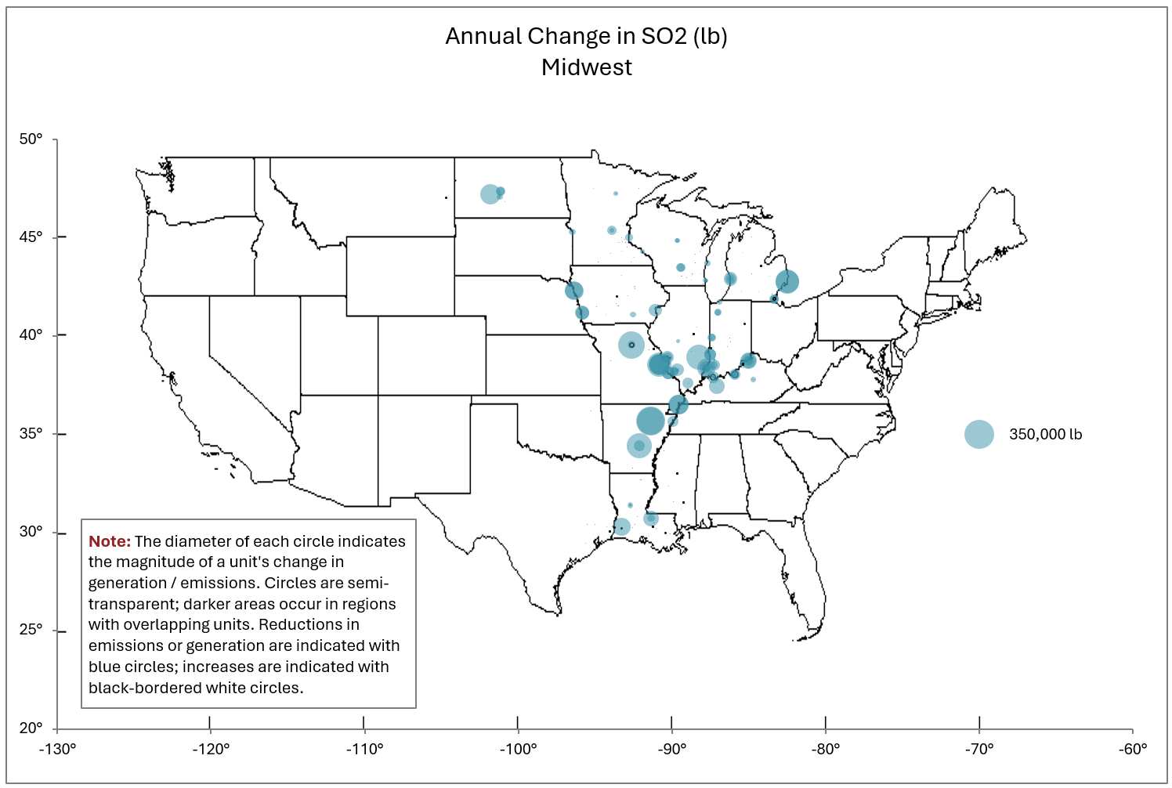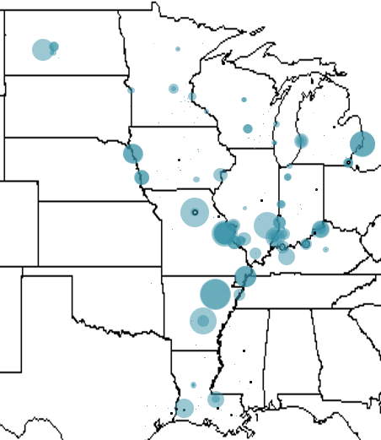

The diameter of each circle indicates the magnitude of an EGU’s change in emissions. Circles are semi-transparent; darker areas occur in regions with overlapping EGUs. Emissions reductions are indicated with blue circles; increases in emissions are indicated with black-bordered white circles.

Increases in emissions are shown as black-bordered white circles. Increasing emissions may occur because higher load is programmed into AVERT (e.g., for testing a higher baseline if reviewing the impact of existing renewable portfolio standards, if shifting load from peak to trough hours, or increases due to EVs), or due to aberrations in the statistical dataset.[37]

Many users will be interested in changes to emissions for smaller areas within a region. Monthly results can be displayed by region, state, or county. Figure 5 displays monthly SO2 emissions changes within a single county in Illinois, continuing the same example shown in Figure 4.

Figure 5. Monthly SO2 emissions reductions for Independence County, Arkansas, from an example wind program in the Midwest region.

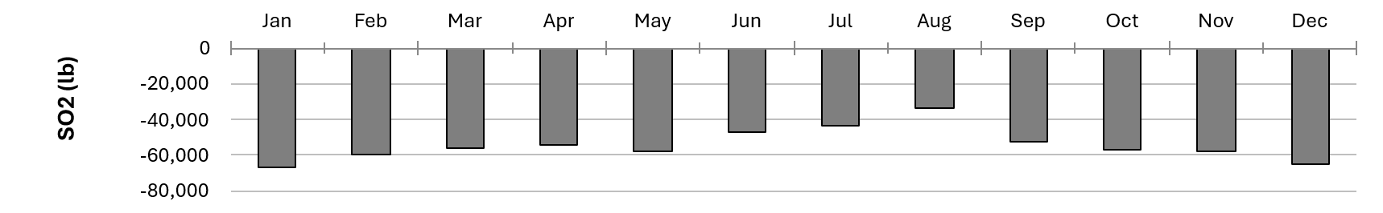

Some users may wish to instead view hourly changes to generation or emissions to understand the behavior of the system at a finer scale or during specific hours of the year. Using the same 2,000 MW onshore wind program, Figure 6 displays the hour-by-hour fossil generation displaced in the week of August 1–7 in the Midwest AVERT region from the wind project. Individual EGUs are color-coded along a gradient from dark blue (baseload EGUs) to light blue (peaking EGUs).[38] The EGUs’ individual generation reductions are shown in stacked bar plots and the net total contribution is shown with a yellow line. The yellow line represents the hourly energy displaced by the wind project. Note that peaking (gas) EGUs are primarily displaced during daytime hours, while baseload (usually coal) EGUs are displaced during off-peak hours.

Figure 6. Hourly generation reductions in the week of August 1 from an example wind program in the Midwest region.

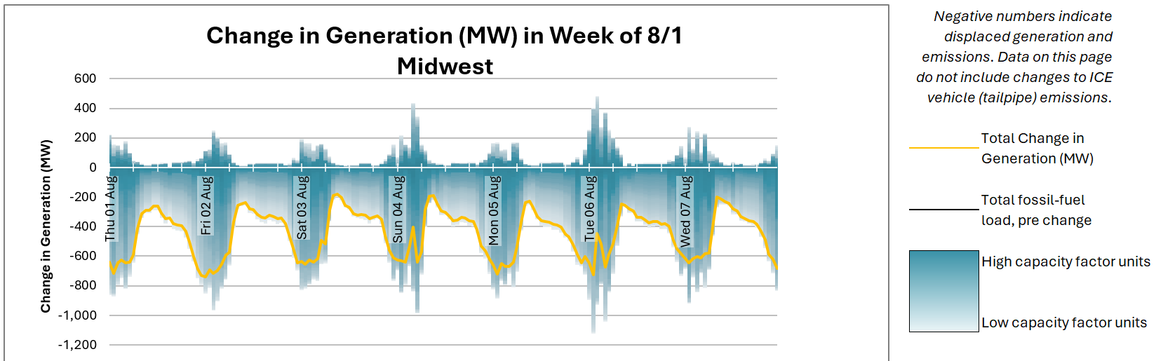

Figure 7 displays SO2 emissions displaced in the same week from the same wind project. Note that almost all of the EGUs portrayed in this figure are dark blue in color; SO2reductions are primarily captured from reductions at high-capacity-factor coal EGUs, which are displaced during off-peak hours.[39]

Figure 7. Hourly emissions reductions in the week of August 1 from an example wind program in the Midwest region.

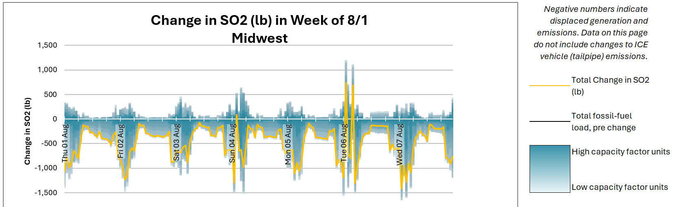

# AVERT Main Module: Step-by-Step Instructions

This section provides step-by-step instructions for using AVERT’s Excel-based Main Module to estimate the change in emissions resulting from energy policies.

To begin, download two files and save them to your computer:

* The Main Module workbook: “AVERT Main Module.xlsb.” Download the workbook at <https://www.epa.gov/avert>.
* The RDF for the region under analysis.
* Default RDFs developed for use by EPA are labeled  
  “AVERT RDF [DataYear] EPA_NetGen25 ([Region]).xlsx”; they can be obtained at <https://www.epa.gov/avert>.
* Regional analyses developed by advanced users using AVERT’s Statistical Module will be saved, by default, in a folder of the Statistical Module titled “AVERT Output.” These files use the following naming convention: “AVERT RDF [DataYear] [RunName] ([Region]) [RunDateTime].xlsx.”

For more detailed installation instructions and model specifications, see Appendix A of this manual.

## AVERT Welcome Page

When launched in Excel, the Main Module opens to its “Welcome” page as shown in Figure 8.

Figure 8. AVERT Main Module “Welcome” page. 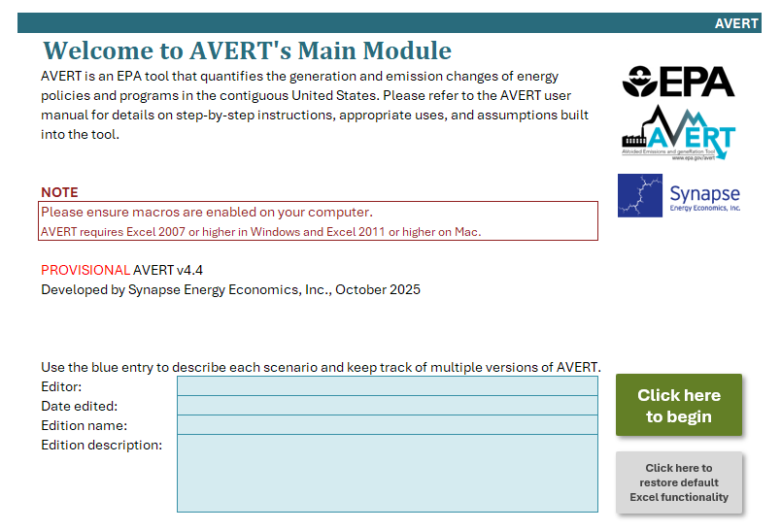

The Main Module is primarily driven by macros to conserve memory and processing time.[40] Before you make any selections or begin calculations, macros must be enabled on your computer. This must be done first, before any other steps; if macros are not enabled before you load an RDF (Step 1), you will need to close the workbook, re-open it, and then enable macros to continue.

To enable macros in Excel 2007 for Windows:

1. Click the Microsoft Office Button , then click “Excel Options.”
2. Click “Trust Center,” click “Trust Center Settings,” then click “Macro Settings.”
3. Click on “Enable all macros.”

To enable macros in Excel 2010 or later for Windows:

1. Click the “File” menu (Office Backstage), then click “Options” in the left sidebar.
2. Click “Trust Center” in the left sidebar, then click the “Trust Center Settings” button in the main window.
3. Click “Macro Settings” in the left sidebar.
4. Choose the “Enable all macros” option and hit “OK.”

To enable macros in Excel 2011 or later for Mac, select “Enable macros” in the dialog box that appears when opening the file.

Next, we recommend that you personalize the Welcome page with details about the user, the date of use, and the energy policy for which emissions changes are to be estimated. This version specification is very useful for keeping track of multiple versions of AVERT saved to the same drive. Please note that the version of AVERT available from EPA does not contain an RDF, and is thus fairly small (36 MB). When an RDF is loaded into AVERT and changes are calculated, the file grows substantially to 70 to 190 MB.

A final note on the Welcome page: The Main Module has been designed to provide a clear user interface. While it is an Excel file, the tabs that drive the calculations for AVERT are hidden to enhance the usability and appearance of the tool, making it more similar to a web-based or executable program. For users who prefer full Excel functionality while using AVERT, there is a button at the lower right-hand side of the Welcome page that reads “Click here to restore default functionality.” You can complete the steps required to estimate changes to emissions regardless of whether or not full Excel functionality is visible.

Click on the button labeled “Click here to begin” to move on to AVERT’s first step.

## Step 1: Load Regional Data File

Next, choose the region of analysis in Step 1 (as shown in Figure 9) and load the corresponding RDF. There are 14 AVERT regions to choose from, described in detail in Section 3. (For details on how the regions were developed, refer to Appendix B.)

Figure 9. Image of the AVERT Main Module’s “Step 1: Import Regional Data File” page.

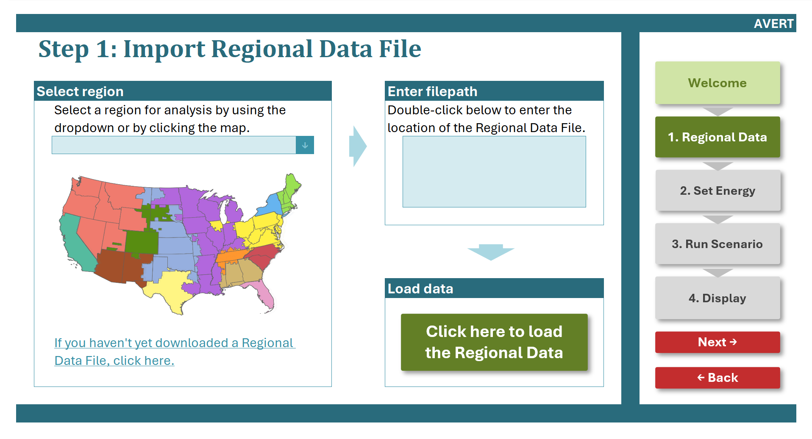

The choice of a region determines both which EGUs are included in the analysis and which default renewable resources are available for modeling the effects of energy policies.

The 14 AVERT regions are:

* California
* Carolinas
* Central
* Florida
* Mid-Atlantic
* Midwest
* New England
* New York
* Northwest
* Rocky Mountains
* Southeast
* Southwest
* Tennessee
* Texas

If you have not yet downloaded an RDF, you can either select a region of interest from the dropdown menu or by clicking on the region in the map, then click the hyperlink in the bottom left of the page.

Then, double-click on the filepath box and navigate to the folder where the RDF has been saved. Once these steps have been completed, click on the green button labeled “Click here to load the Regional Data File.” This step may take several minutes to complete, depending on the size of the region and the speed of the computer used. When the RDF has been loaded, a pop-up box appears containing information about the loaded AVERT region and indicating “Import complete.”

The pop-up box confirms the region and data year loaded by the user and indicates the number of reporting units in the analysis. The pop-up box also specifies the states that are fully represented and partially represented in a loaded AVERT region, as shown in Figure 10.

Figure 10. RDF import pop-up box example for the 2024 Midwest AVERT region.

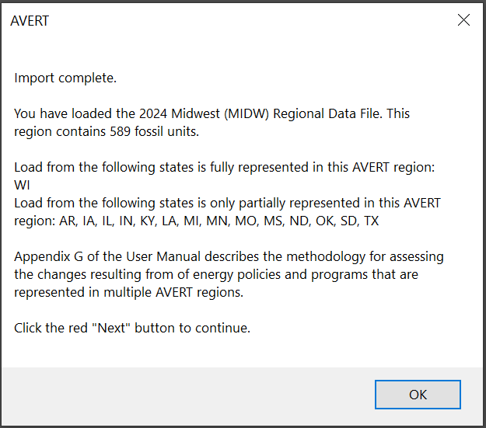

Some states are split across more than one AVERT region. For example, parts of Illinois are in the Midwest Region, while other parts are in the Mid-Atlantic Region.[41] Appendix G of this document describes the process that one should use to determine the emission changes resulting from energy policies in states that are partially represented in any one AVERT region. Users analyzing these states should assign the energy policies proportionally based on the fraction of the state’s electricity sales within each relevant AVERT region. These fractions are shown in Table 6 in Appendix G and, as a reminder and for clarity, in the pop-up box.

After you load an RDF, the blue AVERT header bar will indicate the region and data year in the top left corner (e.g., “Midwest, 2024”). The blue footer bar will also indicate the name of the AVERT run that has been loaded in the RDF (e.g., “EPA_NetGen_PMVOCNH3”). When you run the Statistical Module, you will be able to give runs alternative names.

All four of AVERT’s steps have a navigation panel on the right-hand side. You can click on any step or click “Next” or “Back” to move through the steps of the model. To move on to the next step, click “Next.”

## Step 2: Set Energy Scenario

In this step, you will create an energy profile (schedule of changes to electricity demand for every hour of a year) depicting the change in load expected from an energy policy as shown in Figure 11. In this example, the user has input a 5,000 MW onshore wind program with 50,000 battery EVs, the energy profile of which is being displayed in the chart on the right side of the screen.

Figure 11. Image of the AVERT Main Module’s “Step 2: Set Energy Scenario” page.

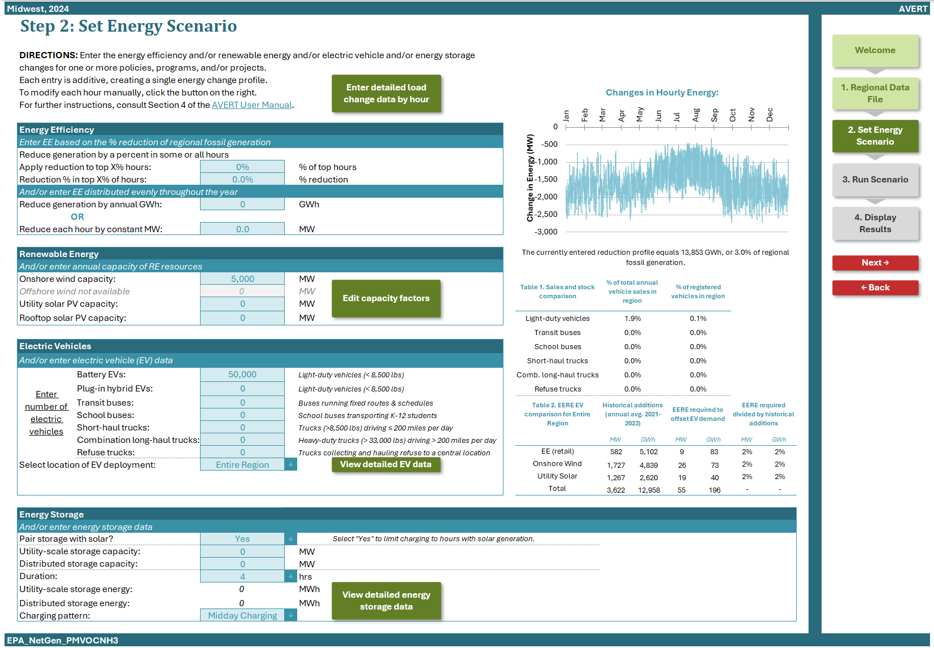

If you enter an energy change (increase or decrease) that exceeds 15 percent of regional fossil load in any given hour, you will be shown an alert highlighting the hours of exceedance (Figure 12), but you can still proceed with the calculations.

Figure 12. Image of the AVERT Main Module’s “Step 2: Set Energy Impacts” page with program size resulting in a more than 15 percent reduction in fossil load in some hours.

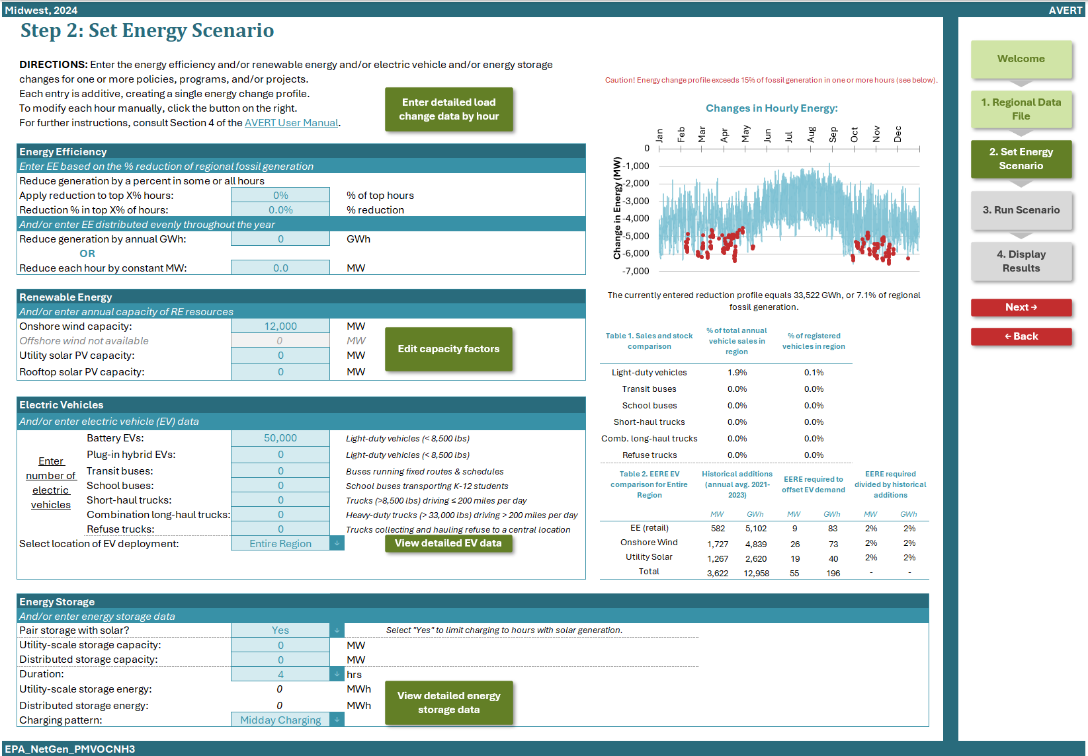

The Step 2 page allows you to estimate a change in load from basic characteristics:

* Enter hourly data manually (see green button in right-hand corner)
* Reduce fossil-fuel generation by a percent in some or all hours
* Reduce fossil-fuel generation by total GWh (flat)
* Reduce fossil-fuel generation by a constant MW in each hour
* Add RE capacity (utility solar, distributed solar, onshore wind, and offshore wind)
* Add EV charging load by specifying the number of EVs (light-duty battery-powered EVs [BEVs], light-duty plug-in hybrid vehicles [PHEVs], electric transit buses, electric school buses, electric short-haul trucks, electric combination long-haul trucks, and electric refuse trucks), and location of EV deployment
* Add energy storage by specifying first whether to model the energy storage with paired solar (solar-plus-storage), and then specifying the utility-scale storage capacity (MW), distributed storage capacity (MW), storage duration (hours), and charging pattern
* Combination of energy policies, including combining pre-set options with manual entry

Choose the option(s) that works best for your modeled energy policy and fill in the necessary data. Each option is described in more detail below. If you choose more than one option (including manual entry), the selected options will be combined into a portfolio of programs. For any program, or combination or programs, the Step 2 page returns a total annual energy change (in GWh) achieved by the modeled energy policy inclusive of appropriate T&D losses. Total hourly changes can be found in the manual input page.

Note that it is not recommended for energy profiles to exceed 15 percent of fossil load in any given hour. If a user-entered energy profile exceeds these recommended limits, a caution message will appear. The graph titled “Changes in Hourly Energy” will also indicate the affected hours. Exceeding the 15 percent threshold in one or more hours does not prohibit the user from proceeding with the calculations.

### Manual User Input

If the hourly energy changes expected from a particular energy policy, program, or measure are known, a customized profile can be created (consisting of 8,760 values for a non-leap year or 8,784 values for a leap year). For example, you might use this approach to test the measured or modeled emission changes from a particular known wind farm or EE program. To enter data manually or cut and paste data from another source, click on the green button that reads “Enter detailed load change data by hour” to get to a manual energy impact data entry screen (Figure 13). Users choose whether to enter a series of data for utility-scale programs or resources or for distributed programs or resources. With either choice, data are entered as a single column of values from 12 a.m. on January 1 through 11 p.m. on December 31. On this page, as with other AVERT inputs, positive values represent displacements. Users who wish to model scenarios with increases in load (for example, an EV scenario, building electrification scenario, or retroactive “what-if” scenario to see what would have happened if a particular energy policy or program had not been implemented) can enter negative displacement values to represent increased loads. All entered values should be in terms of MW-AC, not MW-DC.

This page also includes two columns that indicate whether a user has exceeded the recommended and/or calculable ranges of hourly load changes. Alerts will appear in these two columns if the data entered by the user a) produces a cumulative load change that exceeds 15 percent beyond the upper and lower limits of each hour’s original fossil load or b) produces a new load that is outside the range of AVERT’s ability to calculate generation and emissions changes.[42]

The “Total Change” column on the manual input page shows the total aggregate hourly energy change from the programs input or selected by the user.

Figure 13. Image of the AVERT Main Module’s “Manual Energy Impact Data Entry” screen. 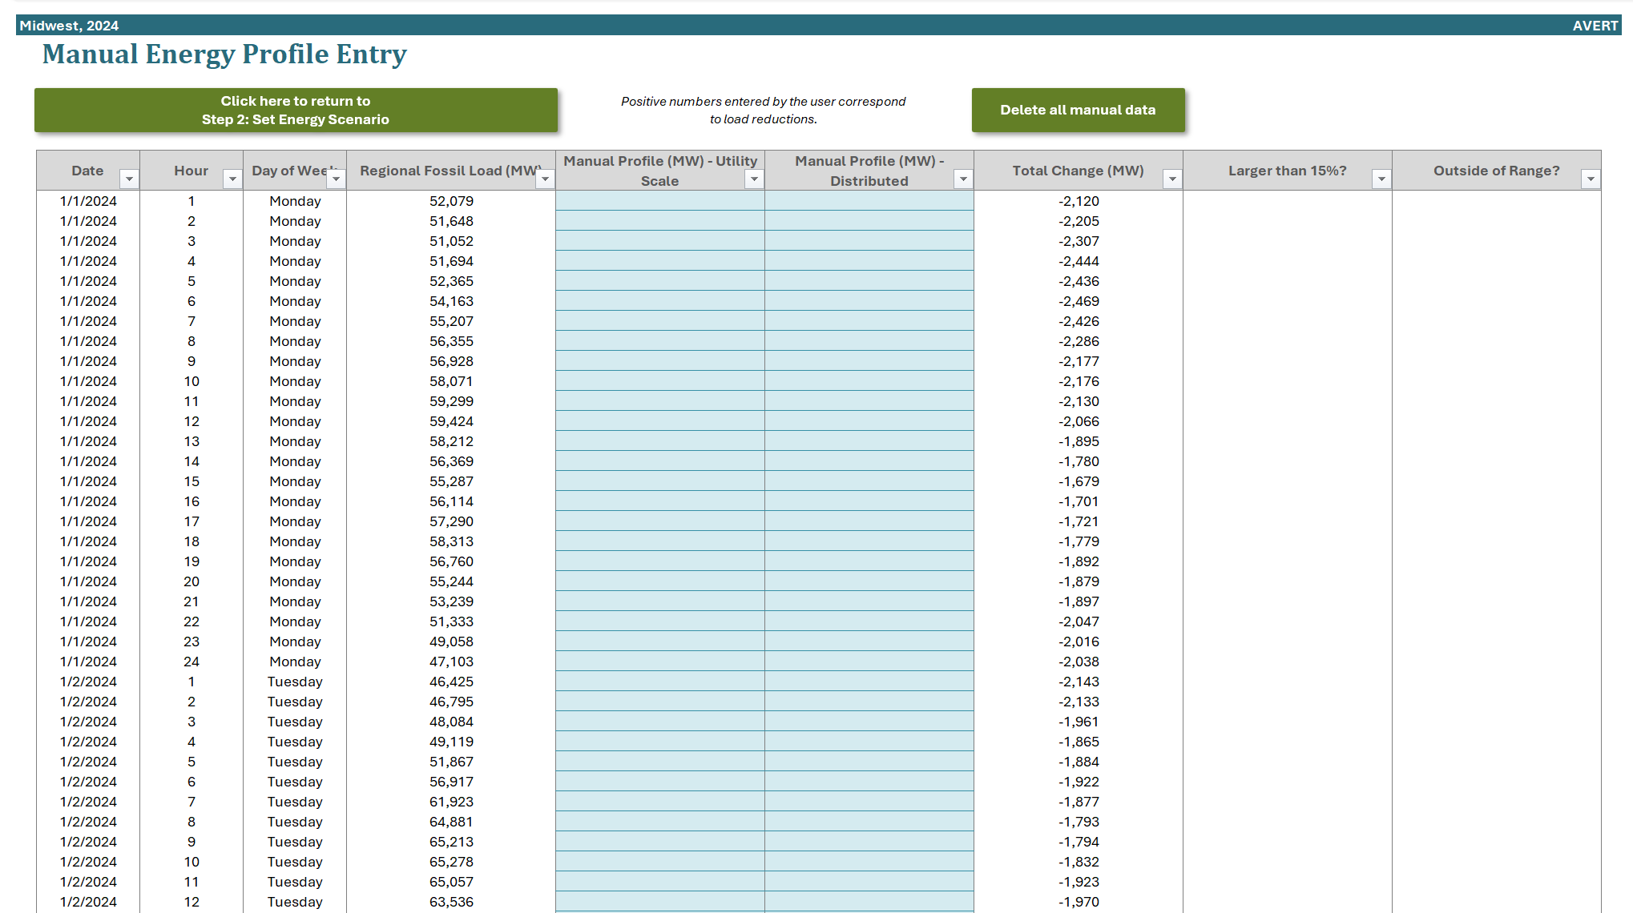

### Reduce Generation by a Percent in Some or All Hours[43]

To estimate the emission changes expected from a broad-based EE or demand response program targeting high-cost peak fossil-consumption hours, enter two values: a) the fraction of hours to which load reduction is applied (with reductions applied to the highest fossil-fuel generation hours first) and b) the percent by which those hours should be reduced. For a broad-based efficiency program, the fraction of hours that experience reductions is very high; for a demand response program, it is very low.

Note that, when the percentage options are used, reductions are a share of *fossil-fuel generation* and not total system load (i.e., consumption). Therefore, using a 2 percent reduction per hour effectively reduces load by 2 percent of fossil-fired generation.

To simulate a broad-based efficiency program, enter 100 percent as the “% of top hours” and an estimated load reduction fraction in the cell labeled “% reduction.” A graph of the selected energy profile—which combines both manual entries and user selections made on the Step 2 page—is shown on this page.

To simulate a peak-reduction targeting program such as demand response, enter a fraction of high-demand hours that the program is expected to affect, and the load reduction (as a fraction of peaking load) that would be targeted in those hours. This type of scenario is recommended for programs that emphasize reductions in peak hours. Generally, reductions exceeding 15 percent of fossil-fired generation are not recommended.[44]

Figure 14 shows a baseline energy profile (in black) and two example load reductions for three days in August. The blue, dotted line represents a 3 percent reduction in fossil-fired generation requirements in every hour of the year. The red, dashed line represents an 8 percent reduction in the 5 percent of hours with the highest demand for fossil-fired generation.

Figure 14. Examples of two load reduction programs as a percentage of some or all hours.

Line graph showing two load reduction programs as a percentage of some or all hours.

It is important to note that reducing load by a percent in some or all hours measures a reduction relative to hourly *fossil-fuel* load, and not system demand (i.e., consumption). It is important to ensure that the total reduction (in annual GWh) or peak reduction (in MW) comports with expectations of a reasonable fractional reduction. For example, if fossil-fuel load only accounts for 50 percent of regional generation, a user attempting to find the emissions changes of a *regional* load reduction of 3 percent should double the size of the reduction specified in AVERT’s Main Module (i.e., to 6 percent) to scale from total fossil-fuel load to regional load. Similarly, to estimate the effect of a portfolio reduction (i.e., a percentage change) where you have an expectation of the total annual reduction (in MWh or GWh), find the correct percentage reduction such that the total amount of energy reduced is equal to the expected quantity.[45] In all situations where EE is being modeled, AVERT increases the value entered to reflect a transmission and distribution loss factor, under the assumption that the user is intending to model reductions in sales, even though the impact modeled is calculated based on the quantity of fossil generation in that region.

### Reduce Generation by Annual GWh

You may have an estimate of the total amount of energy that is targeted or required to be reduced by a program in a given year, but lack information about the distribution of those reductions over the course of the year. “Reduce generation by annual GWh” simply distributes those savings evenly over all hours of the year. The user inputs a total number of GWh expected to be saved in a single year. This may be a highly erroneous assumption if savings are targeted from residential or commercial customers, for whom EE measures tend to target peak use reductions. However, an industrial or refrigeration efficiency program may be well represented by a constant reduction across most hours of the year. Use this option with close attention to the types of programs assumed in your analysis.

### Reduce Each Hour by Constant MW

This option is identical in effect to the annual load reduction by total GWh above. The user selects a constant reduction for every hour of the year in MW.

### Renewable Energy

This option allows you to model onshore wind, offshore wind, utility-scale solar PV, and rooftop-scale solar PV using regionally specific energy profiles. Select the annual capacity (maximum potential electricity generation) for each type of resource, measured in MW. The model applies these values to “hourly capacity factors” that vary by resource type and region. Hourly capacity factors are the likelihood that a resource is generating at its full capacity in a given hour of the year. For example, solar panels might have a 90 percent or higher capacity factor on an August afternoon, but a 0 percent capacity factor at midnight any day of the year. The data and methodology used to develop these capacity factors are described in Appendix C.

You can scale the capacity factors used for each RE technology by clicking on the “Edit capacity factors” button to get to a manual capacity factor entry screen (Figure 15). For each resource, the default average annual capacity factor on this page reflects the average capacity factor across all hours of the year. The user can input their desired average annual capacity factor and the hourly values used in the model will scale accordingly. For example, if the default capacity factor for onshore wind in a region is 25 percent and a user enters a value of 30 percent, all hourly capacity factors for that resource in that region are then scaled up by 20 percent.[46] Capacity factors can be revised upwards or downwards.

All entered values should be in terms of MW-AC, not MW-DC.

Figure 15. Image of AVERT’s “Manual Renewable Energy Capacity Factor (CF) Entry” screen.

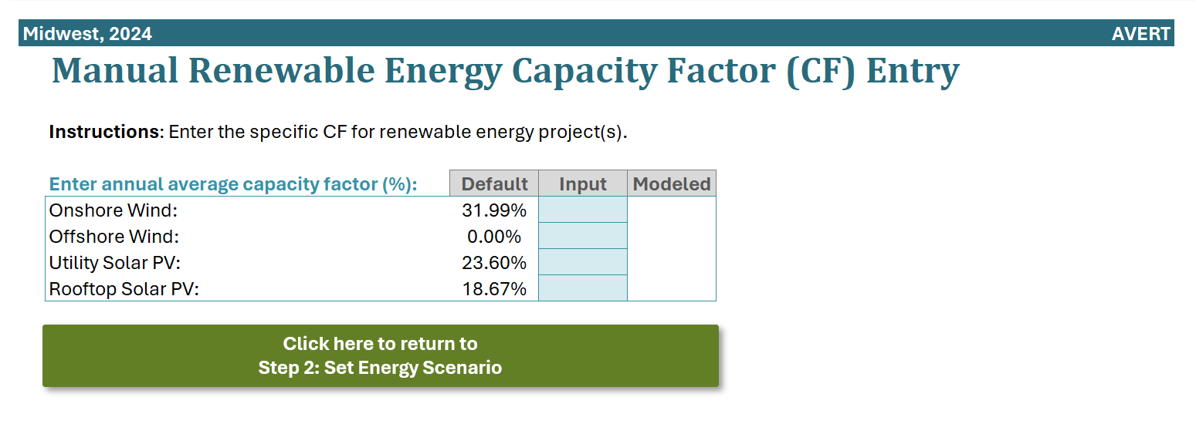

### Electric Vehicles

This option allows users to set the number of EVs they would like to model, as well as where the vehicles will displace emissions from ICE vehicles. More detail on the calculations related to EV impacts can be found in Appendix J. For information on limitations related to modeling the emission impacts of EVs in AVERT, see Appendix L.

#### Number of Electric Vehicles

In Step 2, users can specify a number of EVs to model, which is the number of EVs they expect to be *added* to the road in their scenario. Users have the option of entering inputs for multiple different vehicle types, including:

* Light-duty BEVs[47]
* Light-duty PHEVs
* Transit buses (i.e., buses running fixed routes and schedules)
* School buses (i.e., buses typically transporting K-12 students)
* Short-haul trucks (i.e., trucks that are larger than 8,500 lb and travel fewer than 200 miles per day)[48]
* Combination long-haul trucks (i.e., trucks larger than 33,000 lb that travel more than 200 miles per day)
* Refuse trucks (i.e., trucks that collect and haul refuse to a central location)

More detailed inputs related to the type of vehicles being modeled (e.g., passenger cars versus passenger trucks within the light-duty BEV category) and the fuel type of conventional vehicles being displaced (e.g., gasoline or diesel) are described in Appendix J.

Next to the number of vehicle input cells in Step 2 are two tables that serve as guides for the user. Table 1 translates the inputted number of EVs into shares of vehicle sales and shares of vehicles on the road (i.e., vehicle stock). These shares are based on recent historical data aggregated for the location of EV deployment selected by the user.[49] For example, if a user models 10,000 BEVs in the New York region, which has about 480,000 LDV sales per year and about 9 million LDVs on the road, the shares reported will read 2.1 percent and 0.1 percent, respectively.

Table 2 provides a comparison between the total annual energy impact of the EVs entered and recent trends in RE capacity installation and EE programs. Using the calculations described in the Calculations section of Appendix J, AVERT converts the number of inputted vehicles into an annual GWh quantity. AVERT then compares this GWh quantity against the average first-year GWh generation from wind, solar, and EE resources deployed in the selected state or region between 2021 and 2023. For example, users modeling an addition of 10,000 BEVs in New York will find that the load impact of these vehicles charging is about 36 GWh. Meanwhile, the average first-year GWh generation of wind and solar projects deployed in 2021–2023 is about 530 GWh. In this example, Table 2 helps a user note that the generation required to power 10,000 BEVs is about 2 percent of the annual energy generated from the recent additions from wind, solar, and EE. Table 2 helps users build more likely scenarios combining EVs, EE, and RE. See the Calculations section in Appendix J for more information about how impacts from different resources are combined in AVERT.

#### Location of EV Deployment

The second primary input is the location of EV deployment. EVs may be deployed in the “Entire Region” or in one of the states that is a component of the AVERT region (see Table 1 for information on which states are in each AVERT region). While AVERT’s power sector modeling algorithm is agnostic to where electricity load changes occur within an AVERT region, this input parameter determines where net emission decreases from ICE vehicles occur.[50] The default selection is Entire Region. If the default is selected, vehicle emission reductions are assumed occur throughout the region. Emission reductions are allocated to each county based on the vehicle miles traveled (VMT) in each county relative to the total VMT in the AVERT region. If instead a state is selected, vehicle emission reductions will occur only in the specified state (or portion thereof for states that exist in more than one AVERT region). Emission reductions within the state are allocated to each county based on the VMT in each county, relative to the total VMT in that state (or the portion of that state that lies within the selected AVERT region).[51]

This parameter also informs Table 1 on **Step 2** of the Main Module, as described above in the *Number of Electric Vehicles* section.

### Energy Storage

This option allows users to set the capacity of energy storage they would like to model, the duration, and the charging and discharging pattern the energy storage should follow. Users can modify depth of discharge (DoD), round-trip efficiency (RTE), and the number of cycles the energy storage completes in a year, or use the default selections of these parameters, which are designed to reflect lithium-ion batteries. More detail on these parameters and charging and discharging assumptions can be found in Appendix K.

#### Pair Storage with Solar (Solar-Plus-Storage)

Users can select whether they would like to pair storage with solar generation. Selecting “Yes” will limit energy storage to charge only in hours with concurrently added solar generation. To model paired storage with solar, users must enter some amount of solar PV capacity and storage capacity. Charging will not exceed available solar generation in any hour when the user selects an amount of energy storage that is greater than the available solar generation in a given day. Excess solar generation is modeled as a reduction in fossil generation—the same way as a standalone solar PV entry.

If the user selects “No,” modeled energy storage will charge to its full capacity independently of any modeled solar or wind resources. In this situation, storage will act as additional load to the grid during the days when storage is selected to charge and there is insufficient RE to charge it. Note that due to the RTE losses of energy storage resources, modeling energy storage with no added energy efficiency or renewable energy (EERE) resource will always result in a net increase in required fossil generation on the grid.

#### Storage Capacity and Duration

Users must specify the capacity (maximum potential electricity storage) of energy storage to model, measured in MW. Users have the option of entering capacity separately for utility-scale storage or distributed storage. Users can also enter a duration for the energy storage resources, measured in hours. The duration is the length of time the storage resources can dispatch at their maximum power capacity. The duration selected will apply to both utility-scale and distributed storage. Users can select a duration of 2, 4, 6, or 8 hours.[52]

#### Charging Pattern

Finally, users can select the charging pattern that the storage should follow. This setting determines in which hours the storage should charge and discharge in a 24-hour cycle. As a default option, this pattern will cycle 150 times over the year on the days with the highest fossil generation, unless modified by the user. The default selection is “midday charging,” in which the storage will charge beginning in mid-morning for the duration set by the user, then discharge in the evening. When modeling solar-plus-storage, users should select midday charging to ensure the storage charges during daylight hours. For non-paired systems, users can also select “Overnight Charging,” in which storage will charge in the middle of the night and discharge in the early evening. Users also have the option to select “Manual” and build their own 24-hour profile.

More information on energy storage can be found in Appendix K.

After the energy profile has been designed, click “Next” to move to the next step.

Prior to advancing to the next step, an alert box may pop up (see Figure 16). This alert is triggered when users’ scenarios include EVs but do not include any amount of EERE. The alert, as seen in Figure 16, recommends that users include EERE when modeling EVs with AVERT and points to Table 2 (as seen in Figure 12) as a reference. When users see this message, they may click “Ok” to continue to Step 3, or “Cancel” to return to Step 2 to add EE and RE estimates.

Figure 16. Pop-up message regarding modeling EERE alongside EVs. 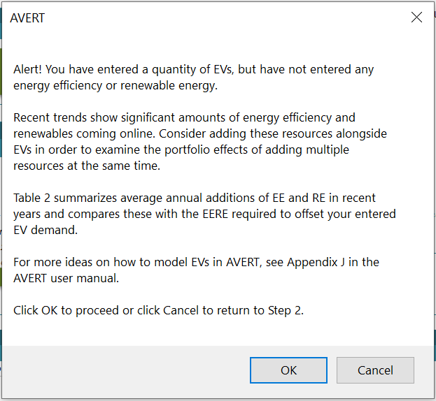

## Step 3: Run Scenario

Step 3 launches the automatic calculation of hourly changes in generation, heat input, and emissions for each EGU in the region as shown in Figure 17.

Figure 17. Image of the AVERT Main Module’s “Step 3: Run Impacts” page.

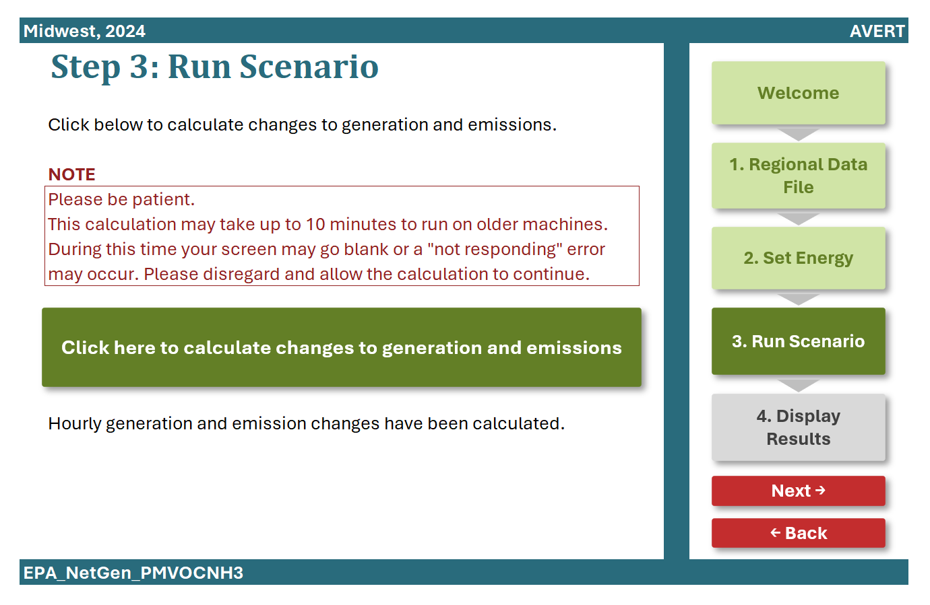

Click on the box labeled “Click here to calculate changes to generation and emissions.” Because of the large amount of data being processed, this calculation may take several minutes depending on the size of the region and the processing speed of the computer. A status bar in the lower left corner indicates the share of processing completed.

Note that two separate alert boxes may pop up when this box is clicked. The first alert informs the user that for at least one of the hours under consideration, the load decrease or increase is more than 15 percent of the original hourly load (see Figure 18). Users can click “OK” and modify their load changes to be within the recommended range, or click “Cancel” to proceed with the calculation.

Figure 18. Pop-up alert for an energy profile that exceeds a 15 percent change in load.

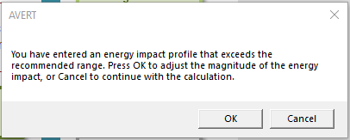

The second alert informs the user that in at least one of the hours where load has been adjusted, the energy profile will be outside the calculable range for AVERT (see Figure 19). In these situations, the user must return to Step 2 and reduce his or her load adjustments to avoid producing this alert.[53]

Figure 19. Pop-up alert for an energy profile that exceeds AVERT’s calculable range.

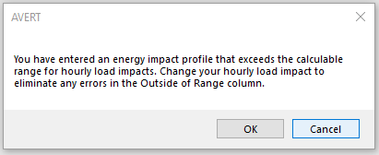

A pop-up box that reads “Calculation complete” will appear once the calculations are complete. Click “Next” to move on to the final step.

## Step 4: Display Results

Step 3 of AVERT’s Main Module generates raw data in the form of hourly estimated changes in generation, heat input, and emissions of PM2.5, SO2, NOx, VOCs, NH3, and CO2 for each EGU in the region. These data are aggregated in charts and tables, which are then accessed through the “Step 4: Display Results” page, as shown in Figure 20.

Figure 20. Image of the AVERT Main Module’s “Step 4: Display Results” page.

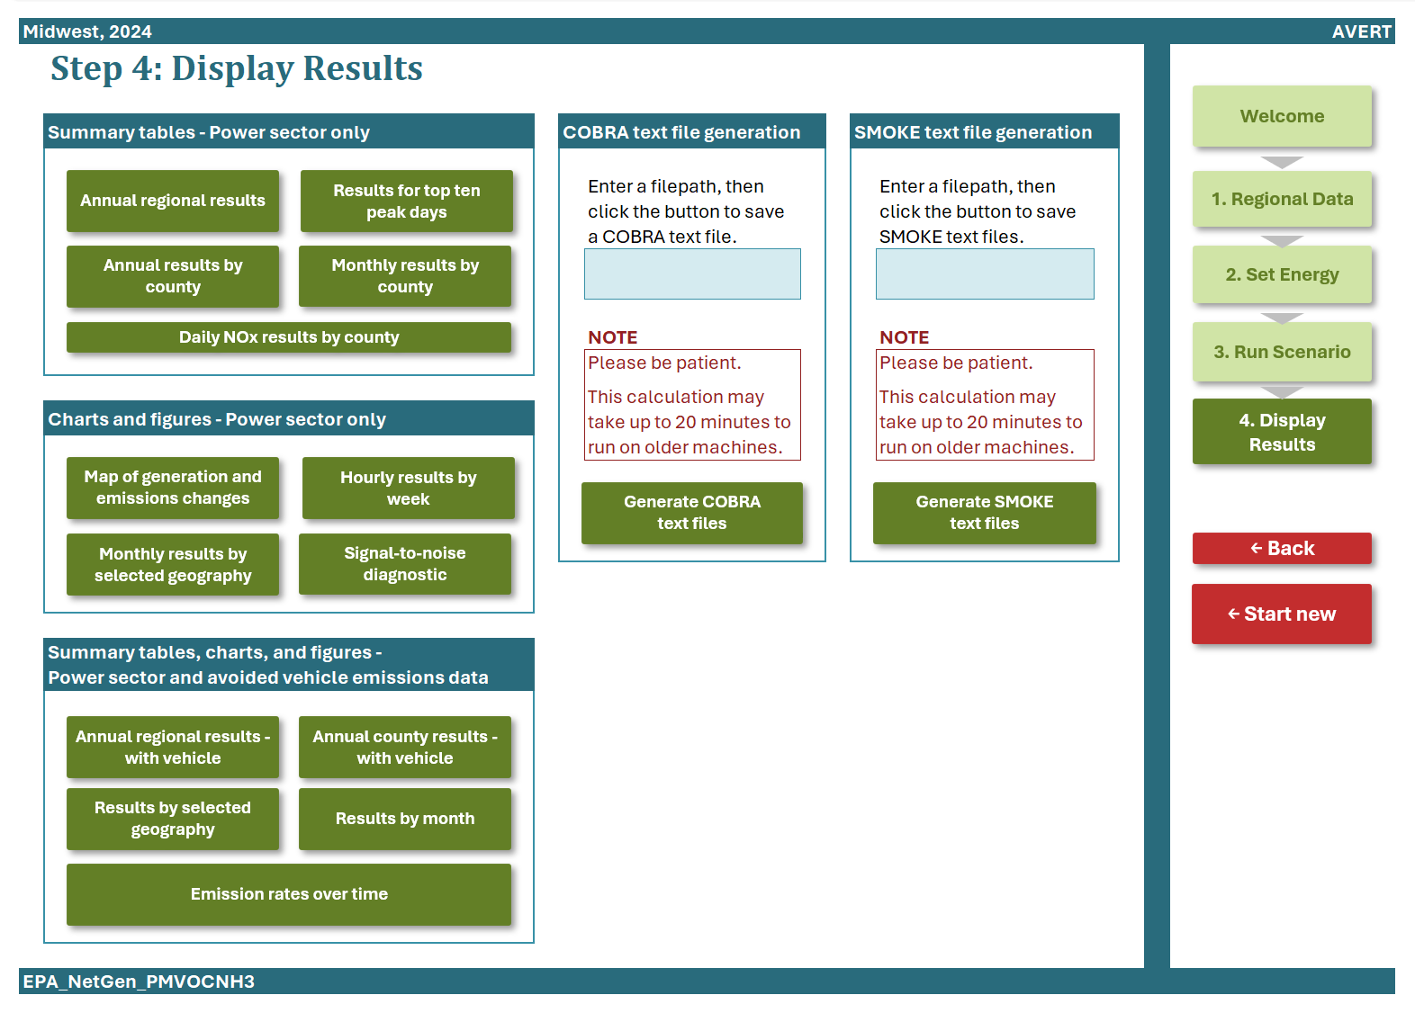

To display outputs, click on each of the green boxes under the headings: summary tables, charts and figures, COBRA text file generation, and SMOKE text file generation. The sample tables and figures shown below use the same example of a 2,000 MW onshore wind installation in the Midwest AVERT region.

### Summary Tables

#### Annual regional results

Figure 21 shows a high-level summary of the results of the analysis. This table displays the total annual generation, heat input, and emissions from the region’s fossil generation fleet as reported in the base year (“Original”) and as calculated by AVERT’s Main Module after the modeled energy change (“Post Change”). The last data column, labeled “Change,” is the delta of “Original” and “Post Change” and is the total annual expected change from the user-defined scenario. The chart also shows total annual fossil-fuel emissions and emission rates for PM2.5, SO2, NOx, VOCs, NH3, and CO2. Emissions and emission rate data is shown separately for total annual NOX and ozone season NOX, a subset of total annual NOx emissions occurring May 1 to September 30. Emission rate data in the first column (under the “Original” heading and labeled as “Average Fossil”) describes the average emission rate associated with fossil-fired plants in the selected AVERT region in the original baseline of the selected year’s data.[54] Fossil-fuel emission rates presented in the third column (under the “Change” heading and labeled as “Marginal Fossil”) are the change in emissions divided by the change in generation, resulting from the user-specified scenario. Emission rates are not shown for the second column (under the “Post Change” heading) because these are frequently very similar to the emission rates calculated in the first column. Users may select from among several different units (lb, short tons, kg, metric tons) to display emissions.

All numerical results are shown rounded to the nearest 10 unit.[55] Dashes (“—”) indicate that AVERT reported a value greater than zero, but lower than the level of reportable significance. True zeros are reported as zero (0) values. Increasing the size of the energy policy will increase the amount of output above the reportable significance level (i.e., reduce the number of dashes in the results datasets).

Figure 21. Image of annual regional results table for an example wind program in the Midwest region.

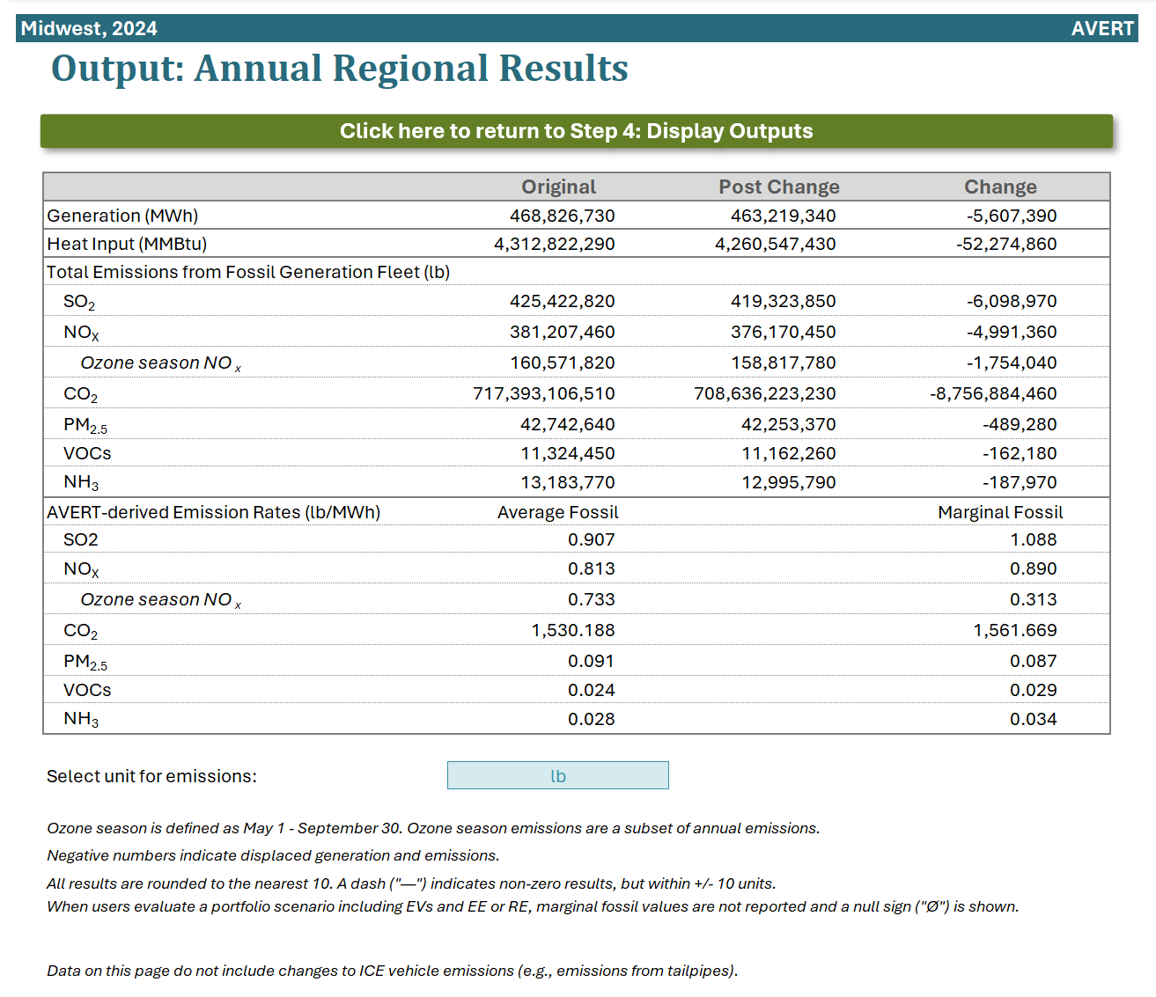

#### Annual results by county

Figure 22 shows a summary of the changes in generation and emissions for each of the counties from each of the states in the region. The Midwest region, for example, contains EGUs in Arkansas, Iowa, Illinois, Indiana, Kentucky, Louisiana, Michigan, Minnesota, Missouri, Mississippi, North Dakota, Oklahoma, South Dakota, Texas, and Wisconsin. A line for each county containing an EGU is displayed.

For each county, the following annual output statistics are given:

* **Peak Generation Post Energy Change (MW):** The peak (maximum) hourly generation produced by an EGU in the base- or future year scenario after energy changes have been applied.[56]
* **Annual Generation Post Energy Change (MWh):** The total annual generation of an EGU in the base- or future year scenario after energy changes have been applied.
* **Annual Change in Generation (MWh):** The EGUs’ estimated change in generation from baseline conditions to post-energy changes over a full year (i.e., the annual increased or decreased generation of this unit).
* **Annual Change in Heat Input/PM2.5/SO2/NOx/CO2/VOCs/NH3 (MMBtu, lb, or tons):** The EGUs’ estimated change in heat input or emissions from baseline conditions to post-energy changes conditions over a full year (i.e., the annual increased or decreased heat input or emissions of this unit).[57]
* **Ozone Season Change in SO2/NOx/PM2.5 (lb):** The EGUs’ estimated change in emissions from baseline conditions to post-energy changes during the ozone season (May to September, inclusive).
* **Ozone Season, 10 Peak Days Change in SO2/NOx/PM2.5 (lb):** The EGUs’ estimated change in emissions from baseline conditions to post energy changes during the 10 highest fossil generation days in the ozone season (May to September, inclusive).

All results (except for peak generation) are shown rounded to the nearest 10. Dashes indicate results greater than zero, but lower than the level of reportable significance. Negative numbers indicate displaced generation and emissions.

Figure 22. Annual results by county for an example wind program in the Midwest region.

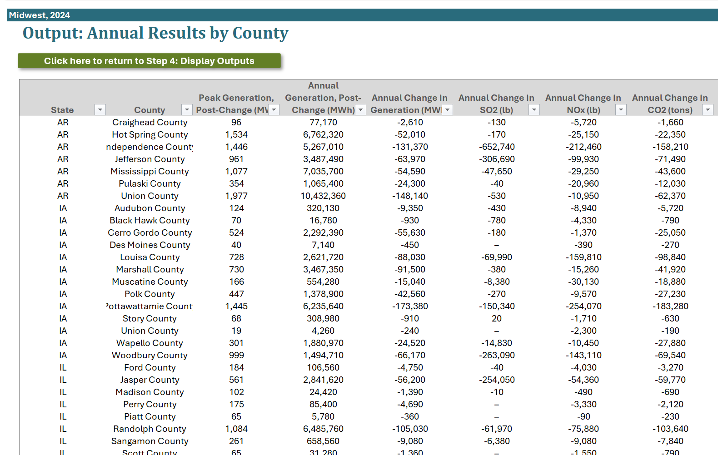

#### Results for top 10 peak days

Figure 23 shows a summary of the 10 days in the region featuring the highest level of fossil fuel load. Separate columns show the total fossil generation in each day, the expected changes in generation, and the simulated changes in generation and emissions. All results are shown rounded to the nearest 10. Dashes indicate results greater than zero, but lower than the level of reportable significance.

Figure 23. Results for the top 10 load days for an example wind program in the Midwest.

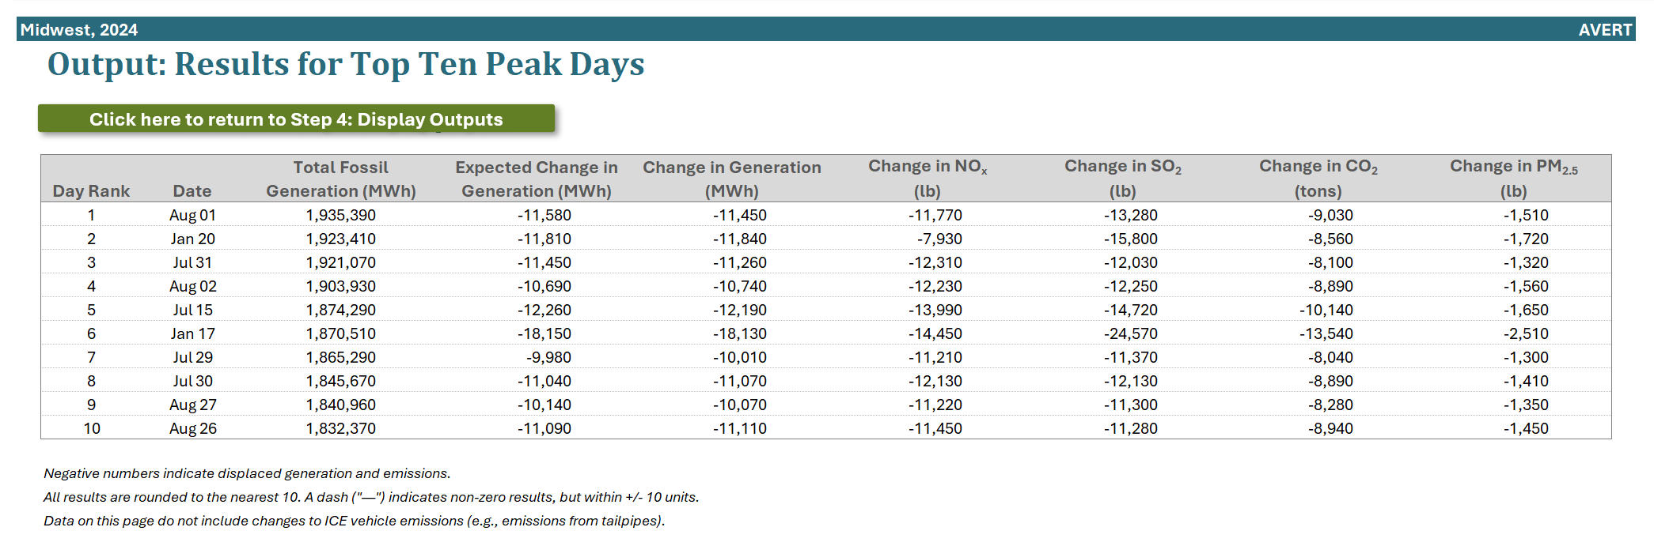

#### Monthly results by county

Figure 24 shows a summary of the change in generation and emissions for each of the counties from each of the states contained within the region, broken out by month and with an annual total. All results (except for change in generation) are shown rounded to the nearest 10. Dashes indicate results greater than zero, but lower than the level of reportable significance.

Figure 24. Monthly results by county for an example wind program in the Midwest region.

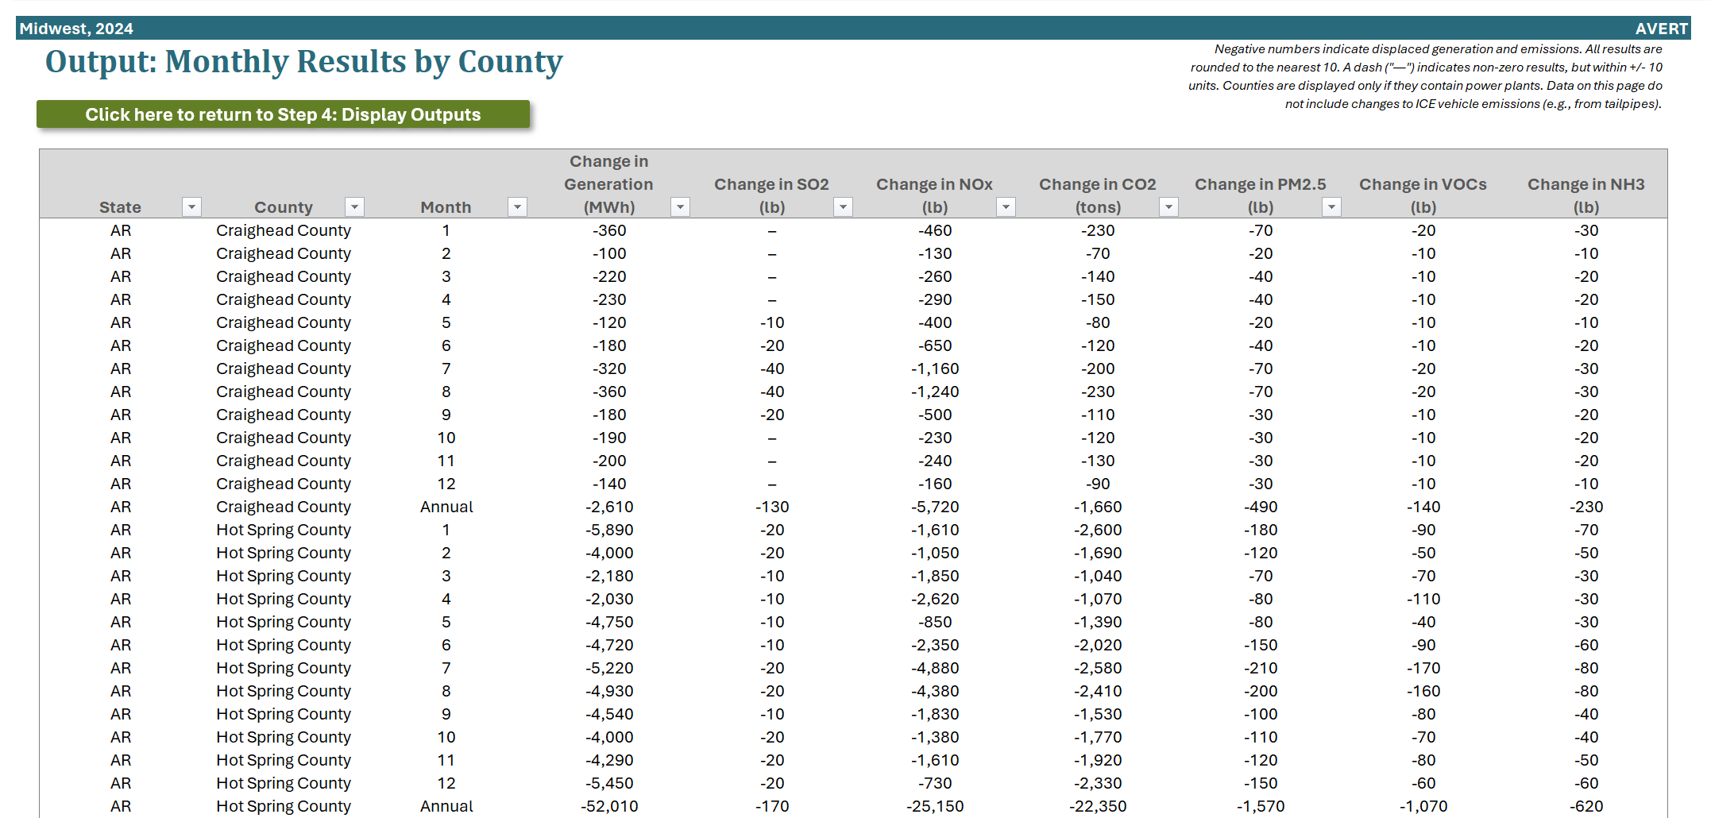

#### Daily NOx results by county

Figure 25 shows a summary of changes in NOx emissions in the counties of each state contained within the region, broken out by day and with a daily average. Users enter up to 10 days for the analysis year in MM/DD format. All results are shown rounded to the nearest 10. Dashes indicate results greater than zero, but lower than the level of reportable significance.

**Figure 25. Daily NOx results by county in the Midwest region.**

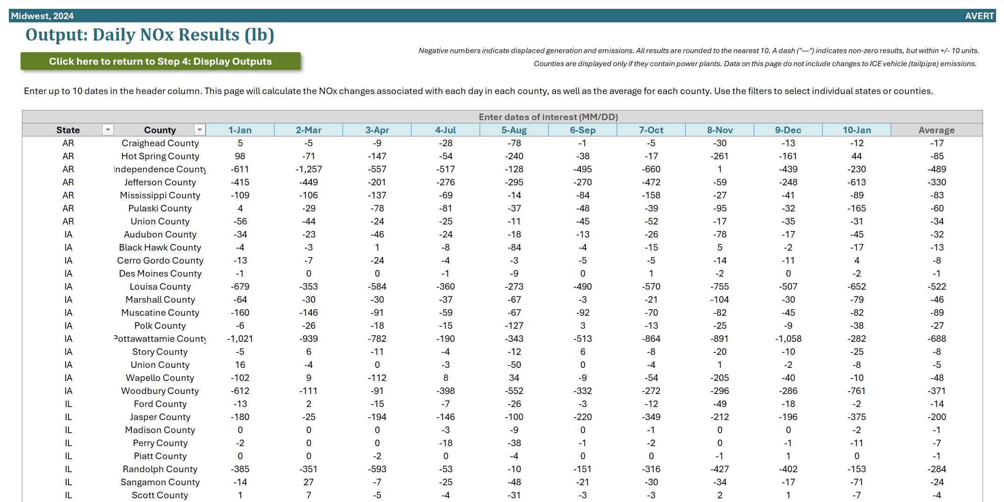

### Charts and Figures

#### Map of generation and emissions changes

This dynamic map (shown in Figure 26) shows where emissions change within the selected region. You can choose from the following options in a dropdown menu:

* Annual Change in Generation (MWh)
* Annual Change in Heat Input (MMBtu)
* Annual Change in SO2 (lb)
* Annual Change in NOx (lb)
* Annual Change in PM2.5 (lb)
* Annual Change in CO2 (tons)
* Ozone Season Change in SO2 (lb)
* Ozone Season Change in NOx (lb)
* Ozone Season Change in PM2.5 (lb)
* Ozone Season, 10 Peak Days Change in SO2 (lb)
* Ozone Season, 10 Peak Days Change in NOx (lb)
* Ozone Season, 10 Peak Days Change in PM2.5 (lb)

Click “Refresh map with selected variable” after making a selection. The map displays the annual, seasonal, or peak change in emissions at specific EGUs in the region. The size of the circles indicates the relative change of each EGU. Circles are semi-transparent. If multiple sources are near the same location, the circle is darker. Emissions increases are shown with black outlines and white interiors; these can occur when the user is modeling an increase in load or can be the result of the timing of maintenance outages in the base-year data (see Appendix H for details).

Figure 26. Map of generation and emissions changes for an example wind program in the Midwest region.

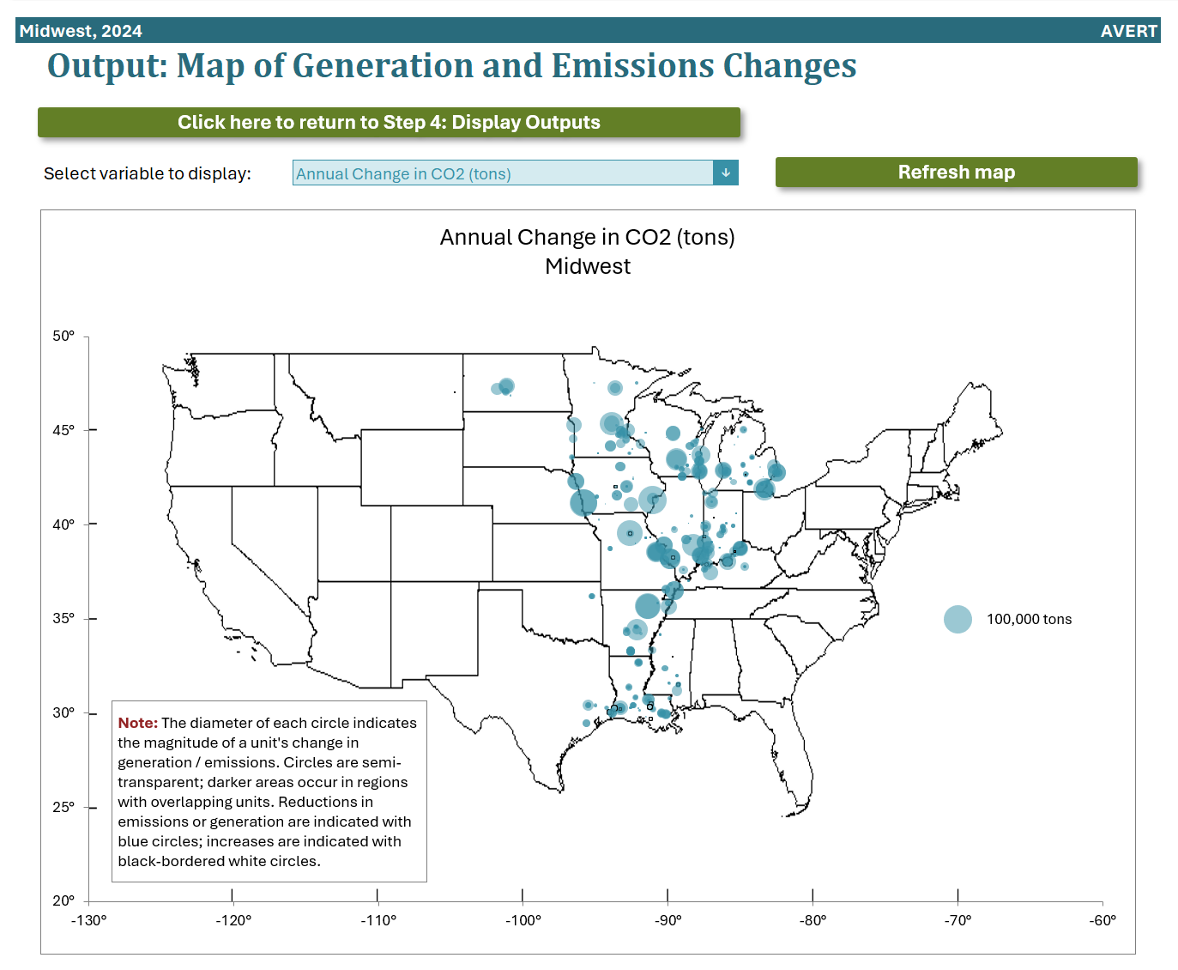

The diameter of each circle indicates the magnitude of an EGU’s change in emissions. Circles are semi-transparent; darker areas occur in regions with overlapping EGUs. Emissions reductions are indicated with blue circles; increases in emissions are indicated with black-bordered white circles.

#### Monthly results by selected geography

Monthly results can be viewed over the entire region or a specific state or county within the region (see examples in Figure 27 and Figure 28). First select “Region,” “State,” or “County” in the top dropdown menu. If selecting a state, choose the state in the next dropdown menu. If selecting a county, choose both the state and the county in the next two dropdown menus.

Figure 27. Monthly results (chart) for an example wind program in the Midwest region. 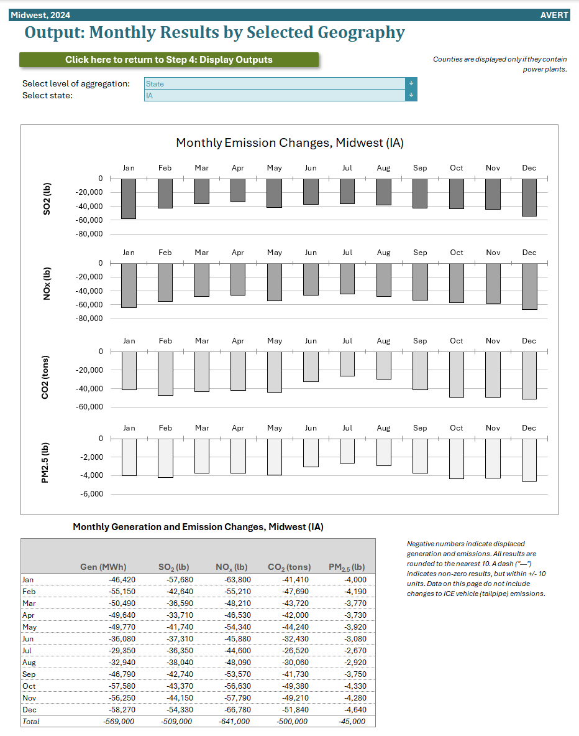

Figure 28. Monthly results (table) for an example wind program in the Midwest region.



#### Hourly results by week

Figure 29 is a dynamic representation of hourly changes in EGU operation. Individual plants are stacked as gradated bar plots, from high-capacity-factor “baseload” EGUs in dark blue to low-capacity-factor peaking EGUs in light blue.[58] The total contribution of all EGUs sums to the yellow line. As noted above, some EGUs can show a net increase in emissions as regional load is reduced, often due to the timing of maintenance outages in the base-year data. The second chart in Figure 29 shows the same week-long energy profile as above, but presents the change in generation in reference to the total fossil-fuel generation. This chart illustrates the degree of change represented by the energy policy relative to the baseline. The solid line represents the total fossil-fuel load by hour in the baseline; the dashed line represents the fossil-fuel load after the user-specified energy change has been modeled.

Figure 29. Hourly results for an example wind program in the Midwest region.

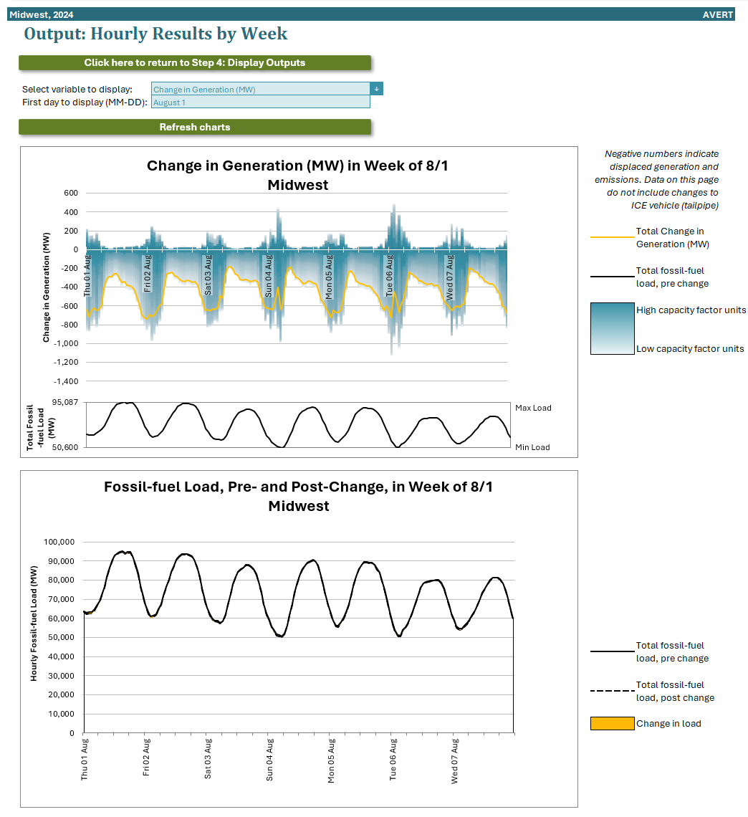

#### Signal-to-noise diagnostic

The signal-to-noise diagnostic shown in Figure 30 has a different structure from the time-series images shown previously. This chart is a scatterplot of every hour of the year (8,760 or, in a leap year, 8,784 points), showing calculated total change in generation in each hour (y-axis) against user-input, expected energy changes in each hour (x-axis). Ideally, AVERT perfectly matches modeled change in unit generation to the amount of energy changes requested by the user. This graphic shows where that assumption holds and where it does not hold, and to what extent. If the generation change is well-matched to the user-input energy change, the graphic will show a straight line with little scatter. If the changes are not well matched, the line will have significant scatter. Overall, the quality of fit (i.e., how well the model captures the requested energy change) can be judged from the R2 metric shown in the chart title.[59] Highly scattered data points should be viewed with less weight than well-constrained data points.

Figure 30. Signal-to-noise diagnostic for an example wind program in the Midwest region.

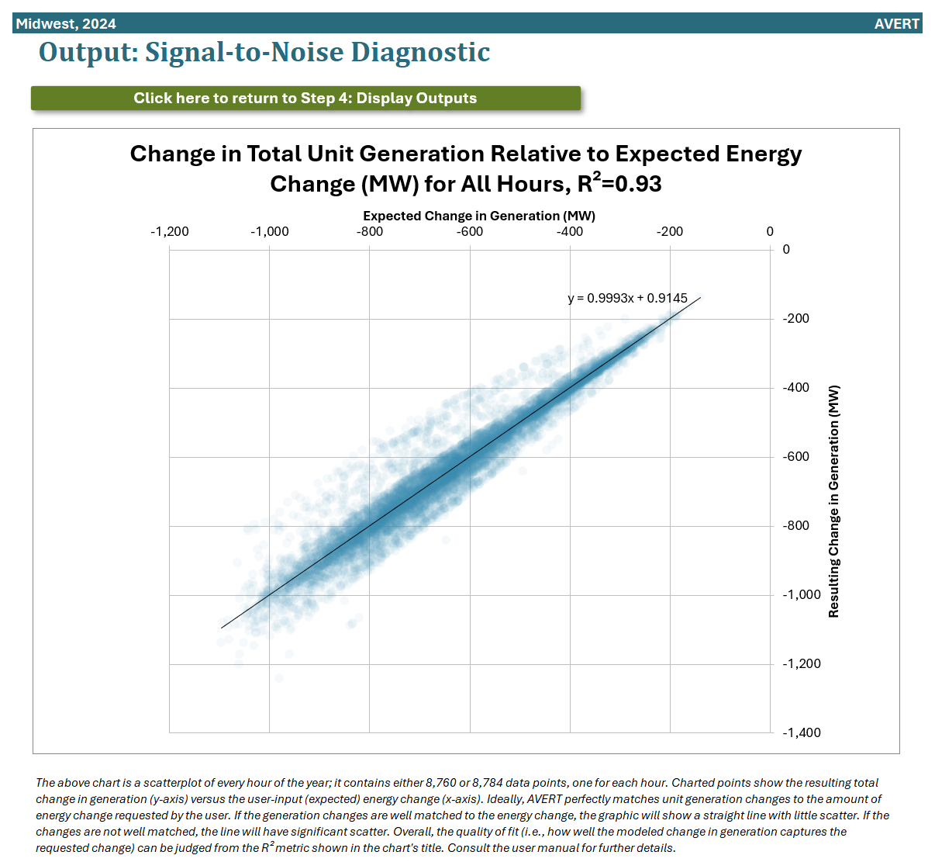

Note that flat load changes (i.e., the same MW increase or decrease in every hour of the year) will result in a very different pattern than shown here. In this unique circumstance, the expected energy changes (the x-axis in this graphic) will be a single value, while there will be variance along the “resulting change in generation” (the y-axis in this graphic). In this case, the R2 value will have limited value, but you can visually review the scatter in the plot to determine the reasonableness of the results.

### Summary Tables, Charts, and Figures: Power Sector and Avoided Vehicle Emissions **Data**

Outputs related to vehicle impacts are confined to four output pages accessed through Step 4: Display Results and discussed below.[60] All other output pages in AVERT do not describe any vehicle impacts.

#### Annual Regional Results, Including Vehicles

This page describes the total regionwide emissions impacts from the electric power sector (“From Fossil Generation”) and from vehicles (“From Vehicles”) for each of the six pollutants modeled in AVERT (see Figure 31). This page also includes a column for “Net Changes,” which combine the emissions impacts from the power sector and vehicles. Users may select from among several different units (lb, short tons, kg, metric tons) to display emissions. A separate table at the bottom of the page provides additional context on how many emissions are produced from the fossil generation sector and from vehicles in the selected region. Throughout this page, negative numbers indicate reductions in emissions.

Figure 31. Annual regional results table, including vehicles, for an example EV and renewable program in the Midwest region.

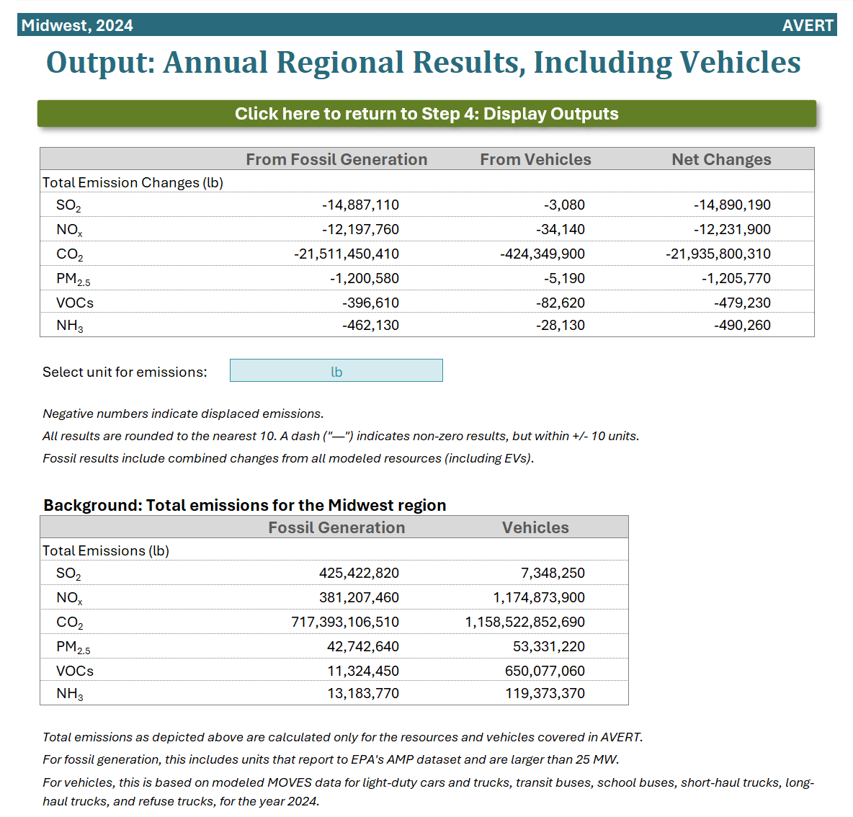

#### Annual Results by County, Including Vehicles

This page describes the emissions impacts from the electric power sector (“From Fossil Generation”) and from vehicles (“From Vehicles”) for each of the six pollutants modeled in AVERT (see Figure 32). On this page, emissions are summarized by state and county. This page also includes a column for “Net Changes,” which combine the emissions impacts from the power sector and vehicles. Throughout this page, negative numbers indicate reductions in emissions. Finally, this page includes a column identifying the FIPS code for each county appearing in the selected analysis to facilitate mapping and visualizing geospatial results.

Figure 32. Annual results by county table, including vehicles, for an example EV and renewable program in the Midwest region.

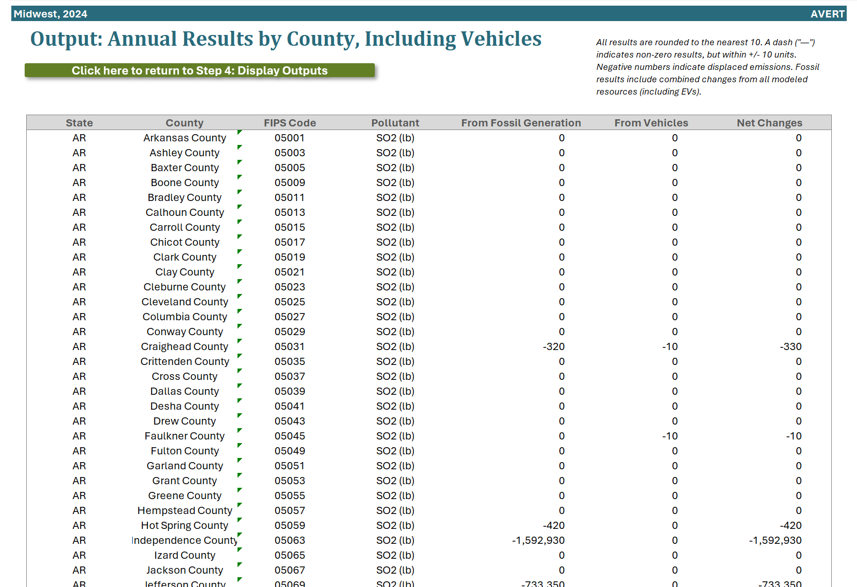

County-level values on this page are used to generate the CSV that is used for COBRA analysis. See the COBRA Text File section, below, for more information about performing analyses in COBRA using AVERT data.

#### Emission Results by Selected Geography, Including Vehicles

This page features a bar chart that compares emission impacts from power generation and vehicles (see Figure 33). A “Net” bar is also shown, which describes the aggregate emission impacts from both the power sector and vehicles. Results are also shown in tabular form. Throughout this page, negative numbers indicate reductions in emissions.

On this page, users may select one of the six pollutants modeled in AVERT. Users may also select different geographic levels of aggregation: They may choose to aggregate all emission impacts together under the “Regional” selection or view emission impacts for just one state or county. Note that some states and counties may have a zero value for emission impacts from either the power sector or vehicles. Emission impacts in the power sector will only be present if that state or county features power plants that are affected by the scenario's load change. Emission impacts from vehicles will only be present if the user has selected the area in question as a location where EVs are being deployed. Note that changes in emissions within counties reflect point source changes (as in power plants) or estimated locations where vehicle emissions have changed. AVERT results should be exported to an air quality model to estimate changes in ambient concentrations of pollutants within counties or regions due to regional air pollution transport.

Figure 33. Emission results by selected geography table and chart, including vehicles, for an example EV and renewable program in the Midwest region.

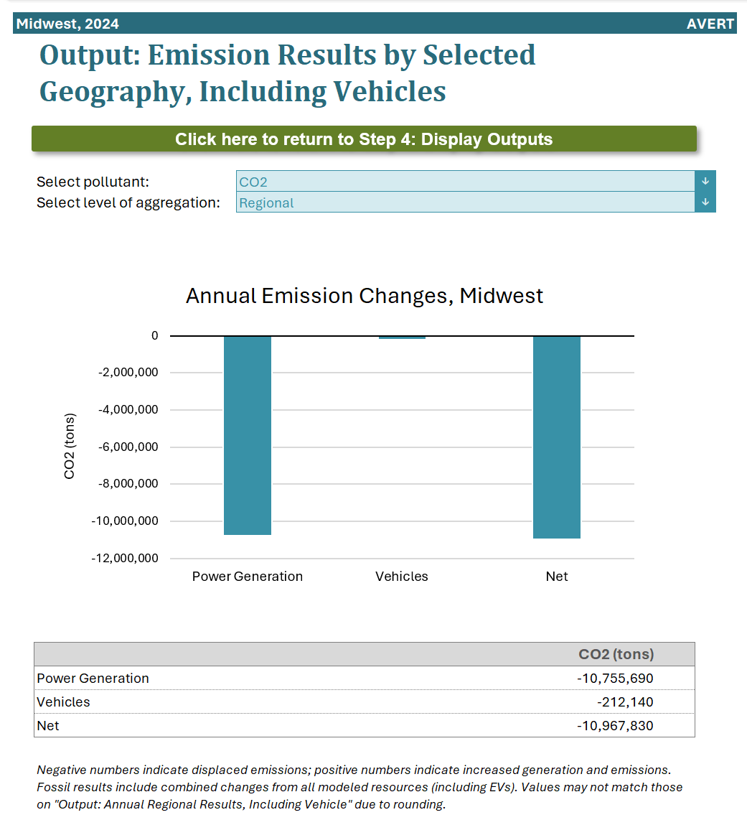

#### Results by Month, Including Vehicles

This page features a bar chart that compares monthly regionwide emission impacts from power generation and from vehicles (see Figure 34). Results are also shown in tabular form. Throughout this page, negative numbers indicate reductions in emissions.

Figure 34. Emission results by month table, including vehicles, for an example EV and renewable program in the Midwest region.

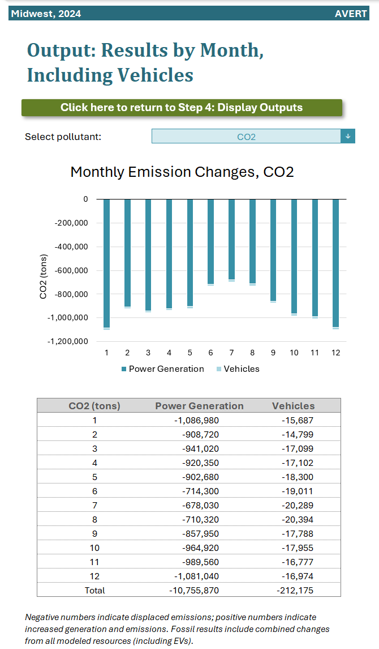

#### Reference: Modeled Marginal Emission Rates Over Time

This page, shown in Figure 35, features a graph of marginal emission rate projections over time. This graph includes AVERT’s modeled marginal emission rates from 2018 through 2024. Emission rates shown for future years includes projected SRMER and long-run marginal emission rates (LRMER) from the National Renewable Energy Laboratory's (NREL's) 2024 Standard Scenarios, as shown in NREL's Cambium data set.[61] AVERT’s calculations assume no additions or retirements of power plants in response to the modeled change in load. This is analogous to the SRMER trajectory and is useful for understanding emission impacts as they occur over a relatively short time horizon (e.g., 5 years), before a structural response can occur. Users who wish to understand how load changes affect emissions over a longer time period would be better served by the LRMER trajectory, which takes into account the fact that power plants may be added or retired in response to the modeled load change. SRMER from the Cambium data set shown for future years do not correspond perfectly to historical AVERT emission rates due to differences in modeling methodology and topology. For more information on SRMER and LRMER, and other approaches to calculating marginal emissions, see “Short-run and Long-run Power Sector Analysis” on page 8.

Users are able to select which of these three emission rates (AVERT’s SRMER, Cambium SRMER, and Cambium LRMER) they would like to display on the graph.

Figure 35. Reference page for modeled emission rates over time. 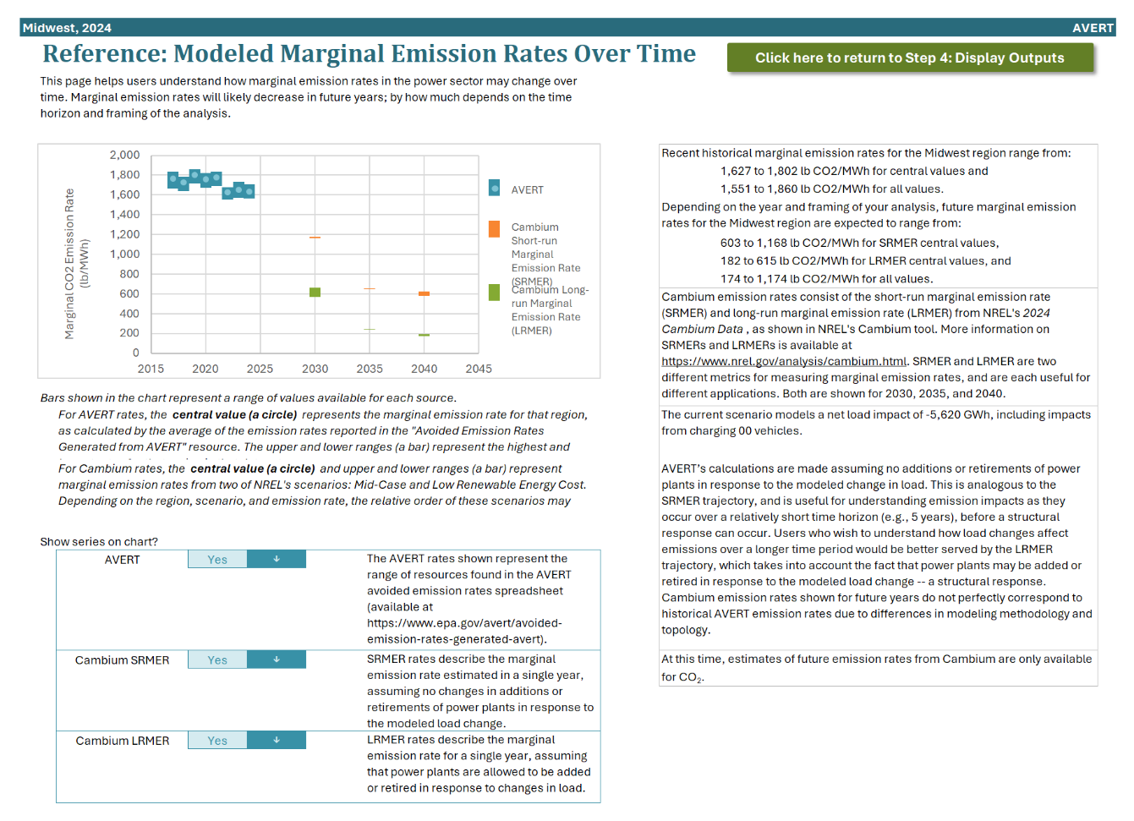

### COBRA Text File

Analysts can use EPA’s CO-Benefits Risk Assessment (COBRA) Health Impacts Screening and Mapping Tool to estimate the public health impacts of the changes in criteria pollutants generated from a scenario analyzed in AVERT. Go to “Step 4: Display Results” sheet and double-click on the blue box to enter a file path under “COBRA text file generation.” Then click the “Generate COBRA text files” green button. One CSV file will be saved in the selected file folder. It will include county-level emission impacts for NOx, SO2, PM2.5, VOC, and NH3 for both the power sector and vehicles. This file can be easily uploaded into COBRA. For COBRA input instructions, refer to COBRA’s main webpage at <https://www.epa.gov/cobra> and EPA’s [COBRA user manual](https://www.epa.gov/cobra/users-manual-co-benefits-risk-assessment-cobra-screening-model).[62] Note that the web version of COBRA does not presently accept file uploads, but it can read in all pollutants through an automated connection from the output screen of the AVERT Web Edition.

### SMOKE Text File

AVERT allows you to create files for use in SMOKE: enter a filepath in the bottom center of the “Step 4: Display Results” sheet, then press the “Generate SMOKE text files” button. Twenty-four text files are then generated in this filepath, two for each month. One of these files is for the selected region and year, pre-energy change, while the second set of files details information post-energy change.[63] For more detailed instructions on how to interpret and use SMOKE outputs from AVERT, see the tutorial and step-by-step instruction slides available on EPA’s website at <https://www.epa.gov/avert>.

### Advanced Outputs

Though AVERT does track the estimated output and emissions from specific EGUs, we recommend only using these outputs for SMOKE processing and/or quantitative validation purposes.

To access annual results on a unit-by-unit basis, restore default Excel functionality via the button on the Welcome page. Data are available for each EGU in the region of interest in the “Summary” worksheet. EGUs are identified by their ORISPL number,[64] unit number, and unit name, fuel type, state, county, and geographic location (latitude/longitude). Summary data are provided for each EGU in a similar format to the county data, as described previously.

In addition, detailed data are available in the worksheets labeled “Gen” (generation), “HeatInput,” “SO2,” “NOx,” “CO2,” “PM2.5”, “VOCs”, and “NH3.” These worksheets record emissions and generation changes for each EGU in the region for each hour of the modeled year. Hours are arrayed vertically; EGUs are arrayed horizontally.

In contrast to the results shown in the summary tables, charts, and figures, which have been rounded to the nearest 10, results shown in the advanced outputs have not been rounded. Unrounded results should only be used after due consideration of their significance.

Appendix A: Installation Instructions

AVERT is divided into three components: an Excel-based platform for user-specified analysis of generation and emission changes (called the **Main Module**), a MATLAB®-based statistical analysis program (called the **Statistical Module**), and a second Excel-based spreadsheet for creating user-specified future year scenarios (called the **Future Year Scenario Template**). This section provides installation instructions for each AVERT module. More detailed information on AVERT components is provided in Section 2 of this manual, “The AVERT Analysis Structure.”

## Main Module

AVERT’s Main Module estimates the change in emissions likely to result from energy policies in reference to a base-year or future year scenario.

### System Requirements

The Main Module requires Excel 2007 or newer to run in Windows. The Main Module can also be used in Excel 2011 or newer for Mac; it has been verified to work up to Excel for Mac v16.49. Macros must be enabled. You do not need to install the Statistical Module and the Future Year Scenario Template to use the Main Module to estimate change in emissions for energy policies modeled in reference to a historical base year; however, you will need all three AVERT modules to model change in emissions with reference to user-created future years.

The Main Module has no special requirements for hard drive space or RAM on the computer running it, but it will run faster on computers with more RAM and higher-speed processors. Excel files generated in the Main Module can exceed 100 MB in size, depending on the number of EGUs in the region of analysis. Analyzing data for large regions may take over 10 minutes on some computers. EPA recommends that users not use any other computer functions (e.g., copy-paste) during this time in order to speed the calculation and avoid errors.

### Installation

To use the Main Module, download two files and save both to the same folder on a local computer or drive:

* The Main Module workbook: “avert-main-module-v4.4-provisional.xlsb” Download the workbook at <https://www.epa.gov/avert>.
* The RDF for the region under analysis.
* Default RDFs developed for use by EPA are labeled  
  “AVERT RDF [DataYear] EPA_ EPA_NetGen_PMVOCNH3 ([Region]).xlsx”; they can be obtained at <https://www.epa.gov/avert>.
* Regional analyses developed by advanced users using AVERT’s Statistical Module will be saved, by default, in a folder of the Statistical Module titled “AVERT Output.” These files use the following naming convention:  
  “AVERT RDF [DataYear] [RunName] ([Region]) [RunDateTime].xlsx.”

In the RDF:

“Region” refers to one of 14 regions defined for the purposes of this tool. AVERT’s regions are described in Section 3 of this manual, under “AVERT Regions” (page 16). The “BaselineYear” tag indicates the base year (the year upon which the analysis is based). Generally, for contemporary or forward-looking analyses, this should be the most recent full year of data available from CAMD’s Air Markets Program (2024), although older data years 2017 through 2023 are also currently available for input.

* “RunDateTime” indicates when the data file was generated by the Statistical Module.

### Launching AVERT’s Main Module

To launch the model, open the Main Module workbook in Excel and follow the step-by-step instructions in Section 4 of this manual.

### Technical Assistance

For more information, please contact EPA’s State and Local Climate and Energy Program at [avert@epa.gov](mailto:avert@epa.gov).

## Statistical Module

AVERT’s MATLAB®-based Statistical Module performs statistical analysis on Power Sector Emissions Data to generate output files used to model emissions changes in the Main Module. Running the Statistical Module is *not* required to operate the Main Module; it is anticipated that most AVERT users will not run it. Users creating specific future year scenarios, however, will need to run the Statistical Module.

For more information on AVERT’s Statistical Module, see Appendix D.

### System Requirements

The Statistical Module requires a machine capable of running Windows XP or higher.

It is recommended that computers operating the Statistical Module have at least 2 GB of memory available. Processing time for individual regions depends on the number of EGUs in the analysis and the number of processors available for use by the MATLAB® platform. In development of AVERT, it was found that for full-scale runs, larger regions could take over two hours to analyze with four processers dedicated to the operation.

The Statistical Module can perform analysis either with a base-year dataset from 2017 through 2024, or with a revised electricity generation fleet created in the Future Year Scenario Template, used in conjunction with a pre-loaded base-year dataset.

### Installation and Launching

To use the Statistical Module, follow the instructions in Appendix E.

This output file can be used directly in the Main Module to analyze change in emissions from energy policies.

### Technical Assistance

For more information, please contact EPA’s State and Local Climate and Energy Program at [avert@epa.gov](mailto:avert@epa.gov).

## Future Year Scenario Template

AVERT’s Future Year Scenario Template allows the user to modify the list of EGUs analyzed by the Statistical Module. EGUs can be added or retired, or have their emission rates modified. Newly added EGUs are copied from existing EGUs (proxy units), but can be scaled to a desired capacity and given a location (county or latitude/longitude) in a different location.

### System Requirements

The Future Year Scenario Template requires Excel 2007 or newer to run. It has been designed for Windows and has not been tested on a Mac, as the companion Statistical Module requires Windows. You do not need to install the Statistical Module to design scenarios within the Future Year Scenario Template, but you will need it to analyze those scenarios and estimate their future emissions in the Main Module.

The Future Year Scenario Template has no special requirements for hard drive space or RAM, but it will run faster on computers with more RAM and higher-speed processors. Scenarios saved by the Future Year Scenario Template are likely to be between 14 and 25 MB in size, depending on the number of EGUs being added in a new scenario.

### Installation

The Future Year Scenario Template is packaged with the Statistical Module executable package. Instructions on obtaining this package can be found in Appendix E.

On downloading and unpacking the package, you will be presented with a folder entitled “AVERT Future Year Scenarios.” This folder contains a number of example templates illustrating retirements, additions, and retrofits.

### Launching and Working with the Future Year Scenario Template

To launch the Future Year Scenario Template, open the workbook in Excel and follow the step-by-step instructions in Appendix F.

### Technical Assistance

For more information, please contact EPA’s State and Local Climate and Energy Program at [avert@epa.gov](mailto:avert@epa.gov).

Appendix B: Power Sector Data

AVERT primarily relies on Power Sector Emissions Data from CAMD, with supplemental data obtained from the National Emissions Inventory (NEI).[65] Table 3 identifies the data source for each pollutant in AVERT and the related data year of each source in AVERT v4.4’s 2024 dataset.

Table 3. Data sources used for each pollutant modeled in the power sector.

|  |  |  |
| --- | --- | --- |
| **Pollutant** | **Source** | **Data year** |
| CO2 | CAMD | 2024 |
| NOX | CAMD | 2024 |
| SO2 | CAMD | 2024 |
| PM2.5 | NEI | 2022 |
| VOCs | NEI | 2022 |
| NH3 | NEI | 2022 |

## Data from CAMD

For the purposes of tracking and verifying emissions, and monitoring emissions trading programs, CAMD collects extensive operational data from nearly all operating fossil-fuel EGUs with generating capacities greater than 25 MW in the lower 48 states (i.e., excluding Alaska and Hawaii).[66] CAMD data include reported gross generation (in MWh per hour),[67] steam output (in tons, from combined heat and power [CHP] facilities), heat input (in million British thermal units, or MMBtu), and emissions of SO2, NOX, and CO2. (Note that emission rates for PM2.5, VOCs, and NH3 come from a different source, the NEI, as described later in this section.) Each quarter, CAMD consolidates information from the previous quarter (i.e., there is typically a three-month delay in releasing data) and produces text-based datasets for each of these factors for each fossil-fuel EGU in each state.[68]

Each power plant reports a “method of determination code” (MODC) for each pollutant for each hour. These MODCs reflect how emissions data were determined, which can vary based on power plant operation and emissions monitoring circumstances. Generally, the data are either classified as “measured” data or “substitute” data. While the vast majority of these data are classified as measured, occasionally power plants report substitute data when measured data are not available. A subset of these substitute data is the “maximum potential concentration” (MPC), the most conservative value power plants are required to report in certain circumstances (e.g., when the emissions monitor is bypassed). The MODCs that correspond to MPC are MODC 12, 18, and 23. To improve reliability of AVERT’s results, data in hours and for pollutants coded with MODC 12, 18, and 23 have been removed from the text-based dataset.[69]

A MATLAB®-based preprocessing engine converts these hourly text files into compact data arrays and a reference EGU records file.[70] The preprocessing engine calls an Excel-based spreadsheet populated with ancillary information about each EGU, with most information gathered from the CAMD “facility information” records. The spreadsheet is populated with ancillary lookup information about each EGU that has reported to CAMD.

AVERT inherits information about hours and time zones from the underlying CAMD data. This means that all datapoints are reported in the local time zone, standard time. As a result, there are some AVERT regions where the aggregated hourly dataset is comprised of power plants that have data shifted by one hour from other power plants in the same region. Six of the 14 regions contain a mix of power plants that are reporting data across multiple time zones. Because datapoints for some power plants would need to be dropped in order to achieve consistent time zone reporting (e.g., one hour at the beginning or end of the year), and because of the overall small difference in time shifting (e.g., one hour), AVERT makes the simplifying assumption that all data reported from all power plants within each AVERT region are in one single, consistent time zone. Table 4 lists the time zones included in each AVERT region.

Table 4. Time zones covered by each AVERT region.

|  |  |
| --- | --- |
| **AVERT Region** | **Time Zones** |
| California | All Pacific |
| Carolinas | All Eastern |
| Central | Mostly Central, some Mountain |
| Florida | All Eastern |
| Mid-Atlantic | Mostly Eastern, some Central |
| Midwest | Mostly Central, some Eastern |
| New England | All Eastern |
| New York | All Eastern |
| Northwest | Mostly Pacific, some Mountain |
| Rocky Mountains | All Mountain |
| Southeast | About 50/50 Eastern and Central |
| Southwest | All Mountain (including Arizona, parts of which does not observe daylight savings) |
| Tennessee | About 50/50 Eastern and Central |
| Texas | All Central |

Gross generation is converted to net generation within the preprocessing engine using unit-specific parasitic loss factors. These factors were calculated based on a comparison of by-plant gross generation[71] and by-plant net generation[72] using 2015 data.[73] Different loss factors are used for coal-fired steam units with and without sulfur controls (8.3 percent and 6.9 percent, respectively), natural-gas-fired combined cycle units (3.3 percent) and combustion turbines (2.2 percent), and natural-gas- or oil-fired steam units (7.7 percent). For example, a sulfur-controlled coal steam unit with an annual gross generation of 100 GWh is assumed to export a total of 91.7 GWh to the grid, while a natural-gas-fired combined cycle unit with the same gross generation is assumed to export 96.7 GWh.

The six data arrays store two-dimensional matrices of net generation, steam output,[74] heat input, SO2, NOx, and CO2 organized by EGU and by hour of the year. Figure 36 shows an example two-dimensional data array for base-year hourly generation (8,760 or 8,784 hours across the horizontal axis) for each of the 4,734 fossil-fuel EGUs (down the vertical axis) for which CAMD collected emissions data in 2011. Black areas represent hours during which particular EGUs are not in operation (or are operating at very low levels, i.e., less than 10 MW). Figure 36 also includes detail from the data array that focuses in on 10 EGUs and hours 3,000 through 4,000 in the base year.

Figure 36. 2011 gross generation output (in MW) for each EGU in each hour of the year.

2011 gross generation output (in MW) for each EGU in each hour of the year.

Colors represent the level of EGU generation.

The reference EGU records file (a structural array in MATLAB®) holds the name, ORISPL number (a value assigned to each plant site by DOE), EPA unit ID, a lookup table pointer to the two-dimensional matrices, locational information, and fuel information for each EGU. Table 5 shows an example record for the Handley Generation Station, Unit 5. The “Unique ID” shown in Table 5 is a unique identifier created within AVERT, consisting of the ORISPL number concatenated with the EPA unit identification number as a string.[75] In addition, each record stores a lookup value (not shown in Table 4), which codes for the location of the plant in the two-dimensional data files.[76]

Table 5. Example record in the reference EGU records file.

|  |  |
| --- | --- |
| **Name** | Handley Generating Station |
| **UnitID** | 5 |
| **NERCSub** | ERCT |
| **NERCSub_Ix** | 26 |
| **State** | TX |
| **State_Ix** | 44 |
| **LUTValue** | 4022 |
| **ORISPL** | 3491 |
| **Lat** | 32.7278 |
| **Lon** | -97.2186 |
| **County** | Tarrant |
| **FuelPrimary** | Pipeline Natural Gas |
| **FuelSecondary** | Diesel Oil |
| **PrimeFuelType** | Gas |
| **UniqueID** | 3491|5 |
| **CSIRegion** | TX |
| **CSIRegionIX** | 9 |

EGU records also include expected CO2 emissions data for units that do not report CO2 to CAMD on an hourly basis. Expected CO2 emissions for these units were calculated as the product of an assumed fuel-specific CO2 content factor and the unit’s heat input for each hour. CO2 factors in tons of CO2 emitted per MMBTU of fuel consumed were calculated using the “unspecified coal,” “natural gas,” and “distillate fuel oil” carbon content values codified for EPA’s Greenhouse Gas Reporting Program in 40 CFR Part 98, Subpart C. Units with a fuel type other than coal, oil, or gas were assumed to have the same carbon emissions factor as oil-fired units.

All AVERT versions after AVERT v3.1.1 (including v4.4) divide the contiguous United States into 14 distinct regions.[77] These regions are aggregates of one or more balancing authorities. Each balancing authority is an entity tasked with the actual operation of the electric grid and ensures that the demand for electricity in every minute of every day is met by adequate supply from the grid’s power plants. In effect, these entities are the smallest discrete component of the grid’s operation. There are about 75 balancing authorities active in the United States today, with each of the nation’s emitting power plants assigned to one of these entities (there are over 4,000 such plants in the contiguous United States today).

Within AVERT, these 75 balancing authorities—and their constituent power plants—are assigned to one of 14 regions. These assignments were developed according to delineations based on geography (e.g., all balancing authorities in California are assigned to the “California” region) or electrical transmission (e.g., balancing authorities in Florida’s panhandle). In many situations, an AVERT region is based around a “core” balancing authority (e.g., PJM, MISO, CAISO) with other smaller balancing authorities grouped with that larger entity for convenience or because there may be substantial transfers of electricity between regions. In most situations, AVERT’s regional assignment is closely based on the regional assignments from EIA’s 930 dataset.[78] Using EIA’s 930 dataset and EIA’s 861 dataset for 2018, we match each electric utility with a balancing authority, and each balancing authority with an AVERT region.[79] Each electric utility is assigned to one and only one balancing authority, and each balancing authority is assigned to one and only one AVERT region. Retail sales from each utility are grouped by state and AVERT region to determine how each state’s electricity sales are split up across the 14 AVERT regions. This is done in order to inform users how they may wish to allocate electricity impacts across different AVERT regions, in situations where a state spans more than one region (see Appendix G for more information). Finally, using data from EIA’s 860 dataset for each analysis year, we match each EGU with a balancing authority and an AVERT region for purposes of creating RDFs.[80]

Analysis based on smaller regions, such as utility service territories, risks missing important interdependencies between the EGUs in a larger region (e.g., the impact of New Jersey load reductions on Ohio EGUs). Using still larger regions, such as the Eastern Interconnect, spreads the influence of load changes too widely, making it difficult to ascribe load changes at a particular location to a reasonable cohort of EGUs.

## Data from the National Emissions Inventory

To determine emission rates for three pollutants—PM2.5, VOCs, and NH3—we rely on data from the full, triennial NEI and interim year NEI point source data.[81] Emissions data for these pollutants is not available from the CAMD dataset on an hourly basis, but is available from the NEI on an annual basis.[82] Using a methodology developed by EPA for eGRID, we match EGUs in the CAMD dataset with facilities in the NEI.[83] Using total emissions for each EGU in either the NEI or point source NEI, we divide by the EGU’s heat input (as reported in the CAMD dataset) to calculate lb-per-MMBtu emission rates. In some cases where there is missing or known anomalous data in the NEI, EGUs are assigned the average rate of similar plants (i.e., the same prime mover and fuel type). These cases include situations where emissions data for one or more pollutant is missing in the NEI for an EGU, situations where an EGU match is unable to be made between the CAMD dataset and the NEI dataset, and situations in which emissions published in the NEI are known to be sourced from outdated data.[84] Emission rates for these three pollutants for each year are stored within the Main Module and are applied to calculate unit-specific emissions for each unit during each hour. When users upload an RDF, NEI emission rate data for the appropriate year is automatically selected in AVERT.

The NEI datasets used in AVERT vary depending on which AVERT dataset the user has selected. Table 6 describes this assignment. Note that the full NEI is published triennially, with the last official release in 2023 for the 2020 data year. Datasets for other years (e.g., 2019,2021, and 2022) are based on data compiled annually in the NEI point source inventories and can be accessed through the Emission Inventory System (EIS)[85] for certain users. More recent years (including 2023 and 2024) do not currently have corresponding NEI datasets released. For 2023 and 2024 analyses, AVERT uses information from the most recent NEI data year (2022). For power plants that were newly constructed in 2023 or 2024, an average emission rate is used, based on existing power plants that are similar to the newly constructed plant in terms of fuel type and prime mover type.

Table 6. NEI data used for each AVERT data year in AVERT v4.4.

|  |  |
| --- | --- |
| **AVERT data year** | **NEI year used** |
| 2017 | 2017 (full NEI) |
| 2018 | 2018 |
| 2019 | 2019 |
| 2020 | 2020 |
| 2021 | 2021 |
| 2022 | 2022 |
| 2023 | 2022 |
| 2024 | 2022 |

Appendix C: Renewable Energy Hourly Profiles

AVERT’s Main Module provides regional estimates of hourly capacity factors for generic solar and wind projects. These capacity factors are meant to provide quickly accessible options to review example renewable project portfolios in each of the regions discussed here. The user is encouraged to develop site-, state-, or region-specific RE load profiles. Where such information is not available or for the purposes of exploration, the proxy capacity factors in the Main Module provide a reasonable basis for expected wind and solar hourly profiles. Hourly capacity factors can also be scaled to reflect an annual capacity factor specified by the user. EPA routinely revisits the default capacity factors and methodologies described below, and updates them to be consistent with the latest available reported and modeled data.

## Rooftop and Utility-Scale Photovoltaic

Annual hourly capacity factors for rooftop PV and utility PV were obtained from the National Renewable Energy Laboratory’s PVWatts v.1 tool.[86] Each hourly capacity factor assembled for each AVERT region is based on the average PV capacity factor for one to 16 cities in the region. The number and location of the sampled cities were chosen to provide a representative distribution of the AVERT region’s insolation (energy from sunlight) at the largest load centers.

## Onshore Wind

Annual hourly capacity factors for onshore wind were developed based on EPA’s *Power Sector Modeling Platform v6 – January 2020 Reference Case* data, which are primarily used as inputs to the Integrated Planning Model (IPM) modeling platform.[87] Table 4-38 from the January 2020 Reference Case data shows onshore regional potential wind capacity (MW) by techno-resource group (TRG) and cost class for 63 electric regions in the contiguous United States.[88] Table 4-39 shows onshore wind generation profiles (kWh of generation per MW of capacity). These data were downloaded in Excel format.

Each of the 63 electric regions are matched to one of the 14 AVERT regions. Annual hourly capacity factors were calculated for each of the 63 regions, then averaged for each of the 14 AVERT regions, weighted by the total potential for onshore wind capacity in each IPM region from all TRGs and cost classes.

Finally, to better approximate observed hourly capacity factors, the annual capacity factors derived from the January 2020 Reference Case data were compared with annual historical (2017–2020) capacity factors for the same regions.[89] The annual historical capacity factors were used to scale the hourly capacity factors from the January 2020 Reference Case data using the following approach:

|  |  |  |  |  |
| --- | --- | --- | --- | --- |
| *January 2020 Reference Case hourly capacity factors* | * | *annual historical  capacity factors* | = | *final hourly capacity factors* |
| *January 2020 Reference Case annual capacity factors* |

Note that several regions (Carolinas, Florida, and Southeast) do not have reported historical wind generation in the EIA datasets. As a result, these regions exclusively rely on capacity factor data from the IPM dataset.

## Offshore Wind

Offshore wind speed data were assembled using information from the Bureau of Ocean Energy Management (BOEM) 2019 modeled hourly offshore wind dataset.[90] These data were downloaded in GIS point format. Figure 37 shows the coverage of the wind speed data in gray.

Figure 37. Map of offshore wind data and lease regions coded by AVERT region.

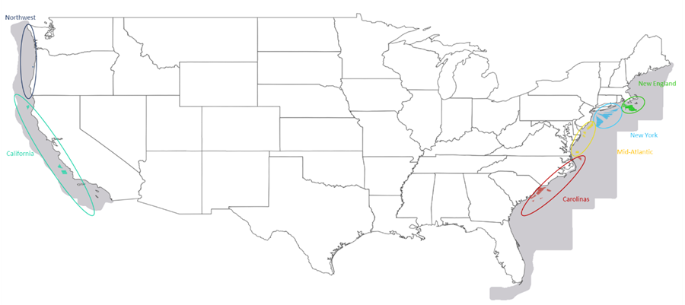

Next, wind speed data were filtered using a dataset of actual and proposed wind lease areas.[91] Each screened BOEM lease area contains thousands of wind speed data points. Each one of these points contains 24-hour wind speed data for each month, which represents a typical hourly wind speed for a representative day for any given month.

BOEM lease areas were then assigned to each AVERT region—some AVERT regions comprise one single BOEM lease area, while other AVERT regions have many BOEM lease areas. Next, the average hourly wind speed (for each 24-hour interval) was calculated from all data points across the lease areas within each AVERT region. Each 24-hour period was then replicated over the course of the entire month to develop a single hourly wind speed dataset for each AVERT region, containing one data point for each hour of the year.

Using data from NREL’s 2016 report *Offshore Wind Energy Resource Assessment for the United States*, the developers of AVERT applied a gross power curve and estimated losses to each hourly wind speed data point to estimate the net power output for each windspeed.[92] The team then divided the net power output by the nameplate capacity of the representative power curve to determine a scalable net hourly capacity factor for each of the hourly data points for each of the AVERT regions.

Only AVERT regions with proximity to actual or proposed offshore wind lease areas can model the addition of offshore wind generators. For example, the Gulf Coast and the Great Lakes do not have actual or proposed offshore wind lease areas, so they are not included in this analysis. AVERT provides offshore wind capacity factors for the New England, New York, Mid-Atlantic, Carolinas, California, and Northwest AVERT regions. AVERT does not provide capacity factor data for the Texas, Midwest, Central, Florida, Southeast, Southwest, Tennessee, or Rocky Mountains AVERT regions. When users enter a non-zero capacity for offshore wind in AVERT regions that do not have hourly offshore wind capacity factors, the model will simply display a change of 0 MW for each hour. Note that currently, BOEM’s wind planning areas are located only in certain areas of the United States coastline. For example, there are no BOEM wind planning areas in Florida or Texas, which means that the AVERT regions that largely encompass these states do not have offshore wind profiles.

Users are encouraged to develop site-specific capacity factor profiles for RE options whenever the data are available. It is important to note that AVERT is *not* a tool for formal greenhouse gas accounting or establishing who may take claim credit for emission reductions of RE programs or projects. It is recommended that companies follow the protocols from the World Resources Institute’s GHG Protocol and the Federal Trade Commission’s *Guides for the Use of Environmental Marketing Claims* for the purposes of greenhouse gas and carbon footprint accounting.[93]

Appendix D: Overview of AVERT’s Statistical Module

For each region, the MATLAB®-based Statistical Module provides the model’s core statistical analysis. (For installation instructions, see Appendix A.)

Data analysis within the Statistical Module is conducted in five steps, described briefly in the sub-sections below:

1. Parsing the base year into “bins” of hours with similar levels of total regional fossil-fuel load.
2. Collecting statistical information (probability distributions for generation, heat input, and emissions) on how each fossil-fuel EGU has responded to regional load requirements in each hour of the base year.
3. Extrapolating this statistical information to extend to potential lower and higher fossil-fuel loads not experienced in the base year.
4. Estimating the ranges of generation, heat input, and emissions likely to be experienced by each EGU for each fossil-fuel load bin (or approximate regional load).
5. Preparing outputs for export to AVERT’s Main Module.

Appendix E provides step-by-step instructions to using the Statistical Module.

The Statistical Module is also equipped to estimate how fossil-fuel EGUs respond to regional load requirements given changes in the fleet of EGUs available in future years. The module inputs information from AVERT’s Future Year Scenario Template to identify existing EGUs to be retired, the expected impact of pollution-control retrofits on existing EGUs’ emission rates, and new EGUs coming on line. AVERT then re-estimates all statistical information based on each region’s projected fleet of fossil-fuel EGUs for a particular future year scenario. (See Appendix F for a more detailed description of the Future Year Scenario Template.)

## Parsing Generation Demand into Fossil-Fuel Load Bins

In its first step, the Statistical Module sums up all fossil-fuel generation in each hour under analysis to arrive at a total regional fossil-fuel load by hour (see Figure 38, which includes a detail of hours 3,000 to 4,000).[94]

Figure 38. 2011 hourly sum of fossil-fuel generation in the Texas region.

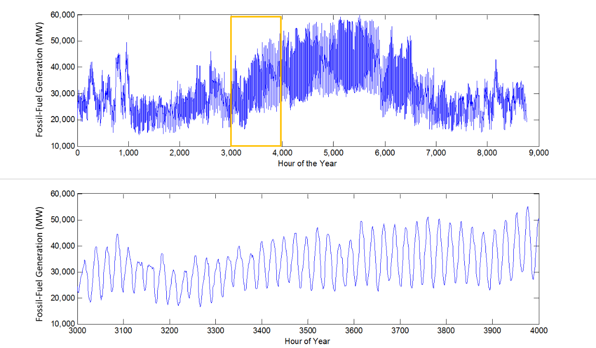

These hourly sums of fossil-fuel generation are sorted from lowest to highest generation level and grouped into 41 “fossil-fuel load bins” for the purpose of collecting statistics for each EGU at each approximate load level (see Figure 39).[95] Thirty-seven of the bins contain 224 or 225 hours; the second lowest and second highest bins contain 204 or 205 hours; and the bins for the lowest and highest fossil-fuel loads contain just 20 hours each to best represent these extreme load levels.[96] Bin thresholds (the fossil-fuel load levels dividing the bins) and bin medians vary by region.[97]

Figure 39 illustrates how the bins are formed relative to total system fossil-fuel load. The figure shows a typical “load duration curve” in dark red for fossil generation in Texas in 2011. This curve represents all fossil-fuel load levels of the year (8,760 data points) in declining order. The horizontal axis represents the fraction of time that fossil generation is at or above a certain level (e.g., fossil generation only exceeds the 20 percent marker in 20 percent, or 1,752, hours). The vertical axis shows the fossil-fuel load for each point on the curve.

Figure 39. 2011 fossil fuel load duration curve for the Texas region, indicating load bins.

Line graph showing the cumulative frequency of load reaching specified bin thresholds over the course of a year in a sample region.

The horizontal axis has 42 light blue lines on it, representing the outside thresholds of the 41 fossil-fuel load bins. Thirty-eight of these lines are evenly spaced from zero percent to 100 percent,[98] capturing 224 or 225 hours each. In other words, each of these bins represents slightly over 2.5 percent of the hours in the year (again, grouped according to total fossil load in that hour rather than by chronology). At the extreme ends, there are two additional light blue lines very near to the zero and 100 percent markers. These additional lines fall 20 hours from the extremes; therefore there are two bins at the extremes with 20 hours each, and two bins just prior to the extremes with 204 or 205 hours each.[99]

Wherever a percentage threshold crosses the fossil-fuel load duration curve, it creates a horizontal line, representing a fossil-fuel load bin threshold. These are the horizontal grey lines shown on the chart above, closely spaced in the lower middle of the graph and spreading out toward the highest and lowest loads. This is because the majority of hours experience total fossil load that is neither extremely high nor extremely low. In other words, there are more hours represented in the middle of the fossil load range (for example, the regime from ~20,000 to ~32,000 MW in Figure 39) than at very high or very low fossil loads. In order to capture an approximately equal number of hours in each bin, each bin in the middle of the fossil load range captures a narrower range of MW. This is shown in Figure 39 based on the spacing between the grey horizontal lines, where the points along the load duration curve that fall between two horizontal threshold lines are the points in the corresponding fossil-fuel load bin, and the points in each bin (apart from the end binds, as discussed above) represent roughly 2.5 percent of hours in the year.

## Collecting Statistical Information

Next AVERT gathers statistics about how each EGU responds to the generation requirements of each fossil-fuel load bin. Three types of probability distributions are constructed: frequency of operation by fossil-fuel load bin, generation level by fossil-fuel load bin, and heat input and emissions by generation level.

### Frequency of Operation by Fossil-Fuel Load Bin

In this first set of probability distributions, AVERT calculates the share of hours within each fossil-fuel load bin for which a particular unit is turned on (i.e., has generation greater than zero). Figure 40shows the frequency of operation for three EGUs in the Texas region in 2011.

Figure 40. 2011 frequency of operation by fossil-fuel load bin for three indicative EGUs in the Texas region.

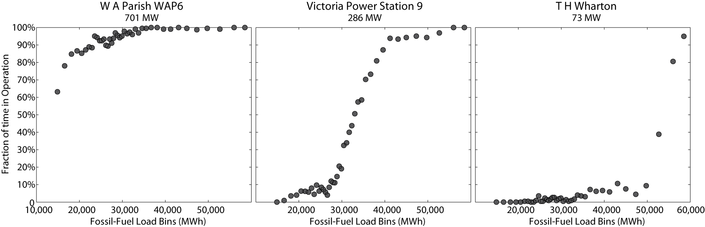

In the figure above, the 701 MW coal-fired EGU shown on the left operates in nearly every hour of the year, with its probability of operation dropping below 90 percent only at the lowest fossil-fuel load requirements. This pattern is typical of a baseload EGU that operates continually with the exception of maintenance outages scheduled to occur at low load requirement levels. The middle EGU, a 286 MW gas-fired station, operates only rarely at low load requirements, but its frequency of operation increases steadily with regional demand. At fossil-fuel load levels above 40,000 MW, this EGU operates in nearly every hour. This pattern is typical of an intermediate-load EGU such as a combined-cycle EGU. The 73 MW gas turbine on the right is a peak-load EGU, operating only at the highest load requirements.

### Generation Level by Fossil-Fuel Load Bin

The second set of probability distributions calculated by AVERT describes generation output for each EGU in operation in each fossil-fuel load bin.[100] AVERT divides each EGU’s generation into 19 evenly spaced “unit generation bins.”[101] Figure 41 depicts the intersection of these two types of bins. Smaller fossil-fuel load bins (where the vertical lines are closer together) indicate a higher concentration of hours at those load levels.

Figure 41. Schematic of unit generation bins and fossil-fuel load bins.

Schematic diagram that shows how AVERT extrapolates load bins.

For each of the 41 fossil-fuel load bins, AVERT determines the number of hours in which the unit generated at an amount within each of the 19 unit generation bins. In this way, the model creates a discrete probability distribution of generation for each fossil-fuel load bin during all hours in which the EGU is in operation.

Figure 42 shows the probability distributions of generation at two EGUs in the Texas region. The axis to the bottom right of each plot represents the region’s fossil-fuel load bins. The axis to the bottom left represents unit generation bins, from zero to the EGU’s maximum generation in the base year. The vertical axis is the probability that the EGU is operating at the given unit generation level in each fossil-fuel load bin.

Figure 42. 2011 generation level by fossil-fuel load bin and unit generation bin for two   
indicative EGUs in the Texas region.

Two three-dimensional graphs that show probabilities with respect to regional load bins and unit-specific generation bins: one graph for a frequently-operated unit and one graph for a peaking unit.

### Heat Input and Emissions by Generation Level

The final set of probability distributions relate EGU heat input and SO2, NOx, and CO2 emissions to unit generation. For heat input and emissions of SO2, NOx, and CO2, statistics for the ozone season and non-ozone seasons are gathered and stored.[102] AVERT creates eight discrete probability distributions—ozone season SO2, NOx, and CO2 emissions and heat input and non-ozone-season SO2, NOx, and CO2 emissions and heat input—for each EGU at each of the 19 unit generation bins. Probability distributions are not a function of regional fossil-fuel load. Figure 43 displays a single EGU’s emissions of SO2 and NOx relative to its generation level.

Figure 43. 2011 ozone-season emissions of SO2 (right graph) and NOx (left graph) by generation level at an indicative EGU in the Texas region.

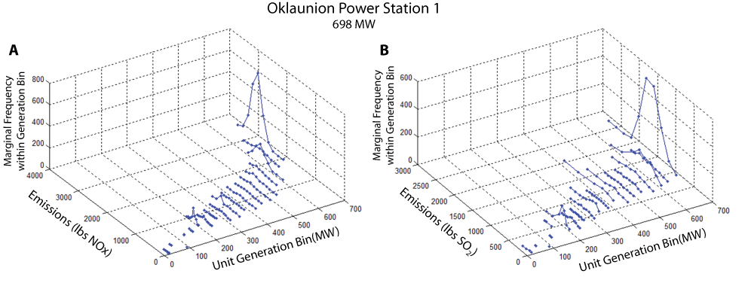

## Extrapolation to Higher and Lower Fossil-Fuel Loads

The end purpose of AVERT is to allow users to estimate the emissions changes resulting from recent historical or expected/proposed near-future energy policies. In either case, the range of fossil-fuel load requirements in the base year may be insufficient to represent all scenarios of interest. For example, a scenario might require the user to examine regional load requirements that are lower than the range represented by the base year. In contrast, a user can choose to estimate the emission changes from policies already in place today, which could entail examining a scenario with fossil loads higher than the range represented by the base year.

In the third step of AVERT, load requirements outside the base-year range are estimated by extrapolating each EGU’s statistics below and above base-year regional load requirements. Two sets of probability distributions are subject to extrapolation: probability of operation and generation level for each fossil-fuel load bin. A flexible number of fossil-fuel load bins are constructed below the regional minimum load (with a lowest bound of zero), and above the regional maximum, such that the new maximum bin threshold is the coincident maximum generation of all of the fossil-fuel EGU on the system—that is, the level of load that could be reached if every fossil-fuel EGU were operating at its maximum output.[103] Bin thresholds and medians vary by region. Theoretically, the regional extrapolated maximum can be reached by the simultaneous use of every EGU in the system, but in practice load curves that reach this maximum are unlikely.

### Extrapolating the Probability of Operation

The minimum amount of potential generation is zero, a level that would require zero generation from all EGUs being modeled in the RDF. If an EGU is already at a zero probability of operation at a low load requirement, the zero value is maintained into the lower potential fossil-fuel load bins. Any probability of operation above zero is extrapolated linearly down to zero from the probability at the lowest recorded load level.

The potential maximum generation is the combined simultaneous maximum output of all EGUs in a region; to reach that maximum point, all EGUs in the region need to be operating at their full capacity. EGUs that have a 100 percent probability of operation at the base-year’s highest fossil-fuel load bin maintain that probability of output. Any probability of operation lower than 100 percent is extrapolated linearly up to the potential maximum from the probability at the highest recorded load level.

Figure 44 displays extrapolated values for the probability of operation for three EGUs in the Texas region. In this figure, black points represent the probability of operation at the base-year fossil-fuel load, and gray points represent the probability of operation at potential high and low fossil-fuel loads beyond the base-year range. Extrapolation is simple in the figure to the left (Tenaska), as the EGU does not operate at all during the lowest loads and operates continually during the highest load periods. The middle figure (Bayou) requires downward extrapolation to a zero probability of generation at a zero load, and the figure to the right (Permian Basin) requires upward extrapolation to meet the highest load requirements.

Figure 44. 2011 base year and extrapolated probabilities of operation for three indicative EGUs in the Texas region.

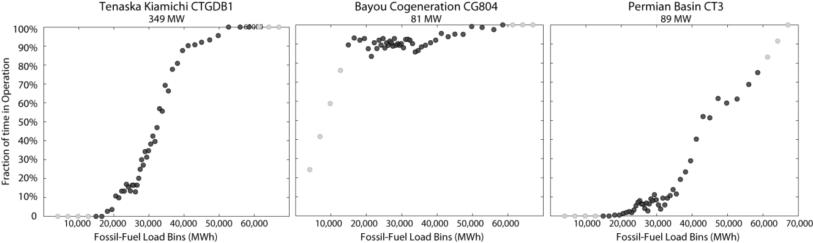

Black points represent the probability of operation during base-year load periods. Gray points are the probability of operation at potential low and high loads beyond the base-year range.

### Extrapolating the Generation Level

EGUs not only run more often at higher load requirements, but also need to generate higher levels of output to meet the requirements of the higher fossil-fuel load bins. Within the base-year range, EGU generation is described as a series of discrete probability distributions for each fossil-fuel load bin.

The extrapolated space encompasses fossil-fuel load bins that extend to the highest possible coincident peak generation (i.e., all EGUs in a region operating at maximum capacity simultaneously) and down to zero. New fossil-fired load bins are created at intervals equal to four times the size of the median load bin.

To extrapolate to potential higher fossil-fuel load bins, AVERT assumes that each unit will have a 100 percent probability of generating at its highest output if fossil load is at its theoretical maximum, and 0 percent of generating at any other level of output given maximum fossil load. For each level of generation (i.e., within each unit generation bin), AVERT determines the slope of the line connecting the unit’s probability of generating at that level at the highest historical fossil load bin to either 100 percent probability (for the highest unit generation bin) or 0 percent probability (for all other generation bins). The unit’s probability of generating at that level is then extrapolated accordingly. Once all levels of generation have been extrapolated, AVERT normalizes the height of the extrapolated load bins such that the total value of all points in each load bin sums to one. A similar process is repeated for lower extrapolated fossil-fuel load bins, except that AVERT assumes that the unit’s output will be zero if total fossil load is zero.

The example in Figure 45 (below) shows an extrapolation of EGU generation to potential lower and higher fossil-fuel load bins. The graphs show base-year unit generation bins (on the left-hand horizontal axis) for any fossil-fuel load bin (on the right-hand horizontal axis). The height of the surface represents the probability of operating at a given generation level in a particular fossil-fuel load bin. Below about 15,000 MW (the lowest fossil-fuel load bin median in 2011) and above about 56,000 MW (the highest fossil-fuel load bin median in 2011), the surface in the figure showing data for the historical year (A) is blank, indicating that no hours fell into those bin combinations in the base year.

To extrapolate to higher and lower fossil-fuel load levels, a line is extended linearly toward the corner constraints described above—100 percent probability of generating at full output given maximum fossil load, and no unit output at a zero fossil load. The bottom graph (B) shows the results of this extrapolation. From 60,000 MW to the peak load, this method returns generation exclusively at this EGU’s maximum, 701 MW. When the probability of operation is zero, the generation output is automatically set to zero as well.

Figure 45. 2011 base year (A) and extrapolated (B) probabilities of generation levels for  
 an indicative EGU in the Texas region.

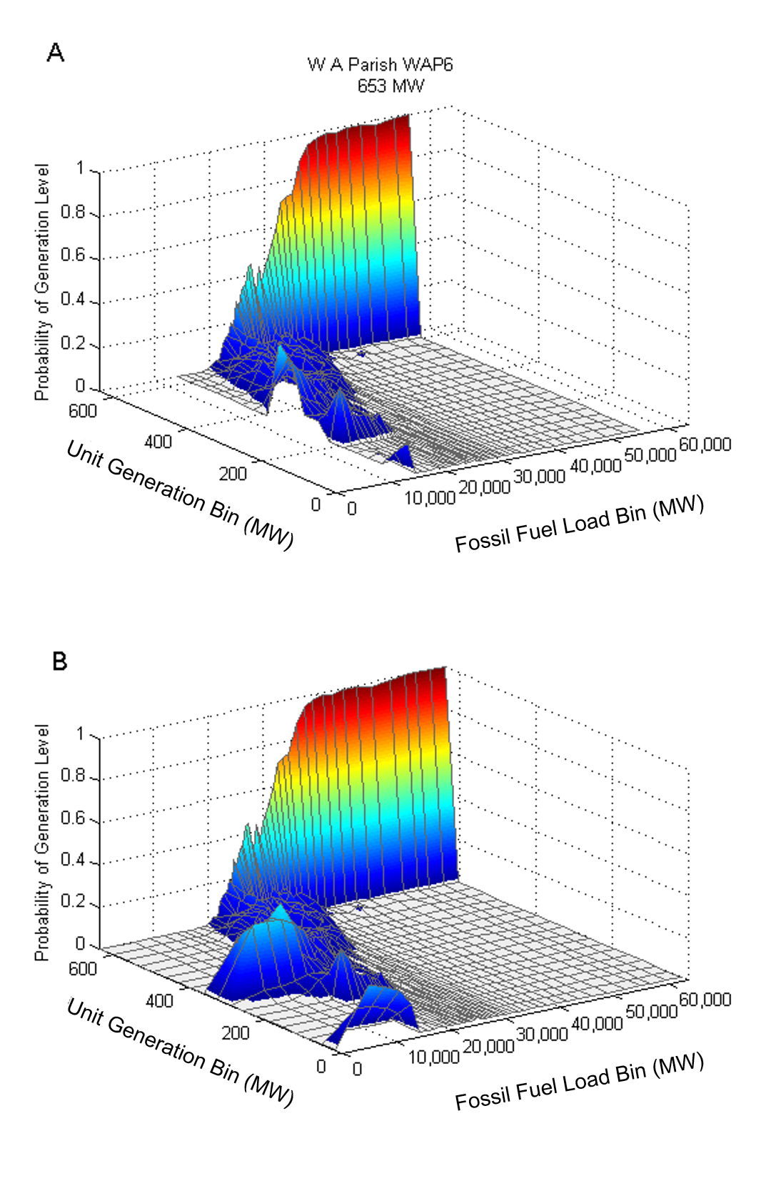

## Statistical Analysis

The fourth step in the Statistical Module is to estimate the predicted range and expected (average) generation, heat input, and SO2, NOx, and CO2 emissions for each EGU at each of the fossil-fuel load requirement bins, from zero MW up to the coincident maximum generation of all of fossil-fuel EGUs in a region.

AVERT’s Monte Carlo analysis (contained within the Statistical Module) uses discrete probability distributions to estimate key variables’ range and expected value for each EGU in each fossil-fuel load bin. For each EGU and fossil-fuel load bin, AVERT draws three random numbers between zero and one:

* The first number drawn is compared to the EGU’s probability of operation at the selected fossil-fuel load bin. If the number drawn is greater than the probability of operation, the EGU is turned off and draws two and three are not conducted. If the number drawn is less than the probability of operation, the EGU is turned on. Figure 46 illustrates this first draw. Starting in fossil-fuel load bin number 15 (representing a particular system-wide fossil load level), the simulator randomly draws a value of 0.25. This value is slightly lower than the probability of operation in bin 15 (approximately 0.40), and this EGU is “turned on.”

Figure 46. EGU frequency of operation and example of random draw selection.

Graph showing how AVERT's Monte Carlo analysis approach works.

* The second number drawn is compared to the discrete *cumulative* distribution function of EGU generation for each fossil-fuel load bin. The model selects the EGU’s unit generation bin as the next highest EGU output greater than the cumulative probability value indicated by the number drawn. Figure 47 illustrates this step: the random draw is 0.33, which results in the selection of unit generation bin 12.

Figure 47. EGU generation histogram, cumulative probability distribution, and example of random draw selection.

Combined histogram and cumulative probability distribution, showing how AVERT's Monte Carlo approach estimates generation.

* The final number drawn is compared to the seven discrete cumulative distributions for heat input and emissions in the unit generation bin identified in the previous draw. In Figure 48, the third random draw is 0.80 and unit emissions bin 15 is selected.

Figure 48. EGU SO2 emissions histogram, cumulative probability distribution, and example of random draw selection.

Combined histogram and cumulative probability distribution, showing how AVERT's Monte Carlo approach estimates emissions.

Generation, heat input, and emissions output from each EGU at each fossil-fuel load bin is recorded for thousands Monte Carlo runs.[104] Each of these runs repeats the process described above of drawing and applying three random numbers in sequence. Examples of the projected generation and NOx emissions at a hypothetical fossil-fuel load of 30,000 MW for the 270 fossil-fuel EGUs in the Texas region are shown in Figure 49 and Figure 50.

Figure 49. Generation (MW) for 1,000 Monte Carlo runs at 270 EGUs in the Texas region at a fossil-fuel load of 30,000 MW (2011).

Graph with Monte Carlo analysis results for generation.

Figure 50. NOx ozone season emissions (lb) for 1,000 Monte Carlo runs at 270 EGUs in the Texas region at a fossil-fuel load of 30,000 MW (2011).

Graph with Monte Carlo analysis results for NOx emissions.

AVERT takes the average (expected value) generation; heat input; and SO2, NOx, and CO2 emissions for each EGU within a region across thousands of Monte Carlo runs and records these values in a new structural array.

## Statistical Output

The final step is to generate an Excel output file to store the expected values of generation and emissions of each EGU at every level of base-year and potential load for each region, and a time series of the total base-year fossil-fuel load in each hour of the year; this file becomes an input file to the Main Module. Eleven sections of the output file each are composed of a matrix of the names and identifiers of each EGU and the expected value at each fossil-fuel load bin, with one section devoted to each of the following:

* Generation (MW)
* Heat input (MMBtu, ozone season)
* Heat input (MMBtu, non-ozone season)
* SO2 emissions (lb, ozone season)
* SO2 emissions (lb, non-ozone season)
* NOx emissions (lb, ozone season)
* NOx emissions (lb, non-ozone season)
* CO2 emissions (tons, ozone season)[105]
* CO2 emissions (tons, non-ozone season)

Appendix E: AVERT’s Statistical Module: Step-by-Step Instructions

This section provides step-by-step instructions for using AVERT’s Statistical Module to prepare inputs for AVERT’s Main Module.

## Step 1: Determine Your Windows Operating Environment

The Statistical Module is designed to work in a 64-bit operating system environment, so you will first need to determine if your Windows system operates in a 32-bit or 64-bit environment. Generally, this information is displayed among the “Properties” of “My Computer” in Windows XP, or “Computer” in Windows Vista, Windows 7, or Windows 8. In Windows 10, press the Start button, type “Settings,” select “System,” select “About,” and check under “Device specifications.” Instructions for determining your Windows environment can be found at <https://support.microsoft.com/en-us/help/15056/windows-32-64-bit-faq>..

## Step 2: Download the Statistical Module Executable

Download the following two files and save them to your computer:

1. **AVERT’s Statistical Module executable package:**“AVERT StatMod [Year] 64bit_package.” Download this MATLAB executable at   
   <https://www.epa.gov/avert>.
2. **The** **MATLAB Compiler Runtime (MCR).** Download the Windows 64-bit version of the MCR for R2012b from the Mathworks website at <https://www.mathworks.com/products/compiler/matlab-runtime.html>.

**Do not download a newer version of the MCR even if one is available from the Mathworks website.** It is important to download version R2012b, also known as version 8.0. The AVERT executable is packaged in a form that can only be compiled by an MCR of the same vintage.

!

**!**

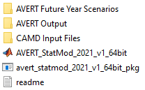Once the AVERT package is downloaded, we recommend creating a folder on your computer titled “AVERT Statistical Module.” Place the AVERT executable package in the folder and run the file. The package will decompress to three files and three subfolders. These folders must stay in the same folder as the Statistical Module for the program to operate successfully.

The folders are:

* **AVERT Future Year Scenarios:** This folder contains the future year scenario template. Other versions of the future year scenario template must be saved in this folder in order for the AVERT Statistical Module to see them.
* **AVERT Output:** This folder will hold RDFs generated by the Statistical Module.
* **CAMD Input Files:** This folder contains MATLAB-formatted flat data files with hourly generation and emissions from each fossil EGU in the United States. The most recent year of data is packaged by default with the Statistical Module. Other years of data can be obtained from EPA, and must be put in this folder to be accessed by the Statistical Module.

The three files are:

* **avert_StatMod_[Year]_v1_64bit_pkg:** The downloaded file containing all of the other files and folders.
* **AVERT_StatMod_[Year]_v1_64bit:** The executable that will run the Statistical Module once the MATLAB compiler is installed.
* **readme.txt:** Basic instructions on the folders and instructions for obtaining the MATLAB compiler.

## Step 3: Download the CAMD Database

The Statistical Module package contains, by default, the most recent data year of data. If another year is desired, additional CAMD Power Sector Emissions Data compatible with AVERT are available at <https://www.epa.gov/avert>. For most purposes, users will want to obtain the most recent data year. Download the file and save it in the subfolder “CAMD Input Files.”

## Step 4: Install the MATLAB Compiler Runtime

The Statistical Module executable requires additional, free MATLAB software in order to function. For additional instruction on how to verify that the MCR is installed properly on your computer, consult the readme.txt file. As noted on the previous page, it is critical to download and install the correct version of the MCR. Using a different version will give you an error message when you try to run the executable file.

## Step 5: If Desired, Complete a Future Year Scenario Template

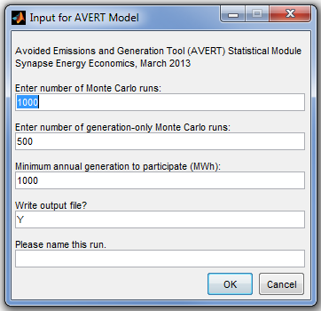The Statistical Module can create either a base-year or a future year scenario (i.e., a scenario in which some EGUs are retired, new EGUs are brought online, and other EGUs change emission rates). The process of creating a Future Year Scenario Template is described in Appendix F. A template for the Future Year Scenario Template is available in the folder “AVERT Future Year Scenarios.”

## Step 6: Launch the AVERT Executable

Click on the AVERT executable to launch the Statistical Module. A window labeled “Input for AVERT Model” will open. In this window, select:

* The number of Monte Carlo runs (default value is 1,000).
* The number of generation-only Monte Carlo runs (default value is 500).
* The minimum annual generation for an EGU to be considered in the model (default value is 1,000 MWh).
* Whether or not an output file should be written. Choose “Y” to create an input file for AVERT’s Excel-based Main Module; choose “N” to skip writing an output file (typically used for test runs only).
* Designate a run name. This name will be part of the output file name.

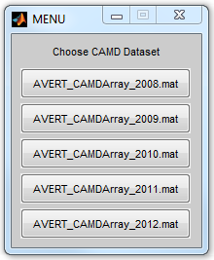***Tip:*** *The number of Monte Carlo runs directly influences how long a run takes to execute. To ensure that inputs and outputs are correctly read, perform a test run with a small number of Monte Carlo runs and generation-only Monte Carlo runs (10 each).* *For final runs where the output will be used in the Main Module, use at least 1,000 Monte Carlo runs and 500 generation-only Monte Carlo runs.These are the same parameters used in the base dataset supplied by EPA.*

## Step 7: Choose a Base Year for Analysis

A window labeled “Choose CAMD Dataset” will open. In this window, choose the data file for your desired base year. A second window showing a progress bar will also be visible.

## Step 8: Choose a Base- or Future Year Scenario

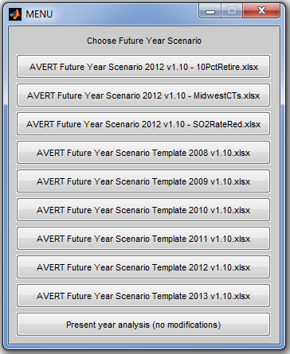A window labeled “Choose Future Year Scenario” will open. In this window, choose a base- or future year scenario for this analysis. A second window showing a progress bar will also be visible.

Note that each historical baseline year has a unique Future Year Scenario Template. Use only the one associated with the historical baseline year of interest. In other words, having chosen a 2012 base year and using a future year scenario, ensure that the base year of the template is also 2012. In the example here, three scenarios have been created for the 2012 base year, titled “10PctRetire,” “MidwestCTs,” and “SO2RateRed.”

## Step 9: Choose Region(s) of Interest

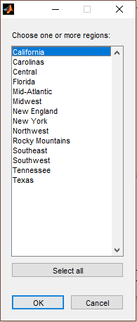A window labeled “Choose one or more regions:” will open. Choose the region for analysis and click “OK,” or choose “Select All” to launch an analysis of each of the 14 AVERT regions in turn. Two additional windows showing progress bars will be visible.

The selection of a region launches the full Monte Carlo analysis, which can take up to several hours to complete depended on computer processing speed, region selected, and number of Monte Carlo runs selected.

A progress bar will inform the user of how far the program has progressed through various analysis stages, with the Monte Carlo runs usually taking the longest time. After all Monte Carlo runs are complete, an output file will be written if selected at the start of the program.

Each region is complete when the status bar reads “Finished with [Region].” If more than one region is chosen, the program automatically proceeds to the next region.

Appendix F: AVERT’s Future Year Scenario Template

AVERT is equipped to estimate change in emissions in scenarios projecting a future year by making adjustments to the regional fleet of fossil-fuel EGUs *before* calculating the probability distributions and expected values discussed in Appendix D.

The user implements these changes before running AVERT’s Statistical Module using a spreadsheet called “AVERT Future Year Scenario Template [Year] New Regions,” where year is the data year associated with the file. The most recent historical baseline year template is stored in a subfolder of the Statistical Module called “AVERT Future Year Scenarios.” To access and use the Future Year Scenario Template, download the Statistical Module, following instructions in Appendix E. To access other historical baseline year datasets and future year scenario templates, visit <https://www.epa.gov/avert>.

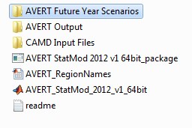For each user-defined scenario, the user is strongly recommended to save this file (in the same subfolder) using the following naming convention:

“AVERT Future Year Scenario [Year] v.4.4 [Scenario X],” where “Scenario X” is a user-defined name and “Year” is the historical baseline year.

The Future Year Scenario Template workbook stores ancillary information about each EGU in the system, and also includes worksheets that the user modifies directly and then inputs into the Statistical Module. This section describes AVERT’s process for projecting three types of user-specified adjustments to the fossil-fuel generation fleet:

* Retiring existing EGUs
* Adding additional “proxy” EGUs
* Changing emission rates for existing EGUs to represent pollution-control retrofits

Users can make adjustments for multiple regions simultaneously; AVERT will correctly associate each EGU with its appropriate region.

**Please note that each historical baseline year has a unique Future Year Scenario Template.** Use the template associated with the historical baseline year of interest.

## Retirement of Existing EGUs

EGUs can be retired from the analysis using the “Retires_Modifications” worksheet. The user finds the EGU of interest and selects “yes” in the dropdown menu under “Retire?”

## Addition of Proxy EGUs

New EGUs can be added to the fossil-fuel fleet in the “Additions” worksheet. This process is more complex than that for retirements and retrofits, and requires some knowledge of the types of EGUs expected to be added into the system. To add a new EGU, the user finds a “proxy” EGU for which statistics are already recorded in AVERT and modifies this proxy to meet the requirements of the user-defined scenario. In most cases and in most regions, the diversity of EGUs is sufficient to provide a proxy for most traditional fossil-fuel generating resources. If completely new types of resources are to be added (i.e., advanced combined cycle, integrated gasification combined cycle, or fossil-fuel backup for wind plants), the proxies available for selection may be insufficient.

In the “Additions” worksheet, the user copies existing rows to create one row for each new EGU required (see Figure 51).

Figure 51. Screenshot of example EGUs in the “Additions” worksheet.

Screen capture of how to add EGUs in the future year scenario template.

For each proxy EGU, the user selects from dropdown menus in the relevant cells:

* The region in which the EGU is to be placed
* The fuel type (gas, oil, coal, or other)
* The unit type (combined cycle, combustion turbine, steam, or other)

The user then chooses an appropriate proxy from a list of available EGUs that meet these selected criteria, and the worksheet automatically fills in the ORISPL code and Unit ID of the proxy and creates a brief description including the base-year capacity, output, and capacity factor of the EGU.

Next, the user adapts the proxy to more closely meet requirements by selecting:

* The desired capacity of the new EGU (i.e., it does not have to be the same size as the historical EGU)
* The state and county in which the EGU will be located

The worksheet automatically fills in the latitude and longitude center of that county as the new EGU’s default location. If a more precise location is known, the user can override this latitude/longitude selection by manually entering the correct coordinates. The only purpose of this location selection is to map EGUs in AVERT’s Main Module. The latitude and longitude serve no function in model calculations.

For units added in the Future Year Scenario Template, PM, VOCs, and NH3 emission rates for are automatically assigned in the Main Module. These emission rates are identical to the emission rates of the proxy unit.

## Pollution-Control Retrofits

Expected changes in emission rates due to pollution-control retrofits are also made in the “Retires_Modifications” worksheet. The user finds the EGU of interest; selects “Yes” in the dropdown menu under “Revise Emissions Rates?”; and inputs new rates in lb/MWh for SO2 and NOx, and in tons/MWh for CO2, in columns I, J, or K, respectively. To leave the rate for a particular pollutant unchanged, the user leaves the relevant cell blank. New rates entered by the user must be greater than zero. These adjusted emission rates will be employed in AVERT as single point estimates of the mean rate; no probability distribution for adjusted emissions is developed for retrofit EGUs.

## Running Future Year Scenarios in AVERT

When running AVERT’s Statistical Module, the user is presented a menu of future year scenario files saved in the “FutureYearScenario” subfolder. The user can choose one of these files or select “Present Year Analysis (no modifications).” If the user selects a “Present Year Analysis,” the model does not read or use any changes to the dataset, including retirements, additions, or changed emission rates. If the user selects a particular future year scenario, the retirements, additions, and emissions modifications from that scenario’s workbook are read into the Statistical Module. Once a region has been selected for analysis, the Statistical Module reports the individual EGUs that have been removed from or added to the region.

Note that each historical baseline year has a unique Future Year Scenario Template. Use the template associated with the historical baseline year of interest.

Future year scenarios require an additional level of calculations before the five steps described in Appendix D can be carried out. For each fossil-fuel load bin, the average generation level of each EGU (retired and active, and including new units) must be determined in a separate Monte Carlo analysis. The results of this analysis change the system fossil-fuel load *perceived* by all of the remaining EGUs to generate the correct output. Because the generation of each EGU is independently derived, each unit’s generation is not affected by the generation levels of other EGUs.

If the net change to generating capacity of retiring old and adding new EGUs results in an increase in total generation, the region will incorrectly generate an amount greater than the required fossil load. AVERT determines how much to back down the “perceived” fossil-fuel load in each bin to output the appropriate amount of generation for that bin.[106] For net reductions in generation, the algorithm is simply reversed: perceived system fossil-fuel load is increased, allowing each EGU to generate more than it otherwise would and make up the gap left by retired EGUs.

Appendix G: AVERT Regions and Instructions for States that Cross Regional Boundaries

AVERT 4.4 divides the contiguous United States (including Washington D.C., but not Alaska, Hawaii, or other territories) into 14 distinct regions. These regions are aggregates of one or more balancing authorities. Refer to Appendix B for additional detail on how the regions were developed.

Each EGU is assigned to exactly one AVERT region. These assignments may change over time as a result of changes in the dynamics of supply and demand. The current version of AVERT assigns EGUs to regions based on the assignments in the 2018 edition of EIA’s 861 database. Electrical boundaries do not necessarily represent political boundaries. As such, only 24 states and the District of Columbia are encompassed entirely within one AVERT region. The remaining states straddle two or more AVERT regions. Refer to Table 1 (on page 17) for the AVERT regions and the states they contain, either in whole or in part.

This section provides instructions for states that are split across more than one AVERT region. AVERT results represent the emission changes of the programs only on generators that are contained within that AVERT region. AVERT regions are defined not by state geography but by the electric sales that occur within their borders, as defined by utility-reported sales to EIA. To capture the emission changes of a state-wide energy policy across two or more AVERT regions, the energy policy must be parsed between the two (or more) AVERT regions straddled by the state.

Figure 52 shows a schematic of such an example. In this case, State A crosses AVERT regions 1 and 2, and thus is only partially represented in each. However, the vast majority of State A’s sales are located in and serve AVERT region 2. With some exceptions, as an approximation, the effects of the energy policy should be split into the two AVERT regions ratably, such that 90 percent of the program (represented by 90 percent of the sales) is run within AVERT region 2, and 10 percent of the program is run within AVERT region 1.

Figure 52. Schematic of recommendation to states that cross AVERT regions.

Conceptual diagram showing how to handle a state that straddles two AVERT regions.

The exception to this rule is if the user has explicit knowledge of the location of new energy projects, programs, or policies and can readily identify the region into which they will fall using the map in Figure 3.

Table 7 indicates, by state, the approximate fraction of electricity sales found in each AVERT region. This table was constructed by reviewing how much fossil electricity was sold in 2018 in each AVERT region. For example, an air quality planner in Arkansas reviewing the displaced emissions benefit of 2,000 MW of wind would run AVERT twice—once with 1,475 MW in the Midwest region, and once with 525 MW in the Central region—and then aggregate the results of these runs. An Arizona air quality planner, conversely, would run AVERT only once, with all the energy changes attributed to the Southwest region.

Table 7. State apportionment in AVERT regions, based on electricity sales in 2018.

| **State** | **Region** | | | | | | | | | | | | | |
| --- | --- | --- | --- | --- | --- | --- | --- | --- | --- | --- | --- | --- | --- | --- |
| **California** | **Southeast** | **Carolinas** | **Florida** | **Tennessee** | **Mid-Atlantic** | **New England** | **New York** | **Northwest** | **Rocky Mountains** | **Southwest** | **Texas** | **Midwest** | **Central** |
| Alabama |  | 74% |  |  | 26% |  |  |  |  |  |  |  |  |  |
| Arkansas |  |  |  |  |  |  |  |  |  |  |  |  | 74% | 26% |
| Arizona |  |  |  |  |  |  |  |  |  |  | 100% |  |  |  |
| California | 100% |  |  |  |  |  |  |  |  |  |  |  |  |  |
| Colorado |  |  |  |  |  |  |  |  |  | 100% |  |  |  |  |
| Connecticut |  |  |  |  |  |  | 100% |  |  |  |  |  |  |  |
| District of Columbia |  |  |  |  |  | 100% |  |  |  |  |  |  |  |  |
| Delaware |  |  |  |  |  | 100% |  |  |  |  |  |  |  |  |
| Florida |  | 6% |  | 94% |  |  |  |  |  |  |  |  |  |  |
| Georgia |  | 98% |  |  | 2% |  |  |  |  |  |  |  |  |  |
| Iowa |  |  |  |  |  |  |  |  |  |  |  |  | 94% | 6% |
| Idaho |  |  |  |  |  |  |  |  | 100% |  |  |  |  |  |
| Illinois |  |  |  |  |  | 65% |  |  |  |  |  |  | 35% |  |
| Indiana |  |  |  |  |  | 21% |  |  |  |  |  |  | 79% |  |
| Kansas |  |  |  |  |  |  |  |  |  |  |  |  |  | 100% |
| Kentucky |  |  |  |  | 15% | 30% |  |  |  |  |  |  | 55% |  |
| Louisiana |  |  |  |  |  |  |  |  |  |  |  |  | 93% | 7% |
| Massachusetts |  |  |  |  |  |  | 100% |  |  |  |  |  |  |  |
| Maryland |  |  |  |  |  | 100% |  |  |  |  |  |  |  |  |
| Maine |  |  |  |  |  |  | 100% |  |  |  |  |  |  |  |
| Michigan |  |  |  |  |  | 4% |  |  |  |  |  |  | 96% |  |
| Minnesota |  |  |  |  |  |  |  |  |  |  |  |  | 99% | 1% |
| Missouri |  |  |  |  |  |  |  |  |  |  |  |  | 65% | 35% |
| Mississippi |  | 23% |  |  | 32% |  |  |  |  |  |  |  | 44% |  |
| Montana |  |  |  |  |  |  |  |  | 91% | 2% |  |  |  | 7% |
| North Carolina |  |  | 96% |  |  | 4% |  |  |  |  |  |  |  |  |
| North Dakota |  |  |  |  |  |  |  |  |  |  |  |  | 53% | 47% |
| Nebraska |  |  |  |  |  |  |  |  |  | 4% |  |  |  | 96% |
| New Hampshire |  |  |  |  |  |  | 100% |  |  |  |  |  |  |  |
| New Jersey |  |  |  |  |  | 100% |  |  |  |  |  |  |  |  |
| New Mexico |  |  |  |  |  |  |  |  |  | 5% | 60% |  |  | 35% |
| Nevada |  |  |  |  |  |  |  |  | 100% |  |  |  |  |  |
| New York |  |  |  |  |  |  |  | 100% |  |  |  |  |  |  |
| Ohio |  |  |  |  |  | 100% |  |  |  |  |  |  |  |  |
| Oklahoma |  |  |  |  |  |  |  |  |  |  |  |  | 5% | 95% |
| Oregon |  |  |  |  |  |  |  |  | 100% |  |  |  |  |  |
| Pennsylvania |  |  |  |  |  | 100% |  |  |  |  |  |  |  |  |
| Rhode Island |  |  |  |  |  |  | 100% |  |  |  |  |  |  |  |
| South Carolina |  |  | 100% |  |  |  |  |  |  |  |  |  |  |  |
| South Dakota |  |  |  |  |  |  |  |  |  | 25% |  |  | 25% | 50% |
| Tennessee |  |  |  |  | 98% | 2% |  |  |  |  |  |  |  |  |
| Texas |  |  |  |  |  |  |  |  |  |  | 1% | 86% | 5% | 7% |
| Utah |  |  |  |  |  |  |  |  | 97% | 3% |  |  |  |  |
| Virginia |  |  |  |  |  | 100% |  |  |  |  |  |  |  |  |
| Vermont |  |  |  |  |  |  | 100% |  |  |  |  |  |  |  |
| Washington |  |  |  |  |  |  |  |  | 100% |  |  |  |  |  |
| Wisconsin |  |  |  |  |  |  |  |  |  |  |  |  | 100% |  |
| West Virginia |  |  |  |  |  | 100% |  |  |  |  |  |  |  |  |
| Wyoming |  |  |  |  |  |  |  |  | 62% | 38% |  |  |  |  |

Appendix H: Frequently Asked Questions

## AVERT Inputs

Are users restricted to the energy profiles created within AVERT’s Main Module?

No. The Main Module maintains simple wind and solar profiles for various regions of the United States for the convenience of users, but does not restrict users to these profiles. Users are encouraged to create energy profiles that reflect their regions and assumptions. Such profiles can be copied into the manual entry page of the Main Module.

Can I review RE options other than wind and solar generation?

Yes. New non-intermittent, must-take renewable generation, such as hydroelectric generation or geothermal generation, can be approximated using either the manual hourly data entry or the preset EE sections. For example, if you want to model the expected changes resulting from a new hydroelectric generator, you could click on “Enter hourly data manually” in AVERT’s Step 2 and enter the expected hourly generation curve. If you assume the non-intermittent resource functions as a purely baseload resource, you could use the “annual GWh” setting as a proxy.

Is there a way for baseload renewables to be included?

You can model changes in non-emitting, must-take baseload renewables like geothermal or hydroelectricity in AVERT using two different methods.

1. You can use the “annual GWh” setting in Step 2. This means you are essentially modeling an EE program as a proxy for baseload renewables. In order to account for transmission and distribution losses, you must first correct your total annual GWh value by reducing its value according to the value of the T&D losses for that year. You can find annual T&D losses in Table 2 of the “Library” tab in the Main Module.
2. If you have an 8,760 hour profile of your EGU, you can enter the profile directly into the “Manual Energy Profile Entry” page of the Main Module. Note that in this case adjustments to T&D losses are automatically included.

How do you handle biomass, waste combustion generators, or CHP generators in AVERT?

If biomass, waste combustion, or CHP generators are emitting and have capacities greater than 25 MW, they are included in EPA’s Power Sector Emissions Data.

AVERT is not currently equipped to estimate the emissions of emitting generators that do not report to CAMD. However, if you know the expected generation and emissions from a new biomass, waste, or CHP generator, you could review the estimated displaced emissions and generation from the inclusion of that generator using AVERT (assuming an hourly energy profile is known for the new EGU) and then add in that generator’s emissions post hoc. To do so, follow the steps below:

1. Determine the estimated energy profile for the CHP generator and associated stack emissions.
2. Input the energy profile for the CHP generator into AVERT under “manual energy profile entry” in Step 2. If the resource is utility-scale (e.g., a central station power plant providing power to wholesale markets), its impacts should be entered in the first column. If it is distributed (e.g., located at the customer site or behind the meter), its impacts should be entered in the second column.
3. Run the Main Module to determine emissions offset due to the new CHP generator.
4. Subtract the CHP stack emissions from emissions offsets to determine the total change in emissions.

*net emissions reduction from CHP generator = AVERT displaced emissions + CHP stack emissions*

There is no current option to review emissions displaced from new biomass, waste, or CHP generators if they do not already report to CAMD.

Are there any plans to incorporate electricity production from biogas facilities into AVERT?

If the facility is an emitting generator and has a capacity greater than 25 MW, it is currently included within the AMP EGU dataset. Otherwise, there are no current plans to incorporate electricity production from these types of facilities. Often, these facilities may generate electricity according to their onsite needs and fuel supply and may not be affected by regional changes in load or dispatch.

How does AVERT account for the dispatch of new RE into the existing system?

RE generation sources typically have very low variable operating costs; in other words, they are very inexpensive to operate once they are constructed. Typically, low-operating-cost resources are dispatched first, and increasingly expensive resources are dispatched thereafter. RE sources are assumed to dispatch first (a common assumption across many economic dispatch models), and thus can be modeled as an equivalent reduction in demand. AVERT simply compares the generation and emissions of all fossil resources before the new RE resource (i.e., at the equivalent of full demand in each hour) and after the new RE resource (i.e., at the equivalent of a reduced demand in each hour). The difference in generation and emissions between the before and after scenarios represents the emissions displaced by RE.

How does AVERT account for the dispatch of new EE into the existing system?

EE usually results in a reduction in demand (in some cases and for some types of programs, it may result in a shifting of demand to off-peak hours). AVERT simply compares the generation and emissions of all fossil resources before the new EE resource (i.e., at the equivalent of full demand in each hour) and after the new EE resource (i.e., at the equivalent of a reduced demand in each hour). The difference in generation and emissions between the before and after scenarios are the emissions that are displaced by EE.

Is there a bound on the smallest change that is appropriate to model?

No, there is no specified lower bound, but users may find the following guidance useful when analyzing small changes. Users can review the output chart titled “Hourly Results by Week” for an indication of how closely their expected energy changes are captured in hour-to-hour unit changes for one week. For very small inputs, this graphical interface will indicate a rougher hour-to-hour energy profile—i.e., the resulting change in generation will look less like the amount of energy change expected. Note that all numerical results are shown rounded to the nearest 10 unit.[107] Dashes indicate that AVERT reported a value greater than zero, but lower than the level of reportable significance. In some cases, no reasonably sized energy policy will result in reportable changes. For example, the review of monthly results for a single small county in a low load month may often result in low significance results. However, the user can use discretion to determine if an energy policy has resulted in an acceptable level of significance based on the signal-to-noise diagnostic and the degree to which critical results are below the level of acceptable significance (i.e., are obscured by dashes in numerical results).

For some smaller inputs, users may find increased “noise” in a given model run. Although the resulting annual changes in emissions or annual average emission rate may resemble what one might expect for results, based on the inputs, results for individual EGUs may exhibit more volatile behavior. For example, in a modeling run that is intended to reduce fossil load (e.g., the user has input some quantity of EE or RE), some individual EGUs may exhibit decreases in generation (as one might expect), while others may exhibit unexpected increases in generation. For a check of these results in aggregate, the user should view the “Signal-to-noise diagnostic,” found on the “Display Results” page of AVERT’s Main Module. As described in this manual (p. 47), this scatter plot shows the changes in generation calculated by AVERT (on the y-axis) against the energy change input by the user. More reasonable results (from a program size perspective) will appear closer to 1:1 lines. Smaller load changes have more noise (i.e., scatter) in this plot, while larger load changes have a straighter line relationship. The R2 value in the title of the chart indicates how much of the change in generation can be explained by the user-input energy change. For examples, an R2 value of 0.9 indicates that AVERT has captured 90 percent of the change in generation required by the user, while a value of 0.7 indicates that AVERT has only correctly captured 70 percent of the energy change input by the user (i.e., noise accounts for 30 percent of the observed variability).

Figure 53 shows two different energy profiles with very different R2 values from the same region, and designed similarly. The graph on the top is a 1.5 percent load reduction during the peak 20 percent of hours. The reduction is sufficiently sized such that the generation reduction is able to match the requirement very closely—over 99 percent of the reduction in generation is a direct result of the energy change input. The graph on the bottom is a 0.25 percent load reduction during all hours of the year. The reduction is insufficiently sized in this case and results in a wide range of uncertain results. By comparison, 92 percent of the generation reduction can be attributed to the energy policy—the rest is noise.

In general, modeling runs that produce a high level of noise (i.e., a low R2) may be useful for describing high-level results (such as annual and regional changes in emissions) but may be less useful for describing changes in generation or emissions on an hourly basis or at any one individual EGU. Modeling runs with comparatively less noise (and larger R2 values) are better suited for these purposes.

Figure 53. Examples of two different load reductions with different R2 values in the signal-to-noise diagnostic. Top: 1.5 percent load reduction in peak 20 percent of hours. Bottom: 0.25 percent load reduction in all hours.

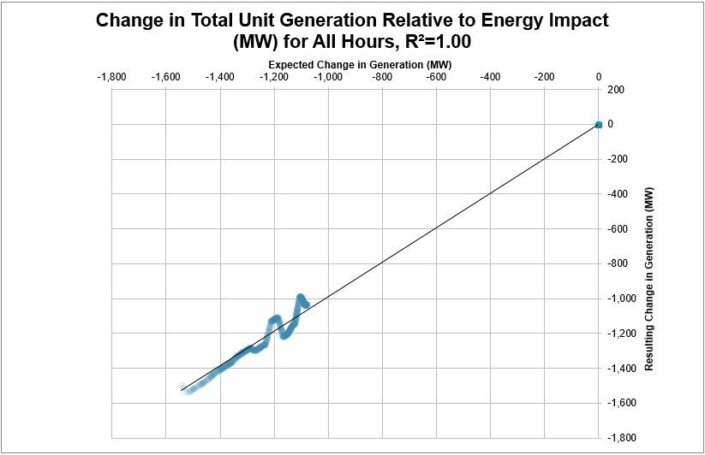

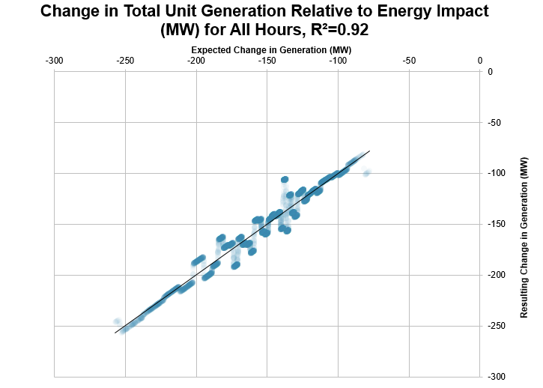

Is there a bound on the largest change that is appropriate to model?

There is not a formal bound on the largest project, program, or policy that should be modeled in AVERT. In general, users should note that AVERT is designed to review marginal operational changes in load, rather than large-scale changes that may change fundamental dynamics. As a guideline, EPA suggests that modeled scenarios generally not deviate 15 percent from baseline fossil generation in any given hour.

With this 15 percent guideline, analysts should use their judgment in deciding whether the results are appropriate for their uses. To assess appropriateness of results, analysts can consider the number of hours out of 8,760 (the number of hours in a year) that exceed the 15 percent threshold and how much greater than 15 percent the resultant fossil generation values are. Analysts should also consider their specific interest in using AVERT. For example, an analyst interested in only annual results may likely be less sensitive to the 15 percent guideline than an analyst interested in the hourly results that span the hours where the threshold is exceeded.

In addition, users may encounter situations in which their selected change to load produces a new hourly load that is outside the range calculable by AVERT. This may occur in situations where load is reduced by 50 percent or more relative to the hour with the lowest load (i.e., well outside the recommended threshold of 15 percent). In situations where load is increased, users may encounter this issue at load increases as low as 10 percent for some regions. In these situations, users should refine their load changes such that an error is not produced on the “Manual User Input” page.

For reference, Table 8 provides each AVERT region’s total annual load, in GWh. Knowing the total annual load in each region may be helpful when using AVERT’s “reduce generation by X% in all hours” option to model the impacts of a broad-based EE program. Figure 54 identifies the distribution of hourly loads in each of the 14 AVERT regions, using data from 2024. Table 7 also shows the maximum and minimum possible load levels able to be modeled in AVERT. These values provide helpful context if one knows the absolute size of a project, policy, or program in units such as MW and one wants a sense of the percentage of regional load that it represents. Note that fossil loads in Table 8 and Figure 54 have *not* been adjusted to reflect the transmission and distribution losses inherent to each region. Demand-side measures (such as EE or distributed solar) avoid not only electricity demand, but also the electricity associated with transmission and distribution losses. As a result, demand-side programs increase the avoided fossil load by an additional 5–9 percent, depending on the region and the year being analyzed.

Table 8. Total regional fossil loads in AVERT regions, 2024.

|  |  |  |  |
| --- | --- | --- | --- |
| **AVERT region** | **Total annual fossil load (GWh)** | **Maximum possible hourly load (MW)** | **Minimum possible hourly load (MW)** |
| California | 77,153 | 25,973 | 1,413 |
| Carolinas | 104,149 | 23,185 | 4,374 |
| Central | 143,469 | 38,631 | 4,761 |
| Florida | 190,005 | 38,122 | 10,330 |
| Mid-Atlantic | 486,893 | 106,897 | 29,804 |
| Midwest | 468,142 | 97,150 | 27,192 |
| New England | 53,220 | 12,433 | 1,630 |
| New York | 70,374 | 18,498 | 3,669 |
| Northwest | 117,957 | 20,817 | 3,355 |
| Rocky Mountains | 46,920 | 9,998 | 2,093 |
| Southeast | 171,627 | 37,507 | 10,051 |
| Southwest | 81,541 | 16,392 | 2,416 |
| Tennessee | 86,898 | 17,537 | 4,074 |
| Texas | 274,642 | 59,540 | 9,634 |

Figure 54. Characteristics of regional hourly fossil loads, 2024.

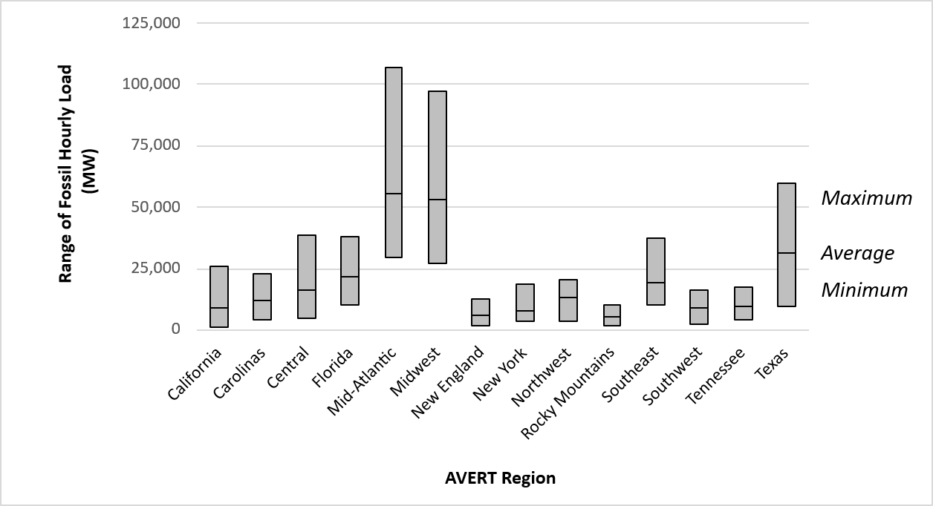

Why might actual planned offshore wind projects trigger a warning in AVERT?

The Excel Main Module gives the user a warning when they have entered an energy profile that collectively exceeds 15 percent of load in at least one hour of the year. This warning could appear when modeling certain large policies, programs, or projects, including ambitious offshore wind projects that may be implemented in the near future. However, this warning will not prevent the user from modeling large quantities of offshore wind—the user can simply ignore the warning message if desired.

Are energy changes applied over the whole region? Is there a way to apply them at the state, county, or municipal level only?

Because AVERT does not model transmission constraints within a region, energy changes are assumed to have change emissions throughout the selected AVERT region. A limitation of AVERT is that it is insensitive to the physical location within a region of new projects, programs, or policies, despite the fact that real-world dispatch decisions may be quite sensitive to specific locations of resources resulting from energy policies as well as EGUs. AVERT assumes that energy changes are spread across the modeled region. It cannot currently identify the differential effects of local versus regional energy changes. Such differentiation requires the use of a production cost model.

For more information, see “Limitations and Caveats” in Section 2 of this manual. Detail on changes at the state and county level are available on the output sheet “Annual Results by County.”

## AVERT Results

Does AVERT account for losses?

Yes, AVERT accounts for three types of losses. First, gross generation as collected in the Power Sector Emissions Data is corrected to account for parasitic consumption of energy onsite at fossil-fired EGUs. AVERT applies a parasitic loss factor to each EGU based on unit and fuel characteristics and subsequently calculates emissions based on each unit’s “net” output of energy exported to the grid. Second, reductions in fossil load due to EE and distributed PV (and increases in fossil load from increased demand) are corrected to account for avoided grid (transmission and distribution) losses, using region-specific, year-specific grid loss factors. Wind and utility-scale PV profiles are not corrected for these losses, as it is assumed they are located at a similar distance from load centers as fossil-fired EGUs. Finally, additional loss factors are assumed for offshore wind due to the fact that these resources are commonly located far from load centers, and because associated transmission lines may be underground or underwater. Using loss estimates from NREL, these factors act to reduce the hourly capacity factors of offshore wind resources.[108] See Appendix C for more detail on how offshore wind capacity factors have been developed in AVERT.

How can users assess the accuracy of the results returned by AVERT’s Main Module?

The current version of the Main Module is not equipped to return information on the accuracy or uncertainty of the model results.

While the Monte Carlo analysis run by AVERT creates information useful for some forms of uncertainty analysis, using this information to assess the accuracy of the results returned by the Main Module would require simultaneously performing a Monte Carlo analysis on the baseline scenario and on the modified scenario, and returning uncertainty metrics associated with the difference between these two scenarios. The current version of AVERT does not contain this information. EPA is exploring a future version of AVERT that could perform explicit uncertainty analyses and allow users to assess the accuracy of results returned by the model.

What is the accuracy of the map chart in AVERT’s Excel-based Main Module?

The map is a visual cue only, and should not be used as a precise rendering of the location or influence of change in generation or emissions from any EGU or cohort of EGUs. Maps could be used for visual presentations to show the general location of emissions.

Why do some EGUs show positive increases in generation with decreases in system load?

Some EGUs show positive increases in generation with decreases in load because the EGU statistics indicate either a slight increase in the probability of operation at very low loads or an increase in generation at very low loads. Spot checks indicate that most of the EGUs that show generation increases with decreases in system load are due to baseload EGUs that show a lower probability of generation at mid-range loads than at either very high or very low loads. In other words, these EGUs counterintuitively *increase* the probability of operation as system load levels become very low. Further inquiry into these EGUs suggests that they have prolonged maintenance outages during spring or autumn—i.e., during periods of generally low load, but possibly not the lowest in the year. Therefore, the EGU will register as non-operational through a wide swath of medium-low loads, but may operate during the very lowest loads of the year. Therefore, the statistics capture this behavior and increase expected generation by a small margin when system load is reduced from very low load periods. This pattern is almost always observed in trough periods.

What kinds of emission rates does AVERT produce?

AVERT’s Annual Regional Results table (see Figure 21) displays information on modeled emissions, generation, and emission rates. Two types of emission rates are shown on the lower box of this page: “Average Fossil” and “Marginal Fossil.”

The first column labeled “Average Fossil” is an emission rate calculated by dividing the mass (tons or pound) of each pollutant in the baseline (“Original”) by the level of generation (MWh) in the baseline (“Original”). These values are derived from the power plants in the AVERT dataset prior to any user-defined change. This is an annual average emission rate of those EGUs in EPA’s Power Sector Emissions database.[109] It is specifically a “fossil” rate because it does not include generation or emissions from other power plants, including nuclear, hydro, wind, solar, or other plant types. See U.S. EPA’s eGRID tool for information on average emission rates that are inclusive of these other EGU types.[110]

The second column, labeled “Marginal Fossil,” is calculated by dividing AVERT’s estimated change in emissions by AVERT’s estimated change in generation. This predicted change in emissions and generation is the impact on the power sector as calculated by AVERT due to the user-defined scenario. This value is called a marginal rate because it describes a change in emissions per unit change in generation. As AVERT only models fossil-fired EGUs in the Power Sector Emissions database—not other types of power plants—we refer to this as a “Marginal Fossil” rate.

Although the Annual Regional Results focus on annual emission rates, it is also possible to calculate more temporally detailed “Average Fossil” and “Marginal Fossil” emission rates using data in the advanced outputs (see page 57). AVERT reports both original and changes in generation and emissions for every hour. Users can divide an emission quantity by the corresponding hourly generation and calculate either “Average Fossil” and “Marginal Fossil” emission rates for a single hour. Users can also use these data to create weighted average values for weeks, months, or other time periods.

How should AVERT’s results be applied to resource impacts longer than a year?

AVERT is best used to conduct short-term analyses, and EPA recommends that users restrict their analyses to a five-year time horizon from the year of the RDF. Analyses that extend past this window may intersect with years when the operation and composition of the grid is substantially different from the baseline year and may not include the structural change that may have been caused by the intervention modeled.

More specifically, the emission rates calculated by AVERT can be classified as “short-run” marginal emission rates (SRMER). These differ from “long-run” marginal emission rates (LRMER) in that short-run rates are focused on operations of the current grid, holding the structure of the grid fixed, while long-run rates incorporate both operational and structural changes to the grid. Each approach is appropriate for distinct purposes. Short-run approaches are appropriate for characterizing the near-term impacts of an intervention prior to the point where structural changes occur.

The medium- to long-term impact of resources like EVs and heat pumps on the grid is also of interest to many users as the power sector’s emission rates for many pollutants are expected to decline over time. While AVERT is not intended to answer these questions, EPA has built a reference output to help put the AVERT results in context, the output page titled “Reference: Modeled Emission Rates Over Time.” On this page, users can compare the CO2 emission rate as modeled in AVERT with a set of emission rates modeled by NREL in its Cambium data set. CO2 SRMER and LRMER are provided for different approaches and different years, allowing users to visualize how grid impacts of interventions are likely to change in the future.

For more information on this topic, see page 54.

Does AVERT account for lifecycle emissions?

No. At this time, AVERT users are only able to analyze emissions related to direct combustion (EGU and ICE vehicle) and select emissions relating to fueling and the volatilization of fuel in ICE vehicles. Users interested in exploring lifecycle emissions may wish to utilize the Greenhouse gases, Regulated Emissions, and Energy use in Technologies (GREET) Model developed by Argonne National Laboratory.[111]

Can AVERT results be used for spatial analyses?

AVERT contains two types of data with geospatial attributes. The first type of data is point source (latitude and longitude) emission data from EGUs. The annual-aggregated EGU emission data with latitude/longitude attributes can be accessed by viewing the tab titled “Summary” in the Excel file. AVERT also presents this annual EGU data aggregated at the county-, state-, and regional-level in some outputs. (Note that AVERT users will have to click the button labeled “Click here to restore default Excel data” on the welcome page of the model to access this “Summary” page.) Users can utilize the latitude and longitude locations to visualize the annual data displayed on this page, or apply this latitude and longitude data to hourly, EGU-specific data for all six pollutants, which can be accessed by viewing the tabs titled “SO2 (lb),” “NOX (lb),” “CO2 (short tons),” “PM2.5 (lb),” “VOCs (lb),” and “NH3 (lb).”

The second type of geospatial data is avoided ICE vehicle emissions aggregated at the county-level (AVERT also presents these data at the state and regional level). These data are a generalization of the emissions *not* occurring on roadways in counties where EVs are being deployed according to the user’s scenario. These data are most easily accessible for geospatial analysis (via FIPS codes) through the page titled “Output: Annual Results by County, Including Vehicles.”

Users may be interested in utilizing these spatial data to understand how policies and programs modeled in AVERT affect overburdened communities or other communities of interest. To support these equity analyses, users could employ a geographic information system (such as ArcMap, QGIS, Google Earth, or another program) to analyze and visualize AVERT data alongside EJScreen[112] or another spatial dataset of interest.

Can AVERT results be used for mobile source regulatory analyses?

No. AVERT may not be used for mobile source regulatory analysis, including SIP and transportation conformity analyses. Consult the most recent EPA guidance document for applying EPA’s MOtor Vehicle Emission Simulator (MOVES) model at: <https://www.epa.gov/moves/latest-version-motor-vehicle-emission-simulator-moves>.

## AVERT Statistical Module

Why is the model driven by system fossil generation instead of by demand or total load?

AVERT is a statistically based model that tracks and reproduces EGU behaviors. EGUs are forecast to operate in the near future much as they operate today. In electrical system dispatch, determining how an EGU operates is largely driven by two factors—total demand on the system and the cost of operation for any given EGU. In economic dispatch, more expensive EGUs are dispatched at higher levels of demand.

In AVERT, the degree to which an EGU will be dispatched in the future is assumed to be the same as the degree to which it has been dispatched at a historical level of demand .This assumption incorporates the relative operational cost of different EGUs. In other words, EGUs that dispatched at high demand were likely more expensive to operate and thus are likely to be on the margin at the same level of demand.

However, if AVERT were to observe the behavior of EGUs against *total* system demand, it would miss an important factor: the large number of non-fossil EGUs that are dispatched at very low operating costs—such as solar, wind, hydroelectric, and nuclear operations. These non-fossil EGU have the same effect as lowering system demand, or specifically, system demand that needs to be met by fossil generation. Therefore, AVERT dispatches against demand for fossil resources, rather than total system demand. New EE or RE policies are assumed to reduce the demand for fossil resources. Figure 55 below illustrates the difference between total system demand and demand for fossil resources.

Figure 55. Diagram schematic of system demand over two days, divided into fossil and non-fossil components illustrating system and fossil demand.

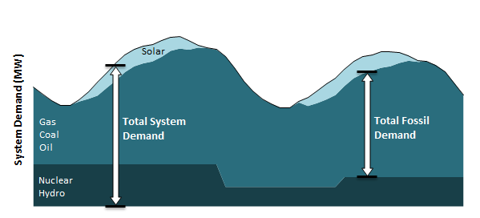

Does the sum of all unit generation in any given Monte Carlo run add up to the size of the load bin (i.e., the expected fossil generation)?

Not necessarily. The generation from each EGU is calculated independently in each Monte Carlo run, meaning that there is no constraint that forces the output of all EGUs to equal the exact size of the load bin. The total sum of all unit generation from any given Monte Carlo run may be slightly larger or smaller than the load bin. However, over large numbers of Monte Carlo runs, the average output of each EGU will sum quite closely to the expected fossil generation, or the size of the load bin.

Is it possible to displace baseload EGUs in AVERT?

Yes. AVERT treats baseload EGUs, or units that run during most hours, including during baseload hours of the year, the same as all other EGUs. There is no distinguishing characteristic that either promotes or prevents an EGU from running during any given hour, except for how it has operated in the past. If an EGU has experienced little downtime in the past and operates continuously even a low levels of load, the model will replicate this behavior going forward. This type of EGU is unlikely to be displaced by EE or RE programs in AVERT. However, an EGU that ramps from high output in the daytime to low output on off-peak hours may show a displacement if system demand declines due to RE or EE.

Can AVERT capture or replicate ramping behavior?

No. AVERT performs a separate calculation for each hour of the year and does not evaluate the rate at which an EGU increases or decreases generation. Capturing that behavior requires a chronological dispatch model.

Can AVERT capture or replicate spinning reserves behavior?

Yes. AVERT captures historical generation patterns. EGUs that maintain a spinning reserve (i.e., maintain a minimum level of generation in most operating hours) will reflect this pattern in the statistics gathered by AVERT. The Lake Hubbard EGU shown in Figure 42. is a classic example of an EGU that appears to maintain a spinning reserve. It maintains an output of about 150 MW per hour for most hours of the year. However, when system demand climbs above 45,000 MW, it quickly climbs towards an output of 500 MW.

Can AVERT capture transmission constraints or changes in transmission?

Generally, no. AVERT operates on the simplifying assumptions that there are no transmission constraints between load centers and EGUs within a region and that regions are independent of each other. Therefore, AVERT is insensitive to the location where new EE or RE resources are placed within a region, and thus does not capture transmission constraints. However, the behavior of some EGUs may be influenced by historical transmission constraints, and this behavior is captured by AVERT. For example, in “load pockets,” or areas of constrained inbound transmission, reliability EGUs may run at lower regional load levels than would otherwise be dictated by economic dispatch. Because AVERT is not an economic model, it simply replicates the behavior of these EGUs, which may capture some elements of current transmission constraints.

Due to the same simplifying assumptions that prevent AVERT from operating as a transmission-constrained dispatch model, AVERT cannot capture future changes in transmission, which typically change which future EGUs can compete to provide the lowest-cost energy in a particular area.

Are recent fuel prices reflected in AVERT?

Yes. To the extent that fuel prices have influenced dispatch during the base data year you choose, AVERT will reflect those dispatch decisions. AVERT cannot, however, change dispatch based on future economic or regulatory conditions, such as expected fuel prices, emissions prices, or specific emissions limits. AVERT should not be used for this type of analysis, as such changes require an economic dispatch model.

Are emissions control technologies reflected in AVERT?

Yes. To the extent that emissions controls were in operation at the time that data were collected in the base data year, emissions will reflect operational (and operating) control technologies. To the extent that a user requires a review of dispatch with different emission rates, they can override observed emission rates using the “Future Year Scenario Template” as described in Appendix F. Modeling emissions prices, specific emissions limits, or fuel switching requires an economic dispatch model.

Are predicted changes in fuel or emissions prices reflected in AVERT?

No. AVERT should not be used for this type of analysis; capturing this behavior requires an economic dispatch model.

What other tools are available to me to estimate changes in emissions aside from AVERT?

You can model generation and emissions changes caused by new energy policies in a production-cost dispatch model. These programs simulate real dispatch decisions based on explicit costs and operational constraints, optimizing generator use to minimize costs. Some of these models are sensitive to EGU ramp-rates, transmission constraints, and outage schedules.

For the most part, these models are highly detailed, proprietary, and require specialized labor and licensure to operate and use, as well as some degree of proprietary knowledge for fuel costs and operational constraints.

AVERT provides an alternative, publicly available tool to estimate changes in emissions in near-term years. Users who wish to conduct analyses more than 5 years from the baseline must use AVERT’s statistical module and future year scenario template. This type of analysis requires access to future year hourly, unit-specific generation and emissions data (e.g., from an electric-sector dispatch model designed to forecast future generation) that can be entered in place of AVERT’s historical data.

## Future Year Scenarios

Why is there a different future year template for each historical baseline year?

AVERT is sensitive to the composition of the electric fossil fuel fleet. Every year, the composition of the fleet changes slightly as new EGUs are added or retired. To accommodate this changing fleet, AVERT creates a new future year scenario template for each historical baseline year. Using a mismatched pair in AVERT’s Statistical Module (e.g., a historical baseline year of 2017 but a future year template of 2019) risks accidentally using proxy “new” EGUs that did not exist in 2017, and thus will not be incorporated into a 2017 analysis.

Why are some generators excluded from AVERT’s Future Year Scenario Template?

AVERT considers EGUs that report to EPA’s CAMD only. This may exclude generators with less than 25 MW of capacity or generators that did not operate in a particular year.

Why do some generators appear in the Future Year Scenario Template but not in the RDF?

AVERT’s Statistical Module allows users to exclude small, low-generation units from consideration in the emissions analysis. Small peakers have statistics that may be non-representative of expected generation patterns (i.e., they cannot be readily extrapolated or interpreted outside of specific events). By default, AVERT excludes units that have generated less than 1,000 MWh per year. For a 25 MW unit (the smallest reporting unit), this would be the equivalent of 40 hours of generation over the year, or less than 0.5 percent of all possible operational hours.

In the future scenario demo, do the total avoided emissions include the impact of retired units, or just the energy impacts adjusted for retirements?

Results from AVERT runs using the Future Year Scenario Template do not include changes in emissions at user-specified retired units. These units are assumed to be retired in both the “before” and “after” cases.

The purpose of the retirements category is to exclude from consideration any units that are likely to be non-operational in the future year, regardless of the energy change modeled.

Does EPA provide projections for use in AVERT’s Future Year Scenarios?

At this time, EPA is not providing EPA projections for use in AVERT. Future scenarios are meant to be developed by users. You can use AVERT’s future year scenario template to make known changes in the regional dataset. Users who wish to conduct analyses more than 5 years from the baseline must use AVERT’s statistical module and future year scenario template. This type of analysis requires access to future year hourly, unit-specific generation and emissions data (e.g., from an electric-sector dispatch model designed to forecast future generation) that can be entered in place of AVERT’s historical data.

Along these lines, EPA has partnered with the Eastern Regional Technical Advisory Committee (ERTAC), a group of state environmental agency senior staff and multi-jurisdictional organizations (e.g., LADCO, MARAMA, WESTSTAR, SESARM, NESCAUM), to provide AVERT-compatible RDFs for ERTAC-specified custom future years.

EPA will issue periodic updates to the historical data files available for download, but will not release stand-alone future scenarios. At this time, EPA anticipates releasing new RDFs in the second quarter of each year.

## Electric Vehicles

If a new electric car is expected to be charged for the next 12 to 15 years, how should we consider the results generated by AVERT?

As described in the above FAQ (“Does EPA provide projections for use in AVERT’s Future Year Scenarios?”), AVERT is best used to conduct short-term analyses. In practice, we recommend that users restrict their analyses to a five-year time horizon from the year of the RDF. Analyses that extend past this window may intersect with years when the operation and composition of the grid is substantially different from the baseline year and may not include the structural change that may have been caused by the intervention modeled.

The medium- to long-term impact of EVs on the grid is also of interest to many users as the power sector’s emission rates for many pollutants are expected to decline over time. While AVERT is not intended to answer these questions, EPA has built a reference output to help put the AVERT results in context: the output page titled “Reference: Modeled Emission Rates Over Time.” On this page, users can compare the CO2 emission rate as modeled in AVERT with a set of emission rates modeled by NREL in its Cambium data set (for more information on this feature, see page 54). CO2 SRMER and LRMER are provided for different approaches and different years, allowing users to estimate how grid impacts of charging vehicles are likely to change in the future.

Which power plants does AVERT assume charge EVs?

AVERT sums the load change from all entered resources (EERE, EVs, and energy storage) in each hour and applies the net change to the fossil power plants in the selected grid region (as defined by the RDF). When modeling EV adoption in the near future, users are recommended to model the amount of EE and RE resources that are estimated to come online during the same period to understand the joint effect of both changes together. For example, if a user is modeling the number of EVs added to the grid over a three-year period, they should also model the amount of EE and RE expected to be added over the same three years.

Which vehicle types are included in AVERT?

AVERT includes 18 different categorizations of vehicle types or use cases and fuels (see Table 9). All vehicle types are based on the framework used by the MOVES5 model. The MOVES5 model also contains a number of vehicle types not included in AVERT. Those include vehicles outside of AVERT’s scope (like motorcycles or motor homes) or vehicles unlikely to be electrified in the near-term (such as intercity buses).[113] MOVES5 also contains a number of vehicle combinations that are not included in AVERT, such as passenger trucks powered by diesel (rather than gasoline). In order to keep the number of vehicle types modellable in AVERT to a manageable number, we have screened out any vehicle combinations representing 5 percent or less of a top-level’s category of vehicle miles travelled. For example, because diesel-powered passenger trucks make up just 1 percent of all miles travelled by light-duty vehicles, these vehicle types are not included in AVERT.

Table 9. Categorization of modeled vehicles in AVERT

|  |  |  |
| --- | --- | --- |
| **Top-level categorization of vehicles** | **Second-level vehicle categorization** | **Fuel categorization** |
| Battery EVs | Passenger cars | Gasoline |
|  | Passenger trucks | Gasoline |
| Plug-in hybrid EVs | Passenger cars | Gasoline |
|  | Passenger trucks | Gasoline |
| Transit buses | Medium-duty transit buses | Gasoline |
|  | Medium-duty transit buses | Diesel |
|  | Heavy-duty transit buses | Diesel |
|  | Heavy-duty transit buses | Compressed natural gas |
| School buses | Medium-duty school buses | Gasoline |
|  | Medium-duty school buses | Diesel |
|  | Heavy-duty school buses | Diesel |
| Short-haul trucks | Light-duty single unit trucks | Gasoline |
|  | Medium-duty single unit trucks | Gasoline |
|  | Medium-duty single unit trucks | Diesel |
|  | Heavy-duty combination trucks | Diesel |
| Combination long-haul trucks | Heavy-duty combination trucks | Diesel |
| Refuse trucks | Medium-duty trucks | Diesel |
|  | Heavy-duty trucks | Diesel |

Note: Light-duty short-haul trucks, includes both the vehicles identified in MOVES5 as “Light-duty, short-haul” as well as the separate category called “light commercial truck.”

Where can I find more detailed descriptions of the vehicle types included in AVERT?

Definitions for the top-level and second-level vehicle categorizations included in AVERT are as follows:

* **Battery EVs:** light-duty battery-powered passenger vehicles smaller than 8,500 lb.
  + Passenger cars: these include hatchbacks, sedans, and small SUVs
  + Passenger trucks: these include medium and large SUVs, pickup trucks, and vans
* **Plug-in hybrid EVs:** light-duty plug-in hybrid passenger vehicles smaller than 8,500 lb.
  + Passenger cars: these include hatchbacks, sedans, and small SUVs
  + Passenger trucks: these include medium and large SUVs, pickup trucks, and vans
* **Transit buses:** any buses primarily transporting passengers on fixed routes and schedules
  + Medium-duty transit buses: these are larger than 14,000 lb. up to 33,000 lb.[114]
  + Heavy-duty transit buses: these are larger than 33,000 lb.
* **School buses:** buses primarily transporting K-12 students between their home and school.
  + Medium-duty school buses: these are larger than 8,500 lb. up to 33,000 lb.
  + Heavy-duty school buses: these are larger than 33,000 lb.
* **Short-haul trucks:** trucks larger than 8,500 lb. that drive less than or equal to 200 miles per day. Single unit trucks are vehicles on a single frame, such as a beverage or box truck. Combination trucks are vehicles with both a tractor and trailer, such as a “semi-truck.”
  + Light-duty single unit trucks: these are larger than 8,500 lb. up to 10,000 lb.
  + Medium-duty single unit trucks: these are 10,000 lb. and up to 33,000 lb.
  + Heavy-duty combination trucks: these are larger than 33,000 lb.
* **Combination long-haul trucks:** heavy-duty trucks larger than 33,000 lb that drive more than 200 miles per day. Combination trucks are vehicles with both a tractor and trailer, such as a “semi-truck.”
* **Refuse trucks:** trucks that collect and haul refuse to a central location
  + Medium-duty refuse trucks: these are larger than 8,500 lb. up to 33,000 lb.
  + Heavy-duty refuse trucks: these are larger than 33,000 lb.

Can I model other types of vehicles in AVERT?

By default, AVERT is designed to allow users to easily model the vehicle types described above. However, AVERT also contains efficiency and VMT data associated with “Other buses”, which include all buses that are not in the transit or school bus categories, such as intercity and coach buses. Users can access the default assumptions for this vehicle type in the Library sheets of the Excel edition.

Should I use AVERT’s definition of “new” vehicle or “existing” vehicle?

With AVERT, users can select an emissions profile for a new or existing ICE vehicle. In many situations, users are likely to want to select “new” for this vehicle type. This allows a user to compare the impact of some number of new EVs relative to the same number of new ICE vehicles. In some cases, users may wish to compare the impacts of replacing an existing ICE vehicle with a new EV. In these situations, users should select “existing” vehicle. In both options, the grid impacts associated with charging EVs will remain the same; changing the option between “new” and “existing” only modifies the emission rate associated with ICE vehicle emissions.

What other sources for charging profiles are there? How would I use them in AVERT?

One potential source for EV charging profiles is the Electric Vehicle Infrastructure Projection Tool (EVI-Pro) Lite.[115] EVI Pro-Lite is the source for AVERT’s “light-duty vehicle” charging profile, but users can utilize EVI-Pro Lite to develop their own custom charging profiles. Charging profiles derived from this tool may be a better representation than the defaults available in AVERT, as EVI-Pro Lite allows users to modify many different options currently not available in AVERT. Users should reference EVI-Pro Lite materials at <https://afdc.energy.gov/evi-pro-lite/load-profile> to learn how to use the tool and generate load profiles.

Users should note that they can export the results from EVI-Pro Lite into a CSV file. Some post-processing may be needed before importing the results into AVERT. As of April 2025, the load profiles will produce results in 15-minute intervals, which must be averaged to produce hourly values usable in AVERT.

Can the vehicle emissions be exported to COBRA?

Yes. When a user generates a COBRA text file, emission changes will be generated for the power sector as well as the vehicle emissions from the transportation sector (see page 56 for more information). This text file will contain a row of vehicle emission changes for every county in the region currently selected for modeling. These county-specific changes are developed by allocating the total regional emissions changes for each pollutant to each county based on the share of VMT in that county relative to the regional total. When COBRA reads the AVERT-generated text file, the emissions will be automatically classified to the appropriate sector (i.e., electricity generation or “transportation,” as the sector is called in COBRA). Because vehicle emissions are emitted close to the ground (unlike pollutants emitted from EGUs, which are emitted from a stack high in the air), these pollutants tend to not travel far distances and, as a result, tend to be more impactful to local communities.

## Energy Storage

**What kinds of energy storage technologies does AVERT model?**

Currently, AVERT models energy storage resources using parameters (DoD, RTE, and number of cycles) reflective of lithium-ion battery storage. Currently, lithium-ion batteries make up more than 90 percent of utility energy storage capacity installed since 2012.[116],[117]Users have the option to modify the parameters embedded in the tool to be more representative of different types of energy storage.

**Are there any online resources for modeling other kinds of energy storage technologies besides lithium-ion battery storage?**

Yes. The Pacific Northwest National Laboratory (PNNL) released a “2022 Grid Energy Storage Technology Cost and Performance Assessment” report, which detailed the findings of an assessment of a number of different energy storage technologies. Aside from lithium-ion batteries, this report provides typical values for parameters such as DoD, RTE, and duration for lead-acid batteries, vanadium redox flow batteries, zinc-based batteries, compressed air energy storage, and pumped storage hydropower. This is just one example option that users can reference when defining their own energy storage characteristics. It is available at: [www.pnnl.gov/sites/default/files/media/file/ESGC%20Cost%20Performance%20Report%202022%20PNNL-33283.pdf](http://www.pnnl.gov/sites/default/files/media/file/ESGC%20Cost%20Performance%20Report%202022%20PNNL-33283.pdf).

Which power plants does AVERT assume charge energy storage?

When modeling energy storage as being paired with solar, AVERT assumes energy storage can only be charged using solar PV resources added by the user in Step 2 of the Main Module. When pairing energy storage with solar, utility-scale storage can only be charged by utility solar PV, and distributed storage can only be charged by rooftop solar PV. When modeling energy storage as being unpaired with solar, AVERT treats a charging battery like any other load served by the grid. For example, when users only enter energy storage, it will be charged by fossil EGUs at the margin.

**What are the default energy storage parameters in AVERT?**

The default energy storage parameters are:

* Number of discharge cycles: 150 cycles per year.
* Days of discharge: The 150 days with greatest fossil load in 2024.
* Duration: 4-hour. Charges and discharges for each 24-hour cycle.
* Round-trip efficiency: 85 percent.
* Depth of discharge: 80 percent.
* Charging profile: Midday.
* PV-plus-storage: Storage is required to be paired with solar PV.

In the AVERT Web Edition, the user can only modify the number of discharges. In the AVERT Excel Edition, the user can modify each of these default values.

Appendix I: Web-Based AVERT

In 2018, EPA released a web-based version of the AVERT Main Module. The Web Edition provides a streamlined interface with much of the same functionality as the downloadable Excel-based Main Module, without the need to use Excel software or upload separate RDFs. The Web Edition relies on the most recent year of input data and has a more limited range of input and output options. It uses the same underlying methods, calculation algorithms, and regional data inputs, and it reflects the same assumptions as the Excel-based Main Module.

## Differences Between the Web Edition and the Excel Main Module

The web-based Main Module has the following limitations:

* The Web Edition relies on a single year of input data, whereas the Excel versions can incorporate data from any year that is posted on the AVERT website.
* The Web Edition does not allow the user to manually input a custom load profile with 8,760 hourly values, model increases in generation or load, or scale RE capacity factors, like the Excel version does.
* For EVs, the Web Edition uses default values for vehicle composition, the weekend:weekday ratio (97 percent for LDVs; 100 percent for transit buses; 12 percent for school buses; and 17 percent for short-haul trucks, combination long-haul trucks, and refuse trucks), and the share of ICE miles replaced by an EV (100 percent). It does not allow the user to input a custom charging profile.
* For energy storage, the Web Edition models all storage as paired “PV-plus-storage” using the midday charging profile and a 4-hour storage duration. It does not allow the user to input custom values for RTE or DoD, or to input a custom charging profile. The Web Edition allows the user to model 75, 100, or 150 discharge cycles per year.
* The Web Edition uses built-in default RDFs, so it does not support future year scenario planning.
* The Web Edition provides a more streamlined range of result formats than the Excel version, consisting of two data tables, three graphs, downloadable CSV data, and a COBRA CSV file.

However, the Web Edition also offers several advantages over the Excel-based Main Module:

* The Web Edition provides some accessibility advantages because it can run in any major web browser, without the need for Excel software or the need to download, save, and import separate RDFs.
* The graphs in the Web Edition have some dynamic capabilities that allow the user to customize the geographic area displayed and save a variety of formats (e.g., JPG, PDF) to display in presentations or reports.
* The Web Edition can run an analysis for a single state, in addition to running an analysis for an AVERT region (see below for more detail). The Excel version analyzes one region at a time, thus requiring manual post-processing for aggregation if users want to model state-level energy changes in states that cross regional boundaries (see Appendix G for more information on these analyses).
* The Web Edition provides a direct connection to import data into the web version of EPA’s COBRA model.

Ultimately, some users will find that the Web Edition meets their needs, while others who wish to use different data years, custom load profiles, custom EV parameters, future RDFs, or additional result formats should use the Excel version.

## Web AVERT State Analysis

For states that span more than one region, the Web Edition allocates energy changes across regions and performs the multiple regional analyses simultaneously. This section describes how the Web Edition performs analyses for states that cross regional boundaries. The methodology for analyses in states that are entirely in one AVERT region is essentially the same as the methodology for analyses of a region.

For states that span more than one region, AVERT apportions the energy changes from the applied scenario proportionately to the two or more regions. For all input options except a percentage reduction (EE by percent), the user-input amounts of EE, RE, EVs, and/or energy storage are prorated to the relevant AVERT regions based on the state’s electricity sales in each region. Table 6 shows state apportionment in AVERT regions based on electricity sales in 2018. The Web Edition then performs one or more regional analyses as normal using these prorated inputs.

For percentage generation reduction (“Percentage reductions in some or all hours”), AVERT uses 2018 state and regional sales data to calculate the proportion of each region’s sales that originated in the selected state. The user-specified percentage is scaled by this amount. This means that a percentage reduction in a state that crosses regional boundaries typically corresponds to a smaller percentage reduction when considered at a regional level. For example, Alabama is in both the Southeast and Tennessee AVERT regions. Alabama’s 2018 fossil sales constituted 66.6 terawatt-hours (TWh) of the 228.1 TWh of fossil sales in the Southeast region. A 10 percent reduction in electricity use in Alabama therefore corresponds to a 6.66 TWh reduction in the Southeast region, which represents a 2.9 percent reduction in total Southeast region sales. AVERT will therefore model 2.9 percent for the Southeast.

Within “Percentage reductions in some or all hours,” the Web Edition applies a simplifying assumption when modeling a targeted program (i.e., percentage reduction during a peak percentage of hours). To streamline the analysis, AVERT applies the reduction to the top X percent of hours in each individual region. These may or may not be the exact same hours that constitute the top X percent of hours in terms of state-specific loads.

Some states that cross regional boundaries are in at least one region that has capacity factors available for offshore wind and at least one region that does not. In these situations, the entire offshore wind capacity entered by the user is allocated to the region that supports offshore wind. This is the case regardless of whether the state has coastline adjacent to potential offshore wind sites or even has any coastline at all. The rationale for allowing landlocked states to model offshore wind is that such states may still invest in offshore wind capacity elsewhere, and their electric regions may still import electricity from offshore wind generation.

## Input Validation

To ensure the user’s inputs are realistic and within the calculable range, AVERT Web Edition implements two rounds of input validation:

* **First pass:** Check each individual input to make sure it is a valid positive number. Users who want to model reverse EERE scenarios (negative inputs) should use the Excel Main Module.
* **Second pass:** Check the aggregate load shape after all inputs have been combined to ensure that it is within AVERT’s recommended range. There are four possible outcomes:
* If any individual hour has a load reduction that amounts to 15 percent or more of that hour’s regional generation, AVERT gives a warning but allows the user to proceed.
* If any individual hour has a load reduction that amounts to 30 percent or more of that hour’s regional generation, AVERT gives an error message and prevents the user from proceeding until they revise their inputs to get the resulting load shape below the 30 percent threshold.
* If any individual hour has an increase in load that would be too large for AVERT to model, AVERT gives an error message and prevents the user from proceeding until they revise their inputs to create an aggregate load shape with an increase that AVERT can model. This is analogous to the error message that the Excel version provides. Each region’s maximum calculable load varies in percentage terms, but it tends to be on the order of a 15 percent increase.
* Otherwise, the user can proceed without any warning.

For state-specific AVERT runs that involve multiple AVERT regions, the program creates a separate new energy impact profile for each affected AVERT region. These regional energy impact profiles are aggregated to create a single graph onscreen, but the region-specific profiles are what actually feed into the AVERT displacement calculations, which are performed by region. The second pass validation step independently tests each new region-specific energy impact profile against the corresponding regional hourly loads in the RDF. AVERT returns a warning or error message, respectively, if any region in the analysis sees an exceedance of 15 percent or 30 percent. It also returns an error message for any exceedance of a region’s maximum calculable load.

Appendix J: Electric Vehicles in AVERT

## Inputs and Assumptions

This appendix describes the user-modifiable inputs and background assumptions found in AVERT related to modeling EVs. At the end of this appendix, there are also practical examples demonstrating how analysts can use AVERT to answer questions about EV emission impacts. EVs are motor vehicles that obtain some or all of their power supply from batteries, which are ultimately charged by power plants on the electric grid. Analysts can use AVERT to estimate the emissions impacts of EV deployment or EV policies and programs. Like EE and RE, EVs are treated as an energy resource in AVERT, so analysts can include EERE, energy storage, and EV resources together in the same scenario. Along with power sector impacts, AVERT estimates the emissions avoided when EVs displace ICE vehicles.

AVERT includes default assumptions for several parameters to help users complete EV analyses more easily. These assumptions are easy to edit if scenario-specific information is available.

Some users may choose only to interact with the Primary Inputs, described in Step 2: Set Energy Scenario (see page 28). More advanced users may wish to modify the default settings in the Detailed Inputs, described here. AVERT also utilizes a set of background assumptions located in the “Library” tab of the Main Module that EPA generally advises against modifying. For information on limitations related to modeling the emission impacts of EVs in AVERT, see Appendix L.

### EV Detailed Inputs – Excel Main Module Only

In **Step 2: Set Energy Scenario** of the Main Module, users may click the “View detailed EV data” button. This will bring users to a page called “EV Detailed Inputs.” On this page, users may modify the default settings for more advanced inputs. This page is separated into three different parts: Part I. Charging Profiles, Part II. Vehicle Composition, and Part III: Model Year and ICE Replacement.

#### Part I: Charging Profiles

Part I is separated into two tables to assist the user in creating a 8,760-hour, user-defined charging profile. In Table A, for each vehicle category, users can view the default weekend and weekday charging profiles, or input a user-defined manual profile.

AVERT provides weekday and weekend charging patterns for the following vehicle categories:

* Light-duty vehicle: Charging from a composite of likely chargers, according to data in NREL’s EVI-Pro Lite tool.[118]
* Transit bus: Little charging throughout the day, with higher levels of charging overnight.[119]
* School bus: Higher levels of charging outside of school start and end times during weekdays, and more even levels of charging during the weekend.
* Short-haul truck: Little charging throughout the day, with higher levels of charging overnight.
* Combination long-haul truck: Little charging throughout the day, with higher levels of charging overnight.
* Refuse truck: Little charging throughout the day and no charging in the evening, with higher levels of charging overnight.

Each charging pattern is defined on a 24-hour basis, where each hour’s load is defined by a percentage of the day’s total charging requirement. For example, if the hour ending in 8 had a value of 20 percent, it would mean that 20 percent of charging occurs between 7:01AM and 8:00AM.[120] Separate charging patterns are provided for weekdays and weekends; AVERT applies the correct charging pattern to each day of the week automatically. See Figure 56 and Figure 57 for a comparison of weekday and weekend charging patterns for the default options.

Figure 56. Default weekday charging patterns found in AVERT.

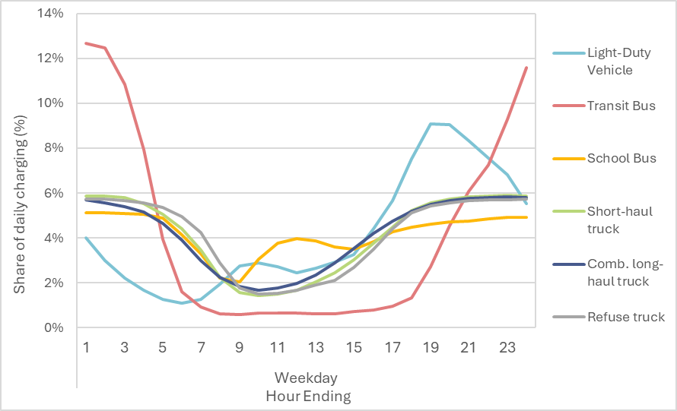

Figure 57. Default weekend charging patterns found in AVERT.

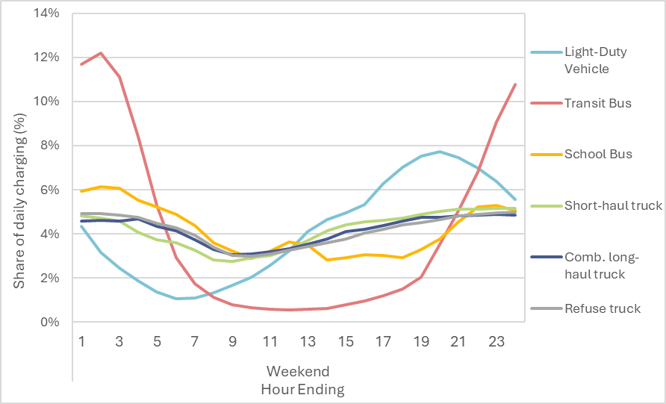

Users also have the option to input their own hourly charging profile for weekdays and weekends. The sum of all 24 hourly values must equal 100 percent.

In Table B, users specify the ratio of weekend to weekday energy consumption for each vehicle type. Based on data from ISO New England’s electric vehicle projection methodology, we assume that transit buses consume the same amount of electricity on weekdays as they do on weekends.[121] We assume on weekends that light-duty vehicles consume 97 percent the amount of energy they consume on weekdays. For school buses, we assume this ratio is 12 percent the amount of energy. All other vehicle types (e.g., short-haul trucks, combination long-haul trucks, and refuse trucks) on weekends consume 17 percent the amount of energy consumed on weekdays.

AVERT automatically estimates the total annual and monthly charging that will need to take place given the number of vehicles specified (see “Calculations” section below). It will then spread these total quantities over each hour based on the charging percentage information provided in this step.

#### Part II: Vehicle Composition

On the second part of this page, users can make further adjustments to the types of vehicles being modeled. Here, users can define things like the share of BEVs and PHEVs that are cars or trucks, or the share of modeled transit buses that use diesel or gasoline as a fuel. This selection modifies the modeled EV efficiencies (larger vehicles are generally larger and less efficient than smaller vehicles) and also modifies the emission rates modeled for the displaced ICE vehicles. Default data in this section is all derived from MOVES5. Figure 58below shows the selection screen on this page. Blue cells indicate values that can be modified by the user, and green cells indicate a sum of entered values. The white cells with black text on the right side of the figure indicate the estimated number of each vehicle type and fuel combination, given the number of vehicles entered by the user and the selected composition.

Figure 58. Default composition of vehicle subtypes in AVERT.

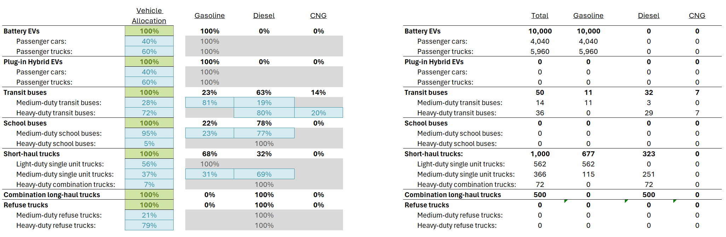

#### Part III: Model Year and ICE Replacement

On the third part of this page, users select a model year to analyze. In the first selectable parameter, EV model year, users can choose a year from 2024 to 2029. This parameter determines two things:

* The modeled EVs’ efficiencies. EVs are expected to become more efficient each year.[122]
* The ICE vehicles are subject to different emissions standards and thus, model year is an important input in determining the impact of EVs on different pollutants.

The default value is 2024.

The second selectable parameter, ICE vehicle being displaced, affects the emission rates of fossil fuel-powered vehicles only. There are two options:

* A selection of “New” will mean that the emission rates of displaced vehicles will be based on new vehicles from the specified EV model year. This selection suggests that new EVs will displace the same number of new fossil fuel-powered vehicles that would have otherwise been added to the vehicle fleet.
* A selection of “Existing” will mean that emission rates of displaced vehicles will be based on a weighted average of all vehicles that are on the road. This selection suggests that new EVs will replace the average existing vehicle.

Users should carefully consider which setting makes the most sense for their scenario. For most analyses, users will probably be best served by selecting “New,” as it allows users to perform a prospective analysis wherein some number of new EVs are purchased in lieu of some number of new fossil fuel-powered vehicles. The “Existing” setting is likely most useful for users who are interested in performing a comparison of their existing vehicle fleet with a future alternative featuring EVs. Users can easily toggle between these two vehicle parameters after a model run as they do not influence power sector load. The default value is “New.”

Users can also specify an ICE replacement rate. This parameter addresses the concept that some drivers of EVs may not drive as many miles with their EV as they might with an ICE vehicle. For example, if the EV has less range than a driver’s ICE vehicle, they might continue to use an ICE vehicle for longer trips. AVERT assumes a default rate of 100 percent, meaning that 100 percent of miles driven by an ICE vehicle are replaced with an EV. Users can modify this parameter if they have relevant data for their analyses. AVERT automatically applies the associated emission rates for the selected state or region, vehicle type, fuel type, modeled year, vintage, and replacement rate.

### Background Assumptions

AVERT uses a set of background assumptions to facilitate the calculation of EV emission impacts.

#### MOVES Modeling

EPA used MOVES to generate emission factors for fossil fuel-powered vehicles.[123] MOVES is an emission modeling system developed by EPA that estimates emissions for mobile sources at the national, county, and project level for criteria air pollutants, greenhouse gases, and air toxics. MOVES serves as EPA's repository of vehicle emission factors, drawing from five decades' worth of emission measurement on hundreds of thousands of vehicles. The model can combine these emission factors with vehicle activity (e.g., VMT, vehicle starts) and fleet characteristics (e.g., age distribution, speed distribution) to produce emissions estimates.

Within the AVERT context, EPA used MOVES to produce metrics related to VMT and total emissions across the following variables:

* States (48 contiguous states plus Washington, D.C.)[124]
* Vehicle type (passenger vehicles, transit buses, school buses, short-haul trucks, combination long-haul trucks, and refuse trucks)
* Fuel type (varies by vehicle type)
* Vehicle model year (the year the vehicle was made: 2023–2029)
* Vehicle age (new or fleet average)
* Modeling year (the year in which the analysis was conducted: 2023–2029)
* Modeling month (the month in which the analysis was conducted)

Reported metrics for each data item include:

* VMT by vehicle type
* Total emissions for CO2, NOX, SO2, PM2.5,[125] VOCs,[126] NH3

For each data item and each pollutant, emissions are divided by VMT to calculate emission rates measured in lb/mile.

MOVES5 was used to produce estimates of VMT by county.[127] These data are used to allocate displaced vehicle emissions to each county. See “Step 2: Set Energy Scenario” on page 29 for more information about how these locations are specified, and see the Calculations section below for how these county-level data are applied.

#### Other Modeling

AVERT incorporates a number of other assumptions to facilitate the calculations behind charging impacts and displaced vehicle emissions. All of these assumptions are found on AVERT’s Library tab. EPA generally recommends that users not modify these assumptions.

* Typical VMT per year: Based on data from MOVES, AVERT assumes that nationwide, each vehicle type travels a standard number of miles in each year, on a per-vehicle basis (see Table 10). Based on MOVES5 assumptions, these VMT per vehicle values do not change by region. However, AVERT adjusts VMT per vehicle values for passenger cars and passenger trucks to derive state- and region-specific values that account for variations in driving patterns in different parts of the U.S.[128]

Table 10. National average VMT for each vehicle type modeled in AVERT.

|  |  |  |
| --- | --- | --- |
| **Vehicle type** | **Vehicle sub-type** | **National average VMT per year per vehicle** |
| Light-duty vehicles | Passenger cars | 10,410 |
| Passenger trucks | 11,467 |
| Transit buses | Medium-duty transit buses | 31,838 |
| Heavy-duty transit buses | 32,432 |
| School buses | Medium-duty school buses | 10,182 |
| Heavy-duty school buses | 10,239 |
| Short-haul trucks | Light-duty single unit trucks | 12,177 |
| Medium-duty single unit trucks | 12,630 |
| Heavy-duty combination trucks | 44,021 |
| Comb. long-haul trucks | Heavy-duty combination trucks | 74,278 |
| Refuse trucks | Medium-duty refuse trucks | 18,921 |
| Heavy-duty refuse trucks | 18,960 |

* EV efficiency: AVERT describes EV efficiency in terms of kWh per VMT (i.e., the number of kWh required to travel one mile). AVERT assumes that EV efficiency improves each year as technology improves. AVERT uses different efficiencies for each vehicle type modeled. All data on EV efficiencies are derived from Argonne National Laboratory’s Autonomie model.[129]
* Percentage of PHEV miles driven on electricity: PHEVs can be driven using electricity stored in batteries or using a conventional fossil fuel-powered engine. AVERT assumes that 59 percent of PHEV miles are driven using electricity.[130] Different vehicles with different specifications related to range and utilization may see a different share of miles driven on electricity and gasoline.
* Climate adjustments: AVERT includes a single annual adjustment factor (from 0 to 8 percent) to account for average regional temperature differences relating to charging requirements. EVs driven in regions that are substantially warmer or colder than AVERT’s moderate-temperature baseline are expected to require more electricity.[131] Using climate data from EVI-Pro Lite, AVERT assigns each region a climate adjustment factor that increases the electricity required to drive a single mile (see Table 11).[132] The MOVES monthly emission rates reflect temperature impacts on ICE vehicle emission rates as well.

Table 11. Climate adjustments to charging requirements in AVERT regions.

|  |  |  |
| --- | --- | --- |
| **AVERT region** | **Local average temperature (°F)** | **Climate adjustment to charging requirements** |
| California | 68 | 100% |
| Carolinas | 68 | 100% |
| Central | 50/68 | 104% |
| Florida | 68/86 | 104% |
| Mid-Atlantic | 50 | 108% |
| Midwest | 50/68 | 104% |
| New England | 50 | 108% |
| New York | 50 | 108% |
| Northwest | 50/68 | 104% |
| Rocky Mountains | 50 | 108% |
| Southeast | 68 | 100% |
| Southwest | 68 | 100% |
| Tennessee | 68 | 100% |
| Texas | 68 | 100% |

## Calculations

This section describes how AVERT combines the above inputs and assumptions to estimate emission impacts in the power sector and from vehicles.

### Power Sector

Power sector impacts (measured in kWh) are first calculated on a monthly basis for each type of vehicle. Monthly impacts are then converted into hourly kWh impacts. AVERT combines these kWh impacts with other energy resources in the scenario and then calculates the generation and emission impacts from specific power plants.

Monthly kWh impact values are calculated as follows:

$$A=B×C×D×E×F$$

Where

**A** is monthly power sector impacts**.** Theseare the resultant kWh changes in demand due to EV charging in a given month.

**B** is the number of vehicles input by the user.

**C** is monthly VMT. This number is estimated by multiplying the typical VMT per year for that region by the percentage of annual miles traveled in a month.[133]

**D** is vehicle efficiency—the amount of electricity required to travel one mile (measured in kWh per mile traveled), adjusted for a region’s climate.

**E** is the fraction of miles driven on electricity. This fraction is 100 percent for BEVs and 59 percent for PHEVs.

**F** is the fraction of miles replaced with an EV. In AVERT, the default is 100 percent.

Next, these monthly kWh impacts are converted into daily impacts by calculating the number of weekday days and weekend days in each month. These data are combined with the ratio of charging that occurs on weekdays versus weekends to estimate the total kWh consumed for any one weekday and any one weekend day in each month.

Third, daily kWh impacts are converted to hourly impacts by allocating the daily kWh across a 24-hour period using the charging pattern specified by the user. This hourly kWh profile is then repeated for each weekday of the month, with a separate kWh profile applied to each weekend. Different profiles are repeated for each of the 12 months.

Finally, hourly impacts for all vehicle types are summed and combined with the other energy resources in the scenario (e.g., EE, RE). As a result, when users model the effect of EV deployments along with EE or RE measures, they may find that the aggregate impact on the power sector is an energy decrease in some or all hours (see Figure 59). The resultant profile is divided by one minus the T&D loss factor to estimate the total vehicle impacts on wholesale power sector generation.

Figure 59. Illustrative example of the combined impacts on marginal generation from EV charging and solar resources.

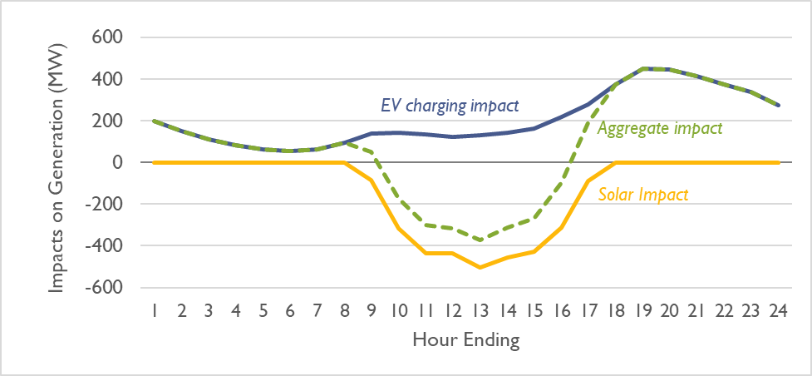

### Vehicles

Emission impacts from vehicles are calculated on a monthly basis for each type of vehicle. For the purposes of AVERT, “emission impacts from vehicles” refer to the impacts associated with emissions from vehicle tailpipes and other emissions closely related to the driving and fueling of vehicles, net of any emissions directly produced from electric vehicles.[134] Unlike power sector impacts, vehicle impacts are only calculated at a monthly level and are not calculated at a daily or hourly level.

Monthly vehicle impact values are calculated for as follows:

$$A=B×C×D×E×F$$

Where

**A** is monthly vehicle impacts. These are the resultant emission changes (in lb) due to avoided ICE vehicle usage (i.e., due to EV charging) in a given month, net of direct emissions from EVs (including PM emissions from brake wear and tire wear).

**B** is the number of vehicles input by the user.

**C** is the monthly VMT. This number is estimated by multiplying the typical VMT per year for that region by MOVES’ estimate of the percentage of annual miles traveled in a month.

**D** is the ICE vehicle emission rate, net of direct emissions from EVs (including PM emissions from brake wear and tire wear).. This is the emission rate derived from MOVES for the vehicle and fuel type being evaluated. This value changes depending on the state or region that has been selected.

**E** is the fraction of miles driven on electricity. This fraction is 100 percent for BEVs and 54 percent for PHEVs.

**F** is the fraction of miles replaced with an EV. In AVERT, the default is 100 percent.

AVERT repeats the above calculation for each vehicle and fuel type being modeled in a particular run. AVERT then repeats the calculation for each pollutant.

Each pollutant’s change in emissions is then summed and applied to each county. Each county receives a share of emission impacts commensurate with that county’s VMT relative to the aggregate VMT for the selected region. For example, if a user chooses to model emission impacts over the “Entire Region,” emission impacts will be distributed over the entire region, based on the VMT in all counties in that region (see Figure 59). If a user chooses to model emission impacts over just one state in the region, emission impacts will be distributed over the state’s counties that are within the selected AVERT region, based on the total VMT in all of the counties in that state in the selected AVERT region. This process is applied separately for each vehicle type (as VMT are distributed non-uniformly by type and county) and reported in AVERT’s outputs.

Figure 59. Formula for estimating VMT for a county in a selected region.

*County A (Annual VMT) in Region Y = $\sum_{Region Y}^{ }{{VMT}_{MOVES}}\frac{County A {VMT}_{NEI}}{\sum_{Region Y}^{ }{ {VMT}_{NEI} }}$*

## How to: Analyzing Emissions Impacts of Electric Vehicles

The AVERT EV module can help answer questions such as the following:

* What is the net emissions impact of adding a certain number of EVs in one year and displacing an equivalent number of ICE vehicles?
* What is the net emissions impact of adding EVs cumulatively over multiple years and displacing an equivalent number of ICE vehicles?
* How much EERE offsets the generation requirement of a certain number of EVs?
* How do vehicle charging profiles affect emissions changes?
* Where, at the county-level, are emissions changing due to vehicle charging and avoided ICE vehicle emissions?
* In which months do NOx emissions or other pollutant emissions vary?
* What are the ozone season implications of adding EVs?
* What are the emissions impacts of adding electric school buses or electric transit buses?
* How do emissions change across different vehicle types?

Other common EV questions are associated with AVERT, but require either data or tools external to AVERT:

* What are the health and associated economic impacts of increases in vehicle electrification?
* How can other existing GIS-based tools be used in coordination with AVERT results?

When considering the following examples, users should bear in mind the caveats and limitations as described in Appendix L, particularly those discussed in the EV sub-section. Note that the following examples are based on data modeled using 2021 RDFs in version v4.0 of AVERT. Screen captures and results may look different from the latest version of AVERT.

### Example 1: What is the impact of deploying 39,000 new battery-powered electric vehicles in 2022 in North Carolina?

1. What are the expected emissions changes from these BEVs?
2. In which months do NOx emissions vary?
3. How are emission changes distributed within each county?

#### Methodology

1. Open AVERT.
2. Load your region and baseline year of interest (in Example 1, Carolinas, 2021).
3. Choose the location of the EV deployment. For Example 1, choose North Carolina.
4. Enter the number of BEVs you would like to model. For Example 1, enter 39,000 BEVs (about 10 percent of annual vehicle sales in North Carolina in 2019). Use Table 1 in AVERT to assist if necessary (shown below as this document’s Table 12).

Table 12. AVERT Step 2: Set Energy Scenario, Table 1.

|  |  |  |
| --- | --- | --- |
| **Table 1. Sales and stock comparison** | **Percent of annual vehicle sales in North Carolina** | **Percent of registered vehicles in North Carolina** |
| Light-duty vehicles | 10.0% | 0.5% |
| Transit buses | 0.0% | 0.0% |
| School buses | 0.0% | 0.0% |

1. Enter the estimated amount of EERE expected to be added by 2022.
2. In this example, because you are starting with 2021 as a baseline year, add the amount of EE, onshore wind capacity, and utility solar PV capacity that is expected to be added in 2022. You can use Table 2 in AVERT (shown below as this document’s Table 13) to help develop the EERE portion of a scenario. Table 2 reports the average annual addition of EERE; it will adjust to the location of EV deployment.
   * 1. EE: Reduce each hour by constant MW: 138 MW
     2. Onshore wind capacity: 0 MW
     3. Utility solar PV capacity: 531 MW

Table 13. AVERT Step 2: Set Energy Scenario, Table 2.

|  |  |  |  |  |  |  |
| --- | --- | --- | --- | --- | --- | --- |
| **Table 2. EERE EV comparison for North Carolina** | **Historical additions (Annual avg. 2018–2020)** | | **EERE required to offset EV demand** | | **EERE required divided by historical additions** | |
|  | **MW** | **GWh** | **MW** | **GWh** | **MW** | **GWh** |
| EE (retail) | 138 | 1,211 | 12 | 103 | 8% | 8% |
| Onshore wind | 0 | 0 | - | - | - | - |
| Utility solar | 531 | 1,084 | 42 | 85 | 8% | 8% |
| Total | 681 | 2,393 | 53 | 188 | - | - |

1. Click “Next”; then, in Step 3, click “Click here to calculate changes to generation and emissions.”
2. In Step 4, analysts can select from a variety of pre-made summary tables, charts, and figures. To answer question **1a (“What are the expected emissions changes from these BEVs?”)**, click the green “Annual regional results—with vehicle” button. The resulting table is shown below as this document’s Table 14.

Table 14. Results for Example 1: Annual regional results, including vehicles.

|  |  |  |  |
| --- | --- | --- | --- |
|  | **From fossil generation** | **From vehicle** | **Net changes** |
| Total emission changes (lb) | | | |
| SO2 | -1,000,690 | -2,550 | -1,003,240 |
| NOx | -1,350,980 | -36,750 | -1,387,730 |
| CO2 | -3,068,879,630 | -384,206,390 | -3,453,086,020 |
| PM2.5 | -200,570 | -2,410 | -202,980 |
| VOCs | -83,920 | -73,970 | -157,890 |
| NH3 | -82,730 | -21,970 | -104,700 |

1. To answer question **1b (“In which months do NOX emissions vary?”)**, click the “Results by month” button in Step 4 (see button circled in red in Figure 61). Note that these results show both regional (AVERT Carolinas) power sector emissions changes and state-level vehicle emissions changes.

Figure 61. How to view results by month, including avoided vehicle transportation emissions.

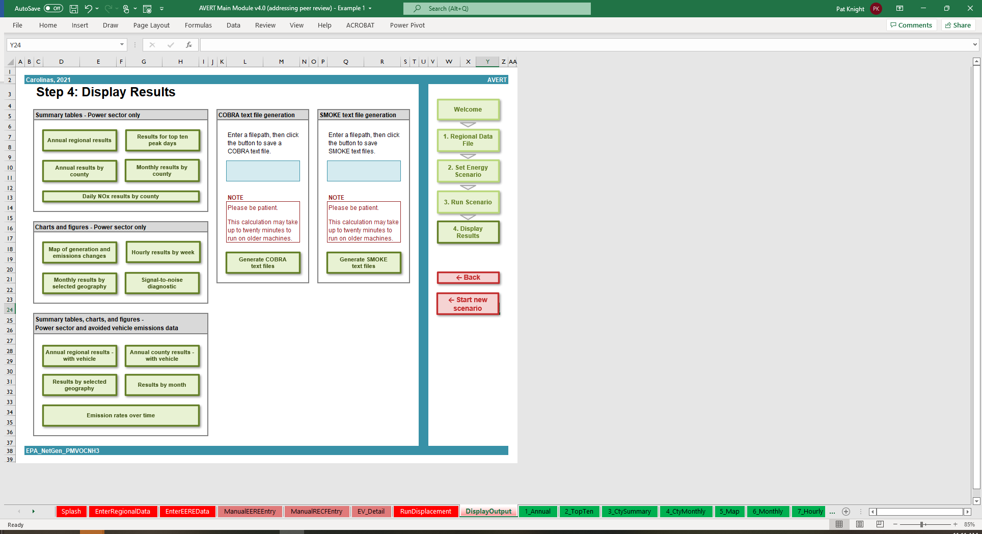

1. To answer question **1c** (**“How are the emission changes distributed in each county?”**), click the “Annual county results—with vehicle” button in Step 4. Analysts can use the filtering function to choose counties and pollutants of interest. For example, Table 15 shows the results for Mecklenburg County, North Carolina.

Table 15. Results for Example 1: Annual results by county, including vehicles.

|  |  |  |  |  |  |  |
| --- | --- | --- | --- | --- | --- | --- |
| **State** | **County** | **FIPS code** | **Pollutant** | **From fossil generation** | **From vehicles** | **Net changes** |
| NC | Mecklenburg County | 37119 | SO2 (lb) | 0 | -270 | -270 |
| NC | Mecklenburg County | 37119 | NOX (lb) | 0 | -3,930 | -3,930 |
| NC | Mecklenburg County | 37119 | CO2 (tons) | 0 | -20,210 | -20,210 |
| NC | Mecklenburg County | 37119 | PM2.5 (lb) | 0 | -260 | -260 |
| NC | Mecklenburg County | 37119 | VOCs (lb) | 0 | -7,910 | -7,910 |
| NC | Mecklenburg County | 37119 | NH3 (lb) | 0 | -2,340 | -2,340 |

Note that in this example, Mecklenburg County shows no emission changes from fossil generation, but an amount of emission changes from vehicles. In every AVERT region there are counties, like Mecklenburg County, that do not have any emitting EGUs (this means that in these counties there are no EGUs per EPA’s Power Sector Emissions Database). This means that scenario results will not show increases or decreases in emissions from fossil generation in those counties. However, all counties will receive some, if small, amount emissions benefits from vehicles when EV scenarios are run. Users will observe that counties with more of the region or state’s VMT will see the largest benefits. In AVERT, changes to vehicle emissions are first allocated for the selected state or region, and then allocated to each county, proportional to VMT.[135]

### Example 2: What if Florida were evaluating the impacts of a proposed policy that increased the sales of electric vehicles by 5 percent each year from 2022 to 2024?

(EV sales are 5 percent of total vehicle sales in 2022, 10 percent in 2023, and 15 percent in 2024.)

1. What are the cumulative emissions changes in 2024?
2. What are the health impacts of Florida’s EVs in 2024?

#### Methodology

1. Open AVERT.
2. Load your region and baseline year of interest (in Example 2, Florida, 2021).
3. Develop three single-year scenarios following the methodology described in Example 1. (EPA suggests creating three separate files and saving them individually.) Table 16 describes the inputs for the three scenarios in this example.

Table 16. Inputs for Example 2.

|  |  |  |  |
| --- | --- | --- | --- |
| **Scenario** | A | B | C |
| **Modeled year** | 2022 | 2023 | 2024 |
| **EV sales percentages** | 5% | 10% | 15% |
| **BEVs** | 58,000 (EVs deployed in 2022) | 174,000 (58,000 EVs deployed in 2022 plus 116,000 EVs deployed in 2023) | 348,000 (174,000 EVs deployed in 2022 and 2023 plus 174,000 EVs deployed in 2024) |
| **EE** | 34 | 68 | 102 |
| **Onshore wind** | 0 | 0 | 0 |
| **Utility PV solar** | 1,062 | 2,124 | 3,186 |

In Scenario C, in certain hours, the load change is greater than the 15 percent guideline suggested by AVERT. For this example, these warnings can be ignored because hours exceeding this 15 percent guideline make up fewer than 2 percent of hours, and no single displacement is larger than 21 percent of hourly load. Including these hours is unlikely to substantially impact annual-level results.

1. Run the three single-year scenarios, saving each one as a separate file. Each file represents the emissions changes in that year, relative to 2021.
2. To answer question 2a (“What are the cumulative emissions changes in 2024?”), click the “Annual regional results—with vehicle” button and sum the “net changes” from each of the three files.
3. To answer question 2b (“What are the health and associated economic impacts of Florida’s EVs in 2024?”), perform a series of steps using EPA’s COBRA model.
4. First, during Step 4 in AVERT, generate a COBRA CSV file for each of the three AVERT scenarios. Each one will be automatically named “COBRA.csv,” so you may want to rename the files to something more helpful in File Explorer or Finder (e.g., “COBRA_Florida_ScenarioA_Inputs.csv”).
5. Download and install the [COBRA model](https://www.epa.gov/cobra), if you have not already.
6. Open COBRA. Perform an analysis for each CSV file, using 2023 as a baseline year and a 3 percent discount rate.[136]
7. Export the COBRA results from each scenario. Open a separate document in Excel, import the results of the three scenarios, and add the results of the three datasets together. Table 17 shows the results of each of the scenarios, as well as the combined impacts, with a focus on total monetized health benefits (low). You can view many other monetized and non-monetized benefits in the COBRA results.

Table 17. COBRA results for Example 2.

|  |  |  |  |  |
| --- | --- | --- | --- | --- |
| **Scenario** | A | B | C | A, B, and C |
| **Modeled year** | 2022 | 2023 | 2024 | Three-year cumulative benefits |
| **Total monetized health benefits, low**  ***(2017 $ million)*** | $24 | $46 | $65 | $136 |

#### Caveats

* Certain health impacts and monetized benefits reflect future benefits (beyond 2024) from avoided deaths.
* Health impacts and monetized benefits reflect only reduced PM2.5. They do not include the impact of ground-level ozone or a price on carbon.

### Example 3: How might different charging profiles for transit buses affect emissions from additional electric vehicles in New York?

1. How do total annual benefits change when a charging profile changes?
2. How do emissions change when transit buses of different fuel types are displaced?

#### Methodology

1. Open AVERT.
2. Load your region and baseline year of interest (in Example 3, New York, 2021).
3. Develop two scenarios following the methodology described in Example 1. (EPA suggests creating two separate files and saving them individually.) Table 18 describes the inputs for the two scenarios.

Table 18. Inputs for Example 3.

|  |  |  |
| --- | --- | --- |
| **Scenario** | A | B |
| **Modeled year** | 2022 | 2022 |
| **Electric transit buses** | 600 | 600 |
| **Charging profile** | Bus | Manual |
| **EE** | 245 | 245 |
| **Onshore wind** | 53 | 53 |
| **Utility PV solar** | 142 | 142 |

1. Next, select a charging profile for your two scenarios. Click on the green button labeled “View detailed EV data.” Modify the parameters in Table A and Table B:
2. For Scenario A, select the “Bus” charging profile in Table A. This is the default bus charging pattern, which models buses being charged primarily overnight.
3. For Scenario B, select “Manual” in Table A, and then enter a charging profile in Table B. In this example, you can enter the charging profile described in Table 19, which describes a situation where half of bus charging occurs overnight, and the other half in mid-day, between the morning and evening rush hours.[137] Copy and paste this same charging profile for both weekdays and weekends (for transit buses, the default “bus” profile used is identical for both weekdays and weekends).

Table 19. Manual charging inputs for Example 3B.

|  |  |
| --- | --- |
| **Hour ending** | **Percent charging** |
| 1 | 11% |
| 2 | 8% |
| 3 | 5% |
| 4 | 3% |
| 5 | 2% |
| 6 | 1% |
| 7 | 1% |
| 8 | 1% |
| 9 | 2% |
| 10 | 3% |
| 11 | 5% |
| 12 | 8% |
| 13 | 11% |
| 14 | 8% |
| 15 | 5% |
| 16 | 3% |
| 17 | 2% |
| 18 | 1% |
| 19 | 1% |
| 20 | 1% |
| 21 | 2% |
| 22 | 3% |
| 23 | 5% |
| 24 | 8% |

1. Run the two single-year scenarios, saving each one as a separate file.
2. To answer **3a** (**“How do total annual benefits change when a charging profile changes?”**), click the “Annual regional results—with vehicle” button and compare the “Net Changes” from each of the two files. Table 20 compares a subset of the results, focused on NOx emissions. Between the two scenarios, Scenario B, which includes larger amounts of daytime charging, produces 1,070 fewer short tons of power sector NOx emissions.

Table 20. Outputs for Example 3, annual regional results, including vehicles, NOx emissions (lb).

|  |  |  |  |
| --- | --- | --- | --- |
| **Scenario** | **From**  **fossil generation** | **From**  **vehicles** | **Net changes** |
| Scenario A | -972,350 | -58,320 | -1,030,670 |
| Scenario B | -971,280 | -58,320 | -1,029,600 |
| Scenario A less Scenario B | -1,070 | 0 | -1,070 |

1. The vehicle emissions reductions results shown above in Table 17 are calculated assuming that the vehicles that EV buses displace resemble the current fleet of transit buses in New York—in this case, 79 percent diesel, 7 percent CNG, and 15 percent gasoline. Users may also be interested in evaluating scenarios targeting different fuel types.
2. To answer **3b** (**“How do emissions change when transit buses of different fuel types are displaced?”**), users do not need to rerun AVERT, and can modify bus fuel types by returning to the **EV Detailed Inputs** page by either navigating by tabs or returning to **Step 2** and clicking “View detailed EV data.”
3. To evaluate a scenario where all displaced buses are diesel buses, users would first navigate to the “View detailed EV data” page and then to “Part II. Vehicle Composition.” Here, users should set the percentage associated with diesel transit buses to 100 percent, and gasoline and CNG to 0 percent. Users should review “Part III. Model and Year and ICE Replacement” within the **EV Detailed Inputs** page to ensure vehicle replacement type aligns with the intended model year and age. At this point, you may wish to save this file as “Scenario C”.
4. To view results, navigate to the page titled, “Annual Regional Results, Including Vehicles” either by clicking the tab named “10_Vehicle”[138] or by clicking through Step 2 and Step 3 in the Main Module.[139]

Table 21 shows that Scenario C, which assumes that EV buses only replace diesel buses, displaces 11,290 more lb of NOX emitted from buses compared with Scenario B, which assumes that EV buses displace a mix of different bus types.

Table 21. Outputs for Example 3, annual regional results, including vehicles, NOX emissions (lb).

|  |  |  |  |
| --- | --- | --- | --- |
| **Scenario** | **From fossil generation** | **From vehicles** | **Net changes** |
| Scenario B | -971,280 | -58,320 | -1,029,600 |
| Scenario C | -971,280 | -69,610 | -1,040,890 |
| Scenario B less Scenario C | 0 | 11,290 | 11,290 |

Appendix K: Energy Storage in AVERT

## Inputs and Assumptions

This appendix describes the user-modifiable inputs and background assumptions found in AVERT related to modeling energy storage. The end of this appendix presents practical examples demonstrating how analysts can use AVERT to answer questions about the emission impacts of energy storage projects, policies, and programs. Energy storage can help shift fossil generation on the grid by charging during low-cost (often low-demand) hours and discharging that captured energy during high-cost (often high-demand) periods. Like EERE and EVs, energy storage is treated as an energy resource in AVERT, so analysts can include EERE, EVs, and energy storage together in the same scenario. Due to losses associated with roundtrip efficiency with energy storage technologies (the processes of charging, storing, and then discharging energy), modeling energy storage with no added EERE resources will result in a net increase in required fossil generation on the grid.

AVERT includes default assumptions for several parameters to help users complete energy storage analyses more easily. These assumptions are easy to edit if scenario-specific information is available.

Some users may choose only to interact with the primary inputs, described in **Step 2:** **Set Energy Scenario** (see page 28). More advanced users may wish to modify the default settings in the detailed inputs described here.

### Energy Storage Detailed Inputs – Excel Main Module Only

In **Step 2: Set Energy Scenario** in the Main Module, users may click the “View detailed energy storage data” button. This will bring users to a page called “Energy Storage Detailed Inputs.” On this page, users can modify the default settings of more advanced inputs. This page is separated into three different parts: Part I. Charging Profiles, Part II. Charging Characteristics, and Part III. Input Validation.

#### Part I. Charging Profiles

Part I is separated into two tables to help the user set the 24-hour charging profile and the days and months in which they wish to allow the energy storage to discharge. Table A shows the hourly configurations for the default overnight charging and midday charging profiles. Each charging profile is defined on a 24-hour basis, where in each hour the energy storage is defined to be charging, discharging, or idle. For example, if the hour ending in 9 is set to “charging,” it would mean the battery charges from 8:01 a.m. to 9:00 a.m. These default patterns are based on the energy storage duration chosen by the user in **Step 2** of the Main Module. For example, if the user selects a duration of four hours, these default patterns will each model four hours of charging and four hours of discharging.[140] In Table A, users can also define a manual charging profile.

The user selects which of the three profiles to model in **Step 2** of the Main Module. If the user selects the manual profile, the duration of the energy storage resource is defined by the actual number of charging and discharging hours entered by the user in the manual profile, which will override the duration set in **Step 2**.

In Table B, users can specify if they want to apply the charging profile to weekends, weekdays, and specific months. If the user selects "no” for a specific month or type of day, energy storage will not be modeled (e.g., will not be charged or discharged) for those days. Note that discharge cycles falling in a restricted day or month are not “reassigned.” This means that the number of discharge cycles may actually be lower than the entered value in Table C (described below).

#### Part II. Charging Characteristics

In Part II of this page, users can modify additional performance specifications. In Table C, users can select the maximum allowable number of discharge cycles to model.[141] This input limits the number of days in the year on which the energy storage resource will dispatch. To determine which days to dispatch the resource, AVERT ranks all days in the year by their fossil generation, from highest to lowest, and dispatches the resource on the days with the highest fossil generation. The default is set to 150 days, based on a 2022 performance assessment of energy storage conducted by PNNL.[142]

The other modifiable parameters in this part of the page are RTE and DoD. RTE represents the ratio of energy stored to energy discharged, accounting for losses due to inefficiencies within the storage resource (i.e., not inclusive of transmission and distribution losses). DoD represents the percent of the maximum storage capacity that is able to discharge. Energy storage resources typically do not charge and discharge their full potential capacity, in order to preserve the longevity of the resource. The default DoD value is set to 80 percent, based on PNNL’s 2022 performance assessment.[143] The default RTE value is set to 85 percent, based on a 2019 study of utility-scale battery storage conducted by NREL.[144] AVERT applies RTE and DoD to the maximum theoretical energy (MWh) the energy resources can store, based on the capacity and duration entered by the user in **Step 2** of the Main Module, to determine real-world charging and discharging characteristics (see “Calculations” section below).

#### Part III. Input Validation

The third part of this page combines the parameters entered above and in **Step 2** of the Main Module to calculate the resulting 24-hour charging profile in terms of the percent of total daily charging or discharging that occurs in each hour. There are no user inputs in this section. Table D calculates the percentage of total charging that occurs in each charging hour, for each of the three charging patterns (overnight charging, midday charging, and manual), defined as 1 divided by duration. Table D also calculates the percentage of discharging that occurs in each discharging hour, defined as -1 divided by duration, multiplied by RTE to account for efficiency losses.

Table E shows the resulting percentage of charging and discharging that will occur in each hour in the 24-hour charging pattern, for each of the three charging patterns, modeled using the inputs from Table A and Table D.

Finally, Table F is used to check whether the manual profile specified by the user will produce a modeling error. The manual profile will yield an error if the ratio of discharging to charging hours specified is such that there are not enough discharging hours to allow the system to fully discharge. The maximum allowable rate of discharge is constrained by the rated capacity (i.e., the user-defined MW) of the system. If Table F displays a “Yes”, indicating a discharge error, the user should increase the number of discharge hours specified in the manual profile in Table A.

### Background Assumptions

AVERT uses a set of background assumptions to facilitate the calculation of energy storage emission impacts.

* Energy storage technology: AVERT models all energy storage as being lithium-ion battery storage. Lithium-ion batteries make up a significant majority of energy storage installed since 2012.[145],[146] Other batteries have different typical characteristics, such as their typical duration, DoD, RTE, and number of days discharged in a year. When modifying AVERT’s default parameter values, we generally recommend considering the real-world characteristics of energy storage technologies commonly seen in literature. For example, PNNL’s 2022 performance assessment offers the characterizations of a number of other storage technologies.[147]
* Charging and discharging patterns: AVERT makes several assumptions about storage charging profiles:
* AVERT currently can only model a 24-hour charging cycle. Long-duration storage (e.g., storage with a discharge period of greater than 12 hours) cannot be modeled. AVERT applies the same 24-hour charging cycle in all days of the year in which storage is being modeled.
* In the default overnight charging and midday charging profiles, systems are assumed to both charge and discharge for the duration specified by the user. For example, if the duration is set to two hours, the default profiles assume the system will charge for two hours and discharge for two hours. These profiles are prescriptive to the hour, so the same hours will charge and discharge over the number of cycles selected. In reality, charging and discharging may vary over different hours from day to day and may charge and discharge for less than an hour at times.
* AVERT assumes the rate of charging is the same in all charging hours, with no ramp up or ramp down time.[148] In reality, the rate of charging over the charging period is likely not linear. The same assumption applies for the rate of discharge.

## Calculations

This section describes how AVERT combines the above inputs and assumptions to estimate emission impacts on the grid from energy storage. Grid impacts (measured in MWh) are calculated differently depending on whether energy storage is modeled with paired solar PV or not. Further, when modeling paired solar, the grid impact calculation is different depending on the availability of solar PV generation in each hour and in each day. This section examines four different example scenarios:

* Energy storage with no paired solar
* Energy storage with paired solar; solar exceeds charging needs
* Energy storage with paired solar; solar is less than charging needs
* Energy storage with paired solar; solar is less than charging needs in some hours but more than enough overall

### Energy Storage with No Paired Solar

For standalone energy storage, energy impacts (measured in MWh) are first calculated for the 24-hour charging cycle of the energy storage system. AVERT then determines which days in the year to apply this 24-hour charging cycle to. AVERT combines these MWh impacts with other energy resources in the scenario and then calculates the generation and emission impacts from specific power plants.

AVERT calculates 24-hour MWh impact values as follows:

* AVERT first calculates the effective energy storage capacity (in MWh) of the system, by multiplying the total rated energy storage capacity calculated in **Step 2** of the Main Module by the system DoD. AVERT then calculates hourly impact values by multiplying this value by the hourly charging and discharging fractions calculated in Table E of the “Energy Storage Detailed Inputs” page, for the charging pattern selected by the user in **Step 2** of the Main Module (overnight charging, midday charging, or the manual profile). The resulting values represent the energy stored or discharged in each hour of the 24-hour cycle.
* AVERT next determines which days to model with this 24-hour charging cycle, based on the “maximum allowable discharge cycles per year” set by the user on the “Energy Storage Detailed Inputs” page. AVERT sorts the total daily fossil generation (MW) of the region (before any user-input modifications to the load are applied) from highest to lowest, and flags the top days for the number of days specified by the user. AVERT identifies additional days to exclude if the user has opted to exclude weekends, weekdays, or specific months in Table B on the “Energy Storage Detailed Inputs” page. Therefore, the number of cycles may be less than the maximum number of cycles entered into Table C.
* Finally, AVERT applies this 24-hour cycle to the appropriate days flagged to be modeled, in order to create the energy storage MWh impact profile for the entire year. Distributed energy storage profiles are divided by one minus the T&D loss factor to estimate the total energy storage impacts on wholesale power sector generation. Distributed and utility-scale energy storage hourly impacts are combined with the other energy resources in the scenario (e.g., EERE, EVs). As a result, when users model the effect of energy storage along with other energy resources, they may find that the aggregate impact on the power sector is an energy decrease in some or all hours (see Figure 58). If users model the effect of energy storage and no other added energy resources, the impact on the power sector will always be a net energy increase, due to the RTE losses of energy storage systems.

### Energy Storage with Paired Solar (PV-Plus-Storage)

When modeling energy storage as being paired with solar, the amount of energy that the system can store is limited by the amount of generation available from user-entered PV during the storage system’s charging period. 24-hour MWh impact values are calculated as described above (“Energy storage with no paired solar” section), and then modified to adjust for solar availability, depending on whether or not the available solar generation is enough to meet the charging demand of the system. Energy storage impacts are calculated separately for distributed and utility-scale energy storage. AVERT compares distributed storage against the rooftop solar PV modeled by the user, and compares utility-scale storage against the utility solar PV modeled by the user. The rest of this section examines the three situations that can arise as a result of differing levels of solar generation availability.

#### Solar Exceeds Charging Needs

This scenario describes how 24-hour impacts are calculated for a day in which solar PV generation exceeds charging demand in every hour where charging occurs. AVERT sums the total charging (in MWh) desired by the system in a 24-hour charging cycle, as calculated above. AVERT then sums the total available MWh generation of solar PV during the charging hours of the energy storage system. If the sum of the available solar generation is greater than the sum of the desired charging (as this scenario describes), the system is able to charge and discharge exactly as demanded, and the resulting 24-hour hourly impacts from the energy storage resource follow the rules described in the “Energy Storage with No Paired Solar” section above. Additionally, any excess solar generation occurring in either charging or discharging hours are “exported to the grid” and added the Energy Impact Profile.

#### Solar Is Less Than Charging Needs

This scenario describes how hourly impacts are calculated for a day in which solar PV generation is less than the charging demanded by the energy storage system. As above, AVERT sums the total charging (in MWh) desired by the system in a 24-hour charging cycle, and compares this against the sum of the total available MWh generation of solar PV during the charging hours of the energy storage system. In this scenario, upon finding that the available solar generation is less than the desired charging, AVERT sets each hour of charging to equal the available solar PV generation (in MWh), because the system cannot charge more than this amount. For the discharging hours in this day, AVERT prorates the desired discharging amount by the ratio of actual total charging allowed to demanded charging.

#### Solar Is Less Than Charging Needs in Some Charging Hours but More Than Enough Overall

This scenario describes how hourly impacts are calculated for a day in which solar PV generation is less than the charging demanded by the energy storage in at least one “charging hour,” but the sum of available solar PV generation across all charging hours in the day is enough to supply the total charging demanded in the day. (Recall that the number of “charging hours” is defined by the duration—2, 4, 6, or 8 hours—and in shorter duration paired resources there will be solar generation in *non-charging hours* not available to charge the battery*.*) In this scenario, AVERT sets each hour of charging equal to the available solar PV generation (in MWh), up to the point where total daily charging equals the total charging demanded in the day. Because the total energy charged is sufficient, the system is able to discharge exactly as demanded, and discharge hours remain identical to those described in the “Energy Storage with No Paired Solar” section.

Appendix L: Caveats and Limitations

## Caveats and Limitations: Power Sector

* **Snapshot analysis:** AVERT provides a representation of the dynamics of electricity dispatch (i.e., which EGUs are put into operation in which hours) in a historical base year. However, it does not model changes in dispatch due to transmission resources, fuel prices, emissions allowances, demand for electricity, or the variable running cost of individual EGUs.[149] The use of AVERT to estimate forward-looking dispatch decisions is made more difficult when there are changes to the electrical grid (e.g., new transmission resources, EGU retirements, pollution control retrofits, or new EGUs), commodity prices (such as fuel or emissions allowances), or operational restrictions (e.g., “reliability must run” designations, curtailment due to new emissions caps). AVERT characterizes EGU retirements, pollution control retrofits, and new EGUs in its Future Year Scenario Template, but the scenarios created are only as good as the user’s predictions of future conditions.
* **No explicit ramping or cycling:** AVERT does not model changes in ramping (periods when EGUs are changing to a new generation level) and cycling (fluctuating generation levels) behavior resulting from energy policies, retirements, environmental controls, or new EGUs.[150] AVERT does not capture the changes in the frequency of ramping and cycling of fossil-fuel EGUs that can result from variability in wind- and sun-powered generation. In addition, it does not capture the ability of slow- or fast-cycling plants to respond to hour-to-hour changes in demand.
* **Average outcome:** AVERT generates an average outcome for each EGU, rather than a specific and precise trajectory. The default RDFs produce generation and emissions levels that are averaged across thousands of hypothetical scenarios of a recent past year. These levels are the statistically expected outcome, and should not be mistaken for an assertion of what did happen in a past year or what will happen in a future year.
* **Limited resolution for generation:** AVERT estimates regional changes in emissions. To do so it predicts the most likely generation levels for individual EGUs given a particular regional fossil-fuel load level and the most likely emission rates for individual EGUs given a particular generation level. Results at the individual EGU level (and for counties containing small numbers of EGUs) have very limited “resolution”; the accuracy of the results is limited at small spatial and temporal scales.
* **Limited ability to capture impacts related to for energy policies with small MW inputs:** Due to the precision limitations within AVERT, when analyzing smaller-scale energy programs, AVERT may return a higher level of “noise” in the changes in emissions. With small inputs, users may notice a divergence between desired changes in generation and modeled changes in generation. Small changes may be overwhelmed by random effects, such as historical non-economic forced outages and weather events. Users are encouraged to use emission rates pre-generated from AVERT for small-scale projects.[151] There is no specific limit on the smallest project that can or should be reviewed in AVERT, but users should be aware that modeling very small energy polices may produce answers that are within the rounding errors of the tool.[152] For additional guidance on modeling small energy projects or policies, see Appendix H. For guidance on how to interpret the noise in the results (particularly for small programs) see the text related to “Signal-to-noise diagnostic” on page 49.
* **Limited ability to capture dispatch implications of very large energy policies:** AVERT is designed to model marginal changes in system demand. Very large-scale energy projects or programs may fundamentally change the way in which dispatchers operate a system. In particular, there is little precedent in the United States for understanding how high penetrations of variable renewable resources (such as wind and solar) impact other EGUs in a system. In some cases, very high penetrations of these resources may result in patterns that are not often observed in the historical dataset, such as the curtailment of slower-cycling coal plants or an increase in the dispatch of fast-cycling peaking plants to smooth irregularities.[153] Appendix H discusses reasonable maximum levels of load change for the purposes of obtaining useful results from AVERT.
* **Precision of results:** AVERT reports results rounded to the nearest 10 units (i.e., MWh, lb of PM2.5, SO2, NOx, or tons[154] of CO2). In general terms, users should consider the number of significant figures in their specified MW load change, and limit their use of AVERT results to that number of significant figures.
* **Non-communicating regions:** AVERT models one region at a time, assuming that each region generates sufficient electricity to meet its own requirements; imports and exports of electricity between regions are assumed to stay constant with changing load requirements. Similarly, changes to emissions are restricted to the confines of the AVERT region selected for the analysis. The basis of this assumption is that analyses on smaller-sized regions would risk missing important interdependencies between EGUs across larger, well-integrated regions. Using yet larger regions than those in AVERT, however, would spread the influence of load changes too widely, making it difficult to ascribe load changes to particular EGUs.
* **Unconstrained transmission:** AVERT looks at the dynamics of each region as a whole regardless of transmission constraints.[155] The model represents how the regional electricity system actually operated in the base year given the existing transmission infrastructure, but is completely insensitive to the physical location within a region of new resources or demand change resulting from energy policies, as well as to the location within a region of retirements, environmental retrofits, and new EGUs modeled in the Future Year Scenario Template. In contrast, actual electricity dispatch decisions may be quite sensitive to the specific locations of resources, including (but not limited to) whether renewable resources are located close to consumers (at “load center”) or in sparsely populated areas.
* **Limited capture of individual EGU dynamics:** Fossil-fuel EGUs, especially those using steam cycles, tend to operate at higher efficiencies and with lower emission rates while in steady-state operation at or near their maximum output (although NOx emissions in particular may be exacerbated by high-output operations). The AVERT approach does account for emission rates appropriate to different levels of generation (which may be associated with periods of fast-ramping or cycling by fossil-fuel EGUs), but does not account for inefficiencies that may be associated with rapid cycling.
* **Limited energy storage charging profiles:** AVERT currently can only model a 24-hour charging cycle and cannot model long-duration storage with a discharge period of greater than 12 hours. In the default charging profiles, systems are assumed to charge and discharge for the same amount of time, assuming the rate of charging is the same in all charging hours. For more details on these limitations, see Appendix K.
* **Infrequent emission events for SO2:** In some limited circumstances, infrequent extreme emission events may be over-represented in the AVERT dataset. For example, instances during which an EGU switches from one fuel to another (e.g., from natural gas to oil), or EGU equipment experiences malfunctions, may cause SO2 emission rates for one or more hours to be hundreds or thousands of times higher than emission rates in other hours with similar levels of generation.[156] Under these conditions, SO2 emission rates produced by AVERT may appear different than they might otherwise be expected to, given the low prevalence of these anomalous-emission hours. These unusual emission rates appear only in certain years, at certain EGUs within a limited number of AVERT regions, and only for SO2 (one of the four pollutants reported in AVERT). Depending on the region and year, these high emission rates produce annual total SO2 emissions -13 percent to 188 percent different from actual observed emissions. Known instances of this issue include:
* 4 EGUs (of 184) in the 2024 New York RDF
* 1 EGU (of 197) in the 2024 Southeast RDF
* 2 EGUs (of 139) in the 2024 Carolinas RDF
* 1 EGU (of 187) in the 2024 Florida RDF
* 1 EGU (of 603) in the 2024 Mid-Atlantic RDF
* 2 EGUs (of 189) in the 2023 New York RDF
* 1 EGU (of 144) in the 2023 Carolinas RDF
* 2 EGUs (of 191) in the 2023 Florida RDF
* 1 EGU (of 617) in the 2023 Mid-Atlantic RDF
* 1 EGU (of 225) in the 2022 New York RDF
* 3 EGUs (of 215) in the 2022 Southeast RDF
* 5 EGUs (of 192) in the 2022 Florida RDF
* 1 EGU (of 127) in the 2022 Southwest RDF
* 1 EGU (of 189) in the 2021 Florida RDF
* 4 EGUs (of 228) in the 2021 New York RDF
* 1 EGU (of 260) in the 2020 California RDF
* 1 EGU (of 152) in the 2020 Carolinas RDF
* 1 EGU (of 190) in the 2020 Florida RDF
* 8 EGUs (of 223) in the 2020 New York RDF
* 1 EGU (of 200) in the 2020 Southeast RDF
* 9 EGUs (of 203) in the 2019 New York RDF
* 1 EGU (of 213) in the 2019 Southeast RDF
* 1 EGU (of 132) in the 2018 New England RDF
* 1 EGU (of 222) in the 2018 New York RDF
* 5 EGUs (of 227) in the 2018 Southeast RDF
* 6 EGUs (of 205) in the 2017 New York RDF
* 4 EGUs (of 207) in the 2017 Southeast RDF

To account for these infrequent emission events, AVERT outputs are modified to not report the marginal SO2 emissions for those EGUs affected by infrequent emission events. This conservative modification ensures that AVERT does not overstate the SO2 emissions impacts from EERE or EVs. Additionally, for the regions and years above, regional SO2 total emissions are based on actual reported emissions (CAMD data) rather than AVERT’s modeled data. EPA is currently evaluating approaches to improve the modeling of units with infrequent events for future versions of AVERT.

## Caveats and Limitations: Modeling Electric Vehicles

The following section describes several key limitations and caveats to using AVERT to estimate emissions associated with EVs.

* **Time horizon:** AVERT provides estimates of changes in emissions in a single, near-term year that is assumed to be taking place within five years of the selected RDF. It does not provide estimates of emissions over the lifetime an EV may operate. Over a longer period of time, electric sector emissions associated with EV charging may decrease as the grid continues to become cleaner. For more information, see the FAQ section titled “Electric Vehicles” on page 109.
* **Lifecycle:** At this time, AVERT only addresses vehicle emissions associated with combustion and evaporation of volatile chemicals from vehicles during refueling and nonuse. AVERT does not account for lifecycle emissions (e.g., those related to upstream fuel production and transportation, upstream manufacturing, or downstream reclamation). For more information, see the FAQ section titled “Electric Vehicles” on page 109.
* **Distribution of vehicle emission changes:** AVERT assumes that changes in ICE vehicle emissions (e.g., from tailpipes and associated vehicle emission sources) are allocated across counties in the modeled AVERT region in line with historical VMT in that county. For example, if a county represents 1 percent of historical VMT relative to total VMT in the entire AVERT region, that county will be allocated 1 percent of avoided emissions from ICE vehicles. In reality, this allocation may be different as some counties may see near-term penetration of EVs that does not match this proportional VMT assignment (e.g., for reasons related to demographics or charging station accessibility). However, because counties are likely to be similar geographically to the typical area an EV drives in the course of a day, we expect this allocation to be a reasonable representation.
* **Climate adjustments:** AVERT assumes that EV efficiencies decrease when vehicles are driven in warmer- or colder-than-average temperature conditions. This assumption is applied at a regional and annual level. In other words, a single factor changes the charging efficiency for a given region based on its annual difference in temperature from AVERT’s baseline temperature conditions. Future versions of AVERT may modify vehicle efficiencies based on weather using more specific regional data, or may modify vehicle efficiencies on a month-to-month basis rather than using a single annual value.
* **Future marginal emission rates:** The page “Reference: Modeled Marginal Emission Rates Over Time” displays region-specific projections for two different kinds of marginal emission rates, both from NREL’s Cambium data set. Users interested in projections of marginal emission rates may wish to consult with other regional estimates published by Independent System Operators (ISOs) or Regional Transmission Organizations (RTOs), utilities, regulators, state energy agencies, or other organizations.
* **Mobile source regulatory analyses:** AVERT may not be used for mobile source regulatory analyses, including SIP and transportation conformity analyses. Consult the most recent EPA guidance document for applying EPA’s MOVES model at: <https://www.epa.gov/moves/latest-version-motor-vehicle-emission-simulator-moves>.
* **MOVES:** MOVES predicts average emissions by vehicle class in a given model year, based on average operation and activity levels. It does not estimate vehicle or manufacturer-specific emissions, or consider driving patterns of individual drivers. Emissions for displaced "existing" vehicles are based on average emissions of vehicles aged 0–40, weighted by vehicle age. These emissions may vary substantially from specific model years that some programs might target for displacement. For more information about MOVES, see: <https://www.epa.gov/moves>.

Appendix M: Version History

EPA has added several enhancements to AVERT since the first release in 2014. Table 19 catalogs the version history of AVERT in reverse chronological order and notes key changes. For a detailed description of what is new in the most recent version of AVERT, see “What’s New in AVERT 4.4?” in the beginning of this user manual.

Table 20. AVERT version history.

| **Version #** | **Release date** | **Updates, bugfixes, and notes** |
| --- | --- | --- |
| 4.4 | *Not formally released* | Updates:   * Released 2024 RDFs and updated transmission and distribution losses for 2024. * Updated vehicle emission rates using results from MOVES5. As part of this update, users can now analyze a wider variety of vehicle types, including medium- and heavy-duty vehicles. * AVERT’s user interface has been refreshed to make it more readable and accessible for users. |
| 4.3 | April 11, 2024 | Updates:   * Released 2023 RDFs and updated transmission and distribution losses for 2023. * Added energy storage and solar PV-plus-storage as new resources to model. * Updated the “Manual Energy Profile Entry” page to allow users to define separate distributed and utility-scale 8,760-hour manual profiles. * Added PV-plus-storage emission rates (for both utility-scale and distributed rooftop PV solar) to the [avoided emission rates workbook](https://www.epa.gov/avert/avoided-emission-rates-generated-avert). |
| 4.2 | October 31, 2023 | Updates:   * Updated vehicle emission rates using results from MOVES4. As part of this update, users can now analyze vehicle model years 2023–2028 (updated from 2020–2025). * Updated the source for data on VMT by county from NEI to MOVES4. |
| 4.1 | April 25, 2023 | Updates:   * Released 2022 Regional Data Files (RDFs) based on data downloaded from <https://campd.epa.gov/data/bulk-data-files> on March 30, 2023, and updated transmission and distribution losses for 2022. * Estimated emission rates for fine particulate matter (PM2.5), volatile organic compounds (VOCs), and ammonia (NH3) for 2022 and updated them for 2020 and 2021. For all three years, power plant emission rates for these three pollutants have been updated to rely on the 2020 National Emissions Inventory (NEI) point source file. For power plants that were newly constructed in 2021 or 2022 and do not yet exist in the NEI, a typical emission rate is used, based on power plants that are similar to the newly constructed plant in terms of fuel type and prime mover type, and were operating in 2020. This means that AVERT runs performed with 2020 and 2021 RDFs in v4.1 will produce different emission impacts for PM2.5, VOCs, and NH3 compared with runs using these same RDFs in earlier versions. * Updated the vehicle sales and stock and the historical energy efficiency and renewable energy additions tables to years 2019–2021. Updated the long-run marginal emission rate reference to Cambium 2022. * Updated Web Edition to use AVERT v4.1 with 2022 RDFs. |
| 4.0 | January 31, 2023 | Updates:   * Added capability to model the impact of electric vehicles on electric power sector emissions and displaced emissions from internal combustion engine vehicles. * Added new summary outputs that include vehicle-related emissions changes. * Added a new output page that references long-run marginal emission rates to allow for comparison with AVERT results. |
| 3.2 | March 29, 2022 | Updates:   * Released 2021 RDFs and updated transmission and distribution losses for 2021. * Estimated emission rates for PM2.5, VOCs, and NH3 for 2021 and updated them for 2020. For both years, AVERT relies on emission rate data from the 2019 NEI point source file, so EGUs built in 2020 and 2021 are not yet listed in the NEI For these EGUs, a typical emission rate is calculated based on new EGUs operating in 2019 that have the same fuel type and prime mover. |
| 3.1.1 | December 9, 2021 | Bugfixes:   * Addressed issues with analyzing the 2020 Midwest RDF. * Addressed visual glitches that occurred when loading RDFs under certain conditions. |
| 3.1 | October 5, 2021 | Updates:   * Updated onshore wind power profiles and capacity factors in the Main Module. * Incorporated PM2.5, VOC, and NH3 data from the NEI. * The AVERT Web Edition still uses 2019 RDFs but reflects the updated Main Module v3.1 with respect to onshore wind capacity factors and new pollutants. |
| 3.0 | September 15, 2020 | Updates:   * Revised AVERT regions to reflect the modern electric grid. The 14 new AVERT regions are based on aggregations of one or more balancing authority(ies).   Note: Prior to AVERT 3.0, there were 10 AVERT regions based on aggregations of the 26 eGRID regions (also in use in the Energy Information Administration’s (EIA’s) Annual Energy Outlook from 2011 to 2019). The switch to a new regional topology in AVERT 3.0 was driven by the fact that these regions are in some cases out of date as the electric grid has evolved and because certain data on electricity demand are not readily available for these regions.   * Added offshore wind. * Added the ability to scale renewable energy capacity factors (Excel-based AVERT only). * Added statewide analysis functionality (web AVERT only) (see Appendix I).   Bugfixes:   * Removed “worst-case” substitute emissions data points from the underlying EPA Clean Air Markets Division (CAMD) input files. |
| 2.3 | May 30, 2019 | Updates:   * Incorporated line loss factors from EIA, which provides unique values for each year.   Note: AVERT 2.3 is a deprecated version of AVERT with 10 regions and fewer features than the most recent version of AVERT. EPA is no longer supporting data updates, enhancements, or bugfixes to this version of AVERT. However, for users who want to use this previous version of AVERT, the Main Module, RDFs for years 2007–2018, Statistical Module packages for years 2007–2018, and user manual are available for download at [www.epa.gov/avert](https://www.epa.gov/avert). |
| 2.2 | March 4, 2019 | Updates:   * Users can now output AVERT calculations to CO-Benefits Risk Assessment Health Impacts Screening and Mapping Tool (COBRA) and Sparse Matrix Operator Kernel Emissions Model (SMOKE) formats even if the modeled changes in load exceed AVERT’s recommended limit of 15 percent of regional load in any hour. |
| 2.1 | October 19, 2018 | Updates:   * Added new columns on “Manual Energy Profile Entry” page that tell the user when the entered generation change exceeds both the recommended and calculable ranges of AVERT in each hour. * Added new pop-up box to “Step 3: Run Impacts” that explains how a user can remedy entered generation change that exceeds both the recommended and calculable ranges of AVERT. |
| 2.0 | May 31, 2018 | Updates:   * Added output files compatible with EPA’s COBRA Health Impact Screening Tool.   Bugfixes:   * Corrected code in the Statistical Module to ensure that AVERT will work with the newest version of MATLAB. |
| 1.6 | July 31, 2017 | Updates:   * Added PM2.5.   Note: RDFs produced prior to summer 2017 do not contain PM2.5 emission data, and they include generation data in “gross” rather than “net” (corrected for parasitic losses) terms. If you load an RDF produced in 2017 or earlier, another pop-up box will alert you to these considerations and suggest that you download a newer RDF from EPA’s website.  RDF import pop-up example for data files produced prior to summer 2017.  Screen shot of popup that appears when user loads an old RDF that does not include PM2.5.   * Adjusted the Statistical Module and RDFs to account for additional generation impacts associated with parasitic loads at the point of generation. * Improved the way data are extrapolated for peak hours.   Bugfixes:   * Corrected summation of annual nitrogen oxides (NO**X**) values. * Removed mismatches in CAMD data-to-AVERT data import pipeline. |
| 1.5 | March 6, 2017 | * Updates: * Added adjustment factor to account for avoided line losses associated with energy efficiency and distributed renewable energy profiles. * Added daily avoided NO**X** by county results. * Improved data display on map figure. * Modified rounding of results to tens rather than hundreds place. * Added caution message for larger-than-recommended energy profiles. * Updated compatibility to Excel for Mac 2016. * Bugfixes: * Corrected unit labeling of NO**X**and sulfur dioxide (SO2) data blocks in RDFs. * Corrected peak-day-finding formula in post-processing sheets. |
| 1.4 | April 25, 2016 | * Updates: * Added compatibility with Excel for Mac 2011. |
| 1.3 | April 28, 2015 | * Updates: * New pop-up box depicts percent generation in each state within an AVERT region. Instructions added for states that reside in multiple AVERT regions. * Bugfixes: * Corrected SMOKE output function bug. |
| 1.2 | November 21, 2014 | * Updates: * Modified default wind capacity factor data to more closely represent measured wind speeds. * Bugfixes: * Corrected transposition of NO**X** and SO2 columns in the Monthly Impact Data by County table in Step 4. |
| 1 | February 18, 2014 | * Original public version of AVERT. |

1. A variety of technologies, policies, programs, and specific projects can be modeled in AVERT. These activities increase or decrease electricity generation, electricity demand, and/or electric sector emissions in at least one hour of the year. For simplicity, the term “energy policies” is used in this document to encompass all these types of activities.
2. See Appendix I at <https://www.epa.gov/energy-efficiency-and-renewable-energy-sips-and-tips/energy-efficiencyrenewable-energy-roadmap>.
3. “Load” is the term used throughout this manual to describe regional demand for electricity.
4. See Appendix I of the *Roadmap for Incorporating Energy Efficiency/Renewable Energy Policies and Programs* (<https://www.epa.gov/energy-efficiency-and-renewable-energy-sips-and-tips/energy-efficiencyrenewable-energy-roadmap>) for details on how this approach can be used in the different NAAQS SIP pathways.
5. “Variable costs” are the costs realized in the hour-to-hour operation of a generator that vary with the amount of energy that the unit produces. They typically include the cost of fuel, maintenance costs that scale with output, and the cost of emissions. Power plants also have “fixed costs”—such as staffing and regular maintenance—that must be met regardless of whether or not their units are generating power.
6. “Must-take” resources are so named because they cannot generally be centrally dispatched (i.e., a controller cannot determine when they provide power), and as such they must be taken when they provide power. These resources can be curtailed under unusual circumstances, such as during periods of excess supply. These periods are not the norm; for the most part, controllers operate dispatchable resources around the must-take resources.
7. The highest-cost unit that is required to meet customer demand at any particular time.
8. U.S. EPA. 2015. *Energy and Environment Guide to Action.* Chapter 4.1. <https://www.epa.gov/statelocalenergy/energy-and-environment-guide-action>.
9. eGRID data can be found at <https://www.epa.gov/energy/egrid>.
10. Grid loss factors approximate the line losses that occur between the electric generating facilities and the buildings that purchase the electricity. They should be included in this calculation.
11. See, for example, the eCALC model, documented in Texas A&M Energy Systems Laboratory. 2004. *Texas Emissions and* Energy *Calculator (eCALC).* <http://oaktrust.library.tamu.edu/handle/1969.1/2079>.
12. See EPA’s Power Sector Emissions Data at [https://campd.epa.gov](https://campd.epa.gov/).
13. Fisher, J., C. James, N. Hughes, D. White, R. Wilson, and B. Biewald. 2011. *Emissions Reductions from Renewable Energy and Energy Efficiency in California Air Quality Management Districts.* <https://www.synapse-energy.com/sites/default/files/Emissions%20Reductions%20from%20Renewable%20Energy%20and%20Energy%20Efficiency%20in%20California%20Air%20Quality%20Management%20Districts%2008-016.pdf>.
14. A variety of utility-standard models are available to estimate the impact of new energy changes on existing plant dispatch. Generally, the models best suited for this purpose in near-term years are the production-cost models, including such systems as Market Analytics—Zonal Analysis, PROMOD IV, and PLEXOS (<http://www.energyexemplar.com>). Some examples of capacity expansion models include such platforms as EGEAS ([https://www.epri.comhttps://www.epri.com](https://www.epri.com)) and System Optimizer and Strategist. Other models, like Anchor Power’s EnCompass model, are increasingly blurring the difference between capacity expansion and production-cost models, allowing analysts to evaluate both simultaneously. These production-cost and capacity expansion models are generally proprietary and usually require either licensure or specific project contracts to operate for most users. Large-scale, integrated assessment models such as ICF’s Integrated Planning Model, or IPM (<https://www.epa.gov/airmarkets/clean-air-markets-power-sector-modeling>); the National Renewable Energy Laboratory’s Regional Energy Deployment System, or ReEDS (<https://www.nrel.gov/analysis/reeds/>); and DOE’s National Energy Modeling System, or NEMS (<https://www.eia.gov/forecasts/aeo/>) are appropriate for testing the implications of large-scale policies and initiatives over longer periods, but use simplified representations of electricity dispatch and generally aggregate units for computational efficiency. These models include such platforms as EGEAS ([https://www.epri.comhttps://www.epri.com](https://www.epri.com)) and System Optimizer and Strategist.
15. For more information about short-run and long-run power sector analysis, see: Gagnon, P., and W. Cole. 2022. Planning for the evolution of the electric grid with a long-run marginal emission rate, iScience 25(3). <https://www.sciencedirect.com/science/article/pii/S2589004222001857>.
16. See EPA’s *Roadmap for Incorporating Energy Efficiency/Renewable Energy Policies and Programs in SIPs* (<https://www.epa.gov/energy-efficiency-and-renewable-energy-sips-and-tips/energy-efficiencyrenewable-energy-roadmap>) for details on other regulatory requirements.
17. For more information about SIPs, see <https://www.epa.gov/sips/basic-information-air-quality-sips>.
18. The ozone precursors that AVERT models are VOCs and NOX. The PM2.5 precursors that AVERT models are NOX, SO2, and NH3.
19. U.S. EPA. 2010. *Assessing the Multiple Benefits of Clean Energy: A Resource for States.* Chapter 3, page 64.
20. COBRA v5.0, published in 2024, does not use NH3 data, but its inclusion in an export from AVERT will not prevent COBRA from running. At this time, AVERT is not capable of producing SMOKE-readable outputs for VOCs or NH3.
21. For more information on EPA’s guidance, refer to EPA’s *Roadmap for Incorporating Energy Efficiency/Renewable Energy Policies and Programs in SIPs/TIPs* at <https://www.epa.gov/energy-efficiency-and-renewable-energy-sips-and-tips/energy-efficiencyrenewable-energy-roadmap>.
22. AVERT may not be used for mobile source regulatory analyses, including SIP and transportation conformity analyses. Consult the most recent EPA guidance document for applying EPA’s MOVES model at: <https://www.epa.gov/moves/latest-version-motor-vehicle-emission-simulator-moves>.
23. A must-run designation indicates that a unit is required to operate for reliability reasons; such units often operate at minimum levels to maintain the ability to meet higher load in subsequent hours.
24. AVERT’s online tutorial provides video demonstrations and information about how to run AVERT: <https://www.epa.gov/avert>.
25. Power Sector Emissions Data are available from EPA’s Clean Air Markets Programs Data website: <https://campd.epa.gov>. For more information, see “CAMD’s Power Sector Emissions Data Guide”: <https://www.epa.gov/sites/production/files/2020-02/documents/camds_power_sector_emissions_data_user_guide.pdf>.
26. AVERT’s “base year” is modeled from recent, detailed hourly generation and emissions data collected by EPA for each U.S. fossil-fired generator with capacity greater than 25 MW. Base-year data are usually made available in the second quarter of the following year.
27. Versions of the Future Year Scenario Template are available for 2017 through the present. It is expected that data for future years will continue to be provided as additional data from CAMD are released.
28. It is recommended that future year scenarios be designed for no more than five years forward from the base data year to account for changing emissions control technologies, changing fuel prices, and retirements and additions into the system. Caution should be exercised in reviewing future year scenarios to ensure reasonable results in light of known or expected system changes.
29. Maximum coincident fossil capacity is equivalent to the sum of each and every fossil generator producing its maximum output in a single hour.
30. The web-based version of AVERT’s Main Module only has a single data year available and limited result formats. Refer to Appendix I for a complete comparison.
31. Excludes EGUs smaller than 25 MW that do not report to CAMD.
32. Technically, within AVERT, the load profile represents aggregate fossil generation for a region, and not end use consumption.
33. AVERT also includes and accounts for emission rates associated with tirewear and breakwear for electric vehicles.
34. Or 8,784 in the case of leap years.
35. AVERT treats wind and utility-scale PV as centralized resources that still require transmission and distribution to end-users; thus, while they displace fossil generation, a simple assumption is that they do not avoid any line losses.
36. Annual Energy Outlook data can be downloaded from [https://www.eia.gov/outlooks/aeo](https://www.eia.gov/outlooks/aeo/). Each Outlook provides historical data for the preceding year. The transmission and distribution line loss factors are calculated as ((Net Generation to the Grid + Net Imports – Total Electricity Sales)/Total Electricity Sales). EIA did not publish an Annual Energy Outlook in 2024, and has not yet published an Annual Energy Outlook in 2025 as of this the time of the analysis of 2024 data. As a result, losses for 2023 and 2024 are assumed to be the same as in 2022.
37. Some units show increasing generation even as regional load decreases. This usually occurs with baseload units during trough hours. It is primarily explained by maintenance outages that occur during periods of low demand, but not necessarily at the lowest demand hour of the year. Statistically, these units appear likely to generate slightly more at the lowest-load hours than at medium-low-load hours. Therefore, reducing demand from a medium-low load to a very low load could appear to increase the output of these units.
38. The color coding is illustrative only. It is not portrayed on an absolute scale, and is relative to all units in the region (i.e., if a region comprises 200 units, they will all be parsed along the gradient from light blue to dark blue; if a region comprises 1,000 units, they will similarly be parsed along the same gradient). Units are sorted based on annual capacity factor. Units with uniform generation across high and low load levels are closer to “high-capacity-factor” behavior, while units with high output at high load levels and none at low load levels are closer to “low-capacity-factor” behavior.
39. High-capacity-factor baseload units operate during most hours of the year, and are (by definition) the bulk of the units (or only units) online during off-peak hours, and therefore are the units that will be displaced in off-peak hours when modeling a decrease to fossil generation. This analysis indicates that baseload units are displaced during off-peak hours, but not during the daytime. During the day, gas plants (with no, or negligible, SO2 emissions) are displaced, and therefore do not appear in this graphic.
40. Due to the large number of calculations—typically several hundred EGUs times 8,760 hours times five output variables, anywhere from 4 to 40 million complex calculations—storage in a dynamic Excel environment would be analytically burdensome and space-intensive. Therefore, most calculations are performed once in a Visual Basic environment, and are not stored in memory.
41. In this case, the division in Illinois is primarily a function of the eastern part of the state falling under the PJM Regional Transmission Organization, while the rest of the state falls into MISO. Other states may have similar situations, where one part of the state is associated with one set of balancing authorities (and therefore one AVERT region) while another state is associated with a different set of balancing authorities and is thus placed in a different AVERT region.
42. AVERT can estimate generation and emissions changes within the range of actual observed load for a certain year. In addition, it uses extrapolated data to estimate the changes that could occur down to a load level of 0 MW and up to a maximum load level associated with all plants within a single region running at full capacity. It is unable to estimate changes outside of this maximum and minimum range.
43. Users wishing to model load increases (e.g., as a result of hourly load shifting) can enter negative numbers. This applies to all input fields.
44. AVERT is designed to review marginal changes in a system, not large-scale changes. At some point, significant changes in load will result in non-marginal changes, such as the decommitment of units.
45. For a program expected to accomplish an annual target reduction through a portfolio efficiency program, the user should find the percent reduction that will accomplish this target. For example, using Texas data from 2012, a portfolio EE program expected to reach 10,000 GWh of annual reduction (Ereq) would require a fractional reduction of 3.79% in all hours of the year (Freq). To find this percentage value (Freq), the user can choose an arbitrary estimated fraction (e.g., 2%, Fest), and review the text below the graphic on the Step 2 page indicating the GWh reduction (Eest). Divide the required annual reduction (Ereq) by the achieved estimated reduction (Eest), then multiply this value by the estimated fraction (Fest). The resulting value is the percentage that should be entered into the “% reduction” box to achieve the desired energy reduction. Check to ensure that the new total energy reduction value (in the text below the graphic) is consistent with the desired results.
46. In some situations, this change may result in capacity factors that are higher than 100% in some hours. In these cases, capacity factors are bounded at 0 and 100%. If this occurs for many hours, the “modeled” capacity factor may not equal the “input” capacity factor. In these situations, the model will display a warning that the desired annual capacity factor is unable to be modeled.
47. In this category, a “light-duty vehicle” or “LDV” is any vehicle weighing less than 8,500 lb. It includes smaller vehicles that may colloquially be called cars, such as sedans, compacts, hatchbacks, and small or compact SUVs. It also includes larger vehicles that may colloquially be called trucks, such as pickup trucks, minivans, or medium or large SUVs. Broadly speaking, an LDV can be thought of as any type of vehicle that a person or household might purchase for personal use (although it could of course be used for business or governmental use).
48. This category includes a large variety of vehicle types, including large light-duty vehicles, medium-duty vehicles, and heavy-duty vehicles.
49. Stock and sales data are based on 2023 state-level annual vehicle population and new registrations data from MOVES5.0.0 with model database version movesdb20241112, published by EPA’s Office of Transportation and Air Quality.
50. These are “net” emission decreases because AVERT takes into account vehicle-specific emissions from electric vehicles, including particulate matter (PM) emissions from EV brake wear and tire wear. In general, PM emissions from these sources are equal to or less than the avoided emissions from an EV’s ICE counterpart.
51. For example, if an analyst working in the Mid-Atlantic RDF is interested in modeling EV deployment in only the state of Illinois, the analyst will find that emission reductions associated with EVs will be allocated only to the 27 Illinois counties that are also assigned to the Mid-Atlantic RDF (there are 102 counties in Illinois). The total of these vehicle emission reductions for this scenario is apportioned to each county relative to the 27 counties in the state and AVERT region.
52. Note that the Web Edition of AVERT applies a default duration of 4 hours that cannot be modified. For more information, see Appendix I.
53. To remedy this error, users may find it useful to review the rightmost column on the “Manual User Input” page, which produces an alert for specific hours where the load change has exceeded AVERT’s calculable range.
54. This value should not be confused for an approximation of the marginal emission rate. It is also not a power-sector-wide average emission rate, as that emission rate would also incorporate generation from other resources (e.g., nuclear, wind, solar, hydro) not modeled in AVERT.
55. The Power Sector Emissions Data are reported in integer units of MWh (generation), lb (PM2.5, NOx SO2, VOCs, and NH3), tons (CO2), and MMBtu (heat input). Results in AVERT are rounded to the closest 10 MWh, lb PM2.5, NOx, SO2, VOCs, and NH3, tons CO2, and MMBtu fuel input.
56. Note that generation is counted on a “net” basis. Generation at the level of the boiler, prior to parasitic use by the plant or generator, is corrected to “net” generation exported to the grid using technology-specific loss factors. Parasitic use may include use for fans, pumps, and heating and cooling, and emissions control equipment. AVERT uses different parasitic loss factors for natural-gas-fired combined cycle units, combustion turbines, and coal-fired steam units with and without controls for sulfur emissions.
57. Note that summary data for VOC and NH3 emissions is not shown on any other output page.
58. Gradations are relative. Within a region, the unit with the highest capacity factor sets the darkest gradation end (baseload), while the unit with the lowest capacity factor sets the lightest gradation end (peaking). Units are sequentially partitioned into color blocks. Most regions include several hundred units, so this gradation will likely be similar in most regions, with true baseload units at the darkest end and true peaking units at the lightest end.
59. R2 values indicate the quality of fit of a line, or how well dependent variables describe independent variables (i.e., how well the y-axis value describes the x-axis). Random points have an R2 value of zero (0), while perfectly matched data have an R2 value of 1. The R2 value of 0.99 shown in this figure indicates that AVERT captures 99% of the energy change expected by the user (i.e., noise accounts for 1% of the observed variability).
60. For the purposes of AVERT, “vehicle emission impacts” refer to the impacts associated with emissions from vehicle tailpipes and other emissions closely related to the driving and fueling of vehicles. Specifically, these include emissions of NOX, SO2, VOCs, and NH3 from vehicle exhaust, emissions of VOCs from vehicle exhaust, evaporation, and refueling, and emissions of PM2.5 (including PM emissions from exhaust, brakewear and tirewear). In AVERT, are “net” emission decreases because AVERT takes into account vehicle-specific emissions from electric vehicles, including particulate matter (PM) emissions from EV brakewear and tirewear. In general, PM emissions from these sources are equal to or less than the avoided emissions from an EV’s ICE counterpart.
61. Gagnon, P., P. A. Sanchez Perez, J. Florez, J. Morris, M. Llerena Velasquez, and J. Eisenman. 2025. Cambium 2024 Data. National Renewable Energy Laboratory. [https://scenarioviewer.nrel.gov](https://scenarioviewer.nrel.gov/).
62. Users may also be interested in using AVERT outputs in a variety of other models for the purposes of analyzing health impacts resulting from changes to emissions. Such models include APEEP (available at <https://public.tepper.cmu.edu/nmuller/APModel.aspx>), EASIUR (available at <https://barney.ce.cmu.edu/~jinhyok/easiur/>), and INMAP (available at <http://spatialmodel.com/inmap/>). More information on the strengths and advantages of these and other models can be found at the Center for Air, Climate, & Energy Solutions, a multi-university research center created through a partnership with U.S. EPA (see <https://www.caces.us/>).
63. At this time, AVERT is not capable of producing SMOKE-readable outputs for VOC or NH3 emissions from the power sector, or any emissions from the transportation sector.
64. The ORIS or ORISPL number is a code used by DOE and EPA to identify specific generating plants, where a “plant” is a site that may include multiple EGUs. Each ORIS number is unique and (usually) persistent. “Unit numbers” are assigned to generators and boilers by DOE and EPA, respectively, and are subject to change or modification by accounting agency or reporting entity.
65. [https://campd.epa.gov](https://campd.epa.gov/) and <https://www.epa.gov/air-emissions-inventories/national-emissions-inventory-nei>.
66. For the purposes of CAMD data collections, “units” are typically individual boilers, but sometimes represent either a single emissions source (i.e., smokestack) from several attached boilers or the consolidated output of a single generator with multiple boilers. CAMD unit designations are often, but not always, the same as DOE unit designations. CAMD’s data guide with more information can be accessed at <https://www.epa.gov/sites/production/files/2020-02/documents/camds_power_sector_emissions_data_user_guide.pdf>.
67. Gross generation is measured at the level of the boiler, prior to parasitic use by the plant or generator. Parasitic use may include use for fans, pumps, heating and cooling, and emissions control equipment. Therefore, generation seen by the grid may differ from the values in this database by 0 to 10%, depending on the unit. Emissions, however, are “at stack” and represent total emissions released to the atmosphere.
68. CAMD collects data from most fossil-fired electrical generating stations over 25 MW in the lower 48 contiguous states (i.e., excludes Alaska, Hawaii, and territories). This dataset generally does not include data from biomass generation or most small diesel backup generators.
69. To create the 2023 RDFs for AVERT, the AVERT team also removed a single hourly data point for NOx emissions with MODC 15 for the Seminole (136) CT1 EGU in the Florida region. This data point corresponds to an hour when this brand-new EGU was in its first few days of operation and did not report NOx emissions data. In this hour, the MODC 15 code assigns a penalty value of 1.25 times the maximum hourly controlled concentration for this EGU, which produces a level of emissions about 400 times higher than observed in all other hours at a comparable level of output for this EGU. Because this data point occurred in the first few days of this plant’s operation, and because it is so obviously inconsistent with this EGU’s typical NOx emissions, it was removed from the AVERT statistical analysis. To learn more about MODCs, see 40 CFR Part 75.57, Table 4a. This step was performed only for the 2023 RDFs and not for any other years.
70. <https://www.mathworks.com/products/matlab.html>.
71. As reported to CAMD.
72. As reported to EIA on Form 923 (<https://www.eia.gov/electricity/data/eia923/>).
73. Empirical parasitic loss factors were found to be comparable to those published in the literature.
74. AVERT does not use steam output.
75. The pipe character (“|”) is used to separate the ORISPL and Unit ID for legibility.
76. Due to coding limitations in Excel and MATLAB, a small number of units have modified UnitIDs relative to the UnitID that appears in CAMD data. For example, units with a UnitID of “1-1” in CAMD data may instead use a UnitID of “N1” in AVERT.
77. These regions include the 48 contiguous states plus Washington, D.C. Power plants in Alaska and Hawaii are not required to report hourly data to EPA’s Continuous Emissions Modeling System (CEMS) dataset used by AVERT and are thus excluded from analysis in the tool.
78. See <https://www.eia.gov/beta/electricity/gridmonitor/>.
79. See <https://www.eia.gov/electricity/data/eia861/>.
80. See <https://www.eia.gov/electricity/data/eia860/>.
81. See <https://www.epa.gov/air-emissions-inventories/national-emissions-inventory-nei>.
82. For more information on the NEI, see the *2017 National Emissions Inventory: January 2021 Updated Release, Technical Support Document*, available at <https://www.epa.gov/sites/default/files/2021-02/documents/nei2017_tsd_full_jan2021.pdf>. More information on the most recent NEI data used in AVERT (released January 2023 for the 2020 data year) is available at <https://www.epa.gov/system/files/documents/2023-01/NEI2020_TSD_Section3_Point.pdf>.
83. See <https://www.epa.gov/egrid/egrid-pm25-methodology>.
84. Users should note that there are different reporting requirements for EGUs between the triennial NEI and interim year point source NEIs. More EGUs are likely to be assigned an average rate in the interim years when reporting requirements capture a smaller universe of EGUs.
85. See <https://www.epa.gov/air-emissions-inventories/emissions-inventory-system-eis-gateway>.
86. National Renewable Energy Laboratory. n.d. PVWatts: A Performance Calculator for Grid-Connected PV Systems. Accessed December 14, 2012. <https://pvwatts.nrel.gov/>.
87. EPA. 2019. Documentation for EPA’s Power Sector Modeling Platform v6 – January 2020 Reference Case. <https://www.epa.gov/airmarkets/documentation-epas-power-sector-modeling-platform-v6-january-2020-reference-case>.
88. Each of the 63 regions are subdivided into smaller regions that are specific to individual states (e.g., PJM Dominion in Virginia, PJM Dominion in North Carolina). As a result, there are 120 different IPM regions in the contiguous United States, each with wind potential data further broken down by TRG and cost class.
89. Annual historical wind capacity factors were calculated using data from EIA 860 and EIA 923. See <https://www.eia.gov/electricity/data/eia860/> and <https://www.eia.gov/electricity/data/eia923/>.
90. Bureau of Ocean Energy Management. 2019. Renewable Energy GIS Data: Hourly Wind Speeds. <https://www.boem.gov/renewable-energy/mapping-and-data/renewable-energy-gis-data>.
91. Bureau of Ocean Energy Management. 2019. Renewable Energy GIS Data: Wind Planning Areas, Wind Energy Areas and Renewable Energy Leases. <https://www.boem.gov/Renewable-Energy-GIS-Data/>. This dataset describes the areas that are most likely to be developed with offshore wind in the next several years. This aligns with the time horizon modeled in AVERT. In other words, it is unlikely that areas outside the current designated and proposed BOEM lease zones would be developed with offshore wind in the near future (e.g., more than 5 years from the present day).
92. National Renewable Energy Laboratory. 2016. *2016 Offshore Wind Energy Resource Assessment for the United States.* Section 7.3.1, Figure 9. <https://www.nrel.gov/docs/fy16osti/66599.pdf>.
93. Federal Trade Commission. 2012. *Guides for the Use of Environmental Marketing Claims.* <https://www.ftc.gov/sites/default/files/documents/federal_register_notices/guides-use-environmental-marketing-claims-green-guides/greenguidesfrn.pdf>.
94. Hour 3,000 = May 5. Hour 4,000 = June 15.
95. “Load” always refers to regional, system-wide demand, and never to individual unit generation. The fossil-fuel load bins group together hours that have similar generation levels ignoring their chronological order.
96. The ranges of the historical fossil-fuel load bins are determined is as follows: A region’s 8,760 one-hour loads are sorted from low to high, and then divided into 39 bins each containing 224 or 225 hours, depending on rounding. For each bin (excluding the highest and lowest of the 39 bins, described below), the maximum threshold is the MW load of the highest-load hour in the bin, and the minimum threshold is the MW load of the highest-load hour the next lower bin. Bin “widths” are the high bin threshold in MW minus the low bin threshold. Bin medians are the load (in MW) of the median hour of the bin. The highest and lowest of the 39 bins are each divided into two parts, such that there are 41 fossil-fuel load bins from historical data in every region. The lowest of the 39 original bins is split into the 20 hours with the lowest loads and the remaining 204 or 205 hours; the highest bin is split into the 20 hours with the highest loads and the remainder.
97. AVERT results include additional fossil-fuel load bins designed to capture regional load levels that did not occur in the base year (see the “Extrapolation to Higher and Lower Fossil-Fuel Loads” sub-section below).
98. Each line represents a demarcation of 2.56%.
99. 20 hours is represented by 0.23% and 99.77% on this axis.
100. For each fossil-fuel load bin, AVERT filters out the units which did not generate, and reviews only the operational units.
101. The thresholds between unit generation bins are unit-specific.
102. Where “ozone season” is considered to be May through September, inclusive, for most states (states with different ozone season designations are not recognized in this model). Ozone season distinctions are used to capture differences in emissions output where generators are required to reduce emissions output during selected times of the year to reduce ozone formation. Heat rate (heat input divided by generation) and CO2 rates are not considered to change considerably from season to season, but are recorded in these categories for computational convenience.
103. The number of fossil-fuel load bins outside the base-year range is determined as follows: For each region, the median of the fossil-fuel load threshold times four sets the MW size of the extrapolated bins. Bins of this size are extended below the base-year minimum until zero is exceeded and above the base-year maximum until the coincident maximum peak load is exceeded. The lowest and highest bins are truncated to begin at zero and end at the coincident maximum, respectively.
104. The base dataset provided by EPA, and the default for users of the Statistical Module, is 1,000 Monte Carlo runs and 500 generation-only Monte Carlo runs.
105. CO2 emissions are divided into ozone and non-ozone seasons to maintain algorithmic consistency with SO2 and NOx emissions. In AVERT results, changes in CO2 emissions are presented in terms of annual totals.
106. In this case, “perceived” load is the fossil-fuel load bin for which the model assigns generation and emissions.
107. The Power Sector Emissions Data are reported in integer units of MWh (generation), lb (NOx and SO2), tons (CO2), and MMBtu (heat input). Results in AVERT are rounded to the closest 10 MWh, lb NOx and SO2, tons CO2, and MMBtu fuel input.
108. These loss factors include wake losses, electric losses, availability losses, and other loss categories, as defined by NREL in National Renewable Energy Laboratory. 2016. 2016 Offshore Wind Energy Resource Assessment for the United States. Section 7.3.1, Figure 9. <https://www.nrel.gov/docs/fy16osti/66599.pdf>.
109. The AVERT Average Fossil rate will be nearly, but not exactly, equal to an average emission rate derived directly from EPA’s Power Sector Emissions database.
110. See <https://www.epa.gov/egrid>.
111. See <https://greet.es.anl.gov/> for more information on GREET.
112. See <https://www.epa.gov/ejscreen>.
113. AVERT’s data library contains information related to emission rates for intercity buses. These vehicles are not included in AVERT’s UI due to the low probability of these vehicle types being electrified in large quantities during AVERT’s modeling horizon.
114. Please note that the weight division between light- and medium-duty vehicles, and medium- and heavy-duty vehicles may have some differences across top-level vehicle categories, as a result of how these vehicles are categorized within the MOVES5 model.
115. U.S. Department of Energy. Electric Vehicle Infrastructure Projection Tool (EVI-Pro Lite). Available at: <https://afdc.energy.gov/evi-pro-lite/load-profile>.
116. U.S. Energy Information Administration. “Electricity explained: Energy storage for electricity generation”. Accessed February 28, 2024. Available at <https://www.eia.gov/energyexplained/electricity/energy-storage-for-electricity-generation.php>.
117. U.S. Energy Information Administration. Form EIA-860 2022, see “3_4_Energy_Storage_Y2022.xlsx”. Available at <https://www.eia.gov/electricity/data/eia860/>.
118. Charging pattern data are based on results of EVI-Pro Lite for St. Louis, Missouri. Available at <https://afdc.energy.gov/evi-pro-lite/load-profile/assumptions>. More information on how this model can be used for developing charging patterns can be found in Appendix H. St. Louis was chosen as a “baseline” city due to its geographical centrality in the United States and due to its relatively moderate climate.
119. Charging patterns for transit buses, school buses, short-haul trucks, combination long-haul trucks, and refuse trucks are based on the National Renewable Energy Laboratory’s (NREL) 2024 “National Summary Statistics for Depot-Based Medium- and Heavy-Duty Vehicle Operations,” available at Available at https://data.nrel.gov/submissions/231.
120. For information on how charging requirements are calculated, see the “Calculations” section on page 117.
121. Ratios of weekend to weekday energy consumption are based on ISO New England’s “Final 2024 Transportation Electrification Forecast,” available at https://www.iso-ne.com/static-assets/documents/100011/transfx2024_final.pdf.
122. Data on EV efficiency over time are drawn from National Renewable Energy Laboratory (NREL). 2017. Electrification Futures Study. <https://www.nrel.gov/docs/fy18osti/70485.pdf>.
123. All analysis was conducted using MOVES5.0.0 with model database version movesdb20241112, published by EPA’s Office of Transportation and Air Quality. MOVES and more information about it (including technical documentation, policy guidance, and user tools) can be obtained from <https://www.epa.gov/moves/latest-version-motor-vehicle-emission-simulator-moves>.
124. Because Alaska, Hawaii, and Puerto Rico are not currently supported in AVERT, vehicle emission rates for these regions were not generated.
125. MOVES reports three different types of PM2.5 emissions: those created from vehicle exhaust, brake wear, and tire wear. PM emissions from brake wear and tire wear are produced from both ICE vehicles and EVs (whereas PM emissions from exhaust are produced from ICE vehicles alone). AVERT incorporates brake wear and tire wear PM emission rates for both EVs and ICE vehicles in order to estimate net avoided PM emissions.
126. MOVES reports three different types of VOC emissions: those created from vehicle exhaust, evaporation, and refueling. EVs are able to avoid all three types of VOC emissions. As a result, the VOC emission rate in AVERT is the sum of all three emission types.
127. VMT comes from MOVES5.0.0 with model database version movesdb20241112, published by EPA’s Office of Transportation and Air Quality. MOVES and more information about it (including technical documentation, policy guidance, and user tools) can be obtained from <https://www.epa.gov/moves/latest-version-motor-vehicle-emission-simulator-moves>.
128. VMT per vehicle values for passenger cars and passenger trucks are developed by taking the national average values from MOVES5, and scaling them, for each state, by the ratio of total annual VMT estimates from the Federal Highway Administration compared to the total annual VMT estimates from MOVES5, for the year 2023. See Federal Highway Administration (FHWA). Highway Statistics 2023. 2024. Tables VM-1, VM-2, VM-4, MV-1, and MV-10. <https://www.fhwa.dot.gov/policyinformation/statistics/2023/>.
129. Ehsan Sabri Islam, Daniela Nieto Prada, Ram Vijayagopal, Charbel Mansour, Paul Phillips, Namdoo Kim, Michel Alhajjar, Aymeric Rousseau. “Detailed Simulation Study to Evaluate Future Transportation Decarbonization Potential”, Report to the US Department of Energy, Contract ANL/TAPS-23/3, October 2023. <https://vms.taps.anl.gov/research-highlights/vehicle-technologies/u-s-doe-vto-hfto-r-d-benefits/>.
130. Gohlke, D., Y. Zhou, X. Wu, C. Courtney. Argonne National Laboratory (ANL). "Assessment of Light-Duty Plug-in Electric Vehicles in the United States, 2010-2021. November 2022. Available at: <https://publications.anl.gov/anlpubs/2022/11/178584.pdf>.
131. EVs being driven in hot or cold regions may require more electricity due to increased HVAC use, battery inefficiencies, and charging inefficiencies.
132. Given that St. Louis, Missouri, is AVERT’s baseline city for establishing an EV charging profile, it is defined as AVERT’s “baseline” climate. St. Louis, Missouri, has an average temperature of 68°F, which is typical of many cities across the United States. Per EVI-Pro Lite, an EV driving in a city that is 18°F warmer than a city with the 68°F baseline (like St. Louis) uses about the same additional amount of electricity as an EV driving in a city that is 18°F colder. Some regions contain a mix of cities with different temperatures. (At this time, AVERT does not apply a climate adjustment factor that reflects how climate in any one region changes month to month.) Each region receives a climate adjustment as appropriate relative to this baseline. See Table 9 of the AVERT Main Module’s “Library” tab for region-specific adjustment factors and additional explanation.
133. For passenger cars and passenger trucks, AVERT uses MOVES estimate of the percentage of annual miles traveled in a month. According to the data from MOVES, VMT varies by month, with summer months having more miles traveled than winter months. Per the MOVES data, these monthly shares do not change by state or by vehicle type. For school buses, AVERT applies the percentage of annual miles traveled in each month from ISO New England’s “Final 2024 Transportation Electrification Forecast” for school buses, available at: <https://www.iso-ne.com/static-assets/documents/100011/transfx2024_final.pdf>. For all other vehicle types, AVERT assumes no variation in monthly VMT across the year.
134. AVERT estimates the PM emissions associated with brake wear and tire wear from EVs. These are estimated with rates (derived from MOVES) that are specific to each vehicle type, fuel, and state (MOVES does not distinguish differences in PM brake wear or tire wear rates for EVs within a year [i.e., across months], or between model years.) These lb-per-mile rates are multiplied by the number of EVs entered by the user and MOVES-derived assumptions on miles driven per year to estimate total PM emissions from EVs. These emissions are then subtracted from those emissions estimated to be avoided from ICE vehicles to determine net emissions.
135. Users can view the county-level VMT assumptions by clicking the green “Welcome” button on “Step 4: Display Results,” then clicking the grey button labeled “Click here to restore default Excel.” Users can then navigate to the tab titled “CountyFIPS.” Columns G through J describe the county-level VMT for different vehicle types. Users can filter the data using columns D or O (states and AVERT regions, respectively) to show only the counties that are in their state or region. For our example, we see that Mecklenburg County has about 10 percent of North Carolina’s passenger car and truck VMT, which means that it has 10 percent of North Carolina’s emission changes.
136. For more information about COBRA and developing COBRA scenarios, see [www.epa.gov/cobra](http://www.epa.gov/cobra).
137. Users may also wish to consult other sources (e.g., NREL’s [EVI-Pro Lite](https://afdc.energy.gov/evi-pro-lite)) for more information regarding charging profiles, particularly for scenarios relating to LDVs.
138. See Step 9 under Example 1 above for information on how to enter default Excel mode.
139. Tip: AVERT does *not* need to be rerun to evaluate changes to inputs that only affect vehicle emissions—users can navigate by using Excel’s tabs to save time. However, if users make changes to inputs that change electric-sector impacts, or if they are not sure if their changes result in different electric sector impacts, they should re-run AVERT using the button found on Step 3.
140. Note that even if the storage resource has available capacity to continue charging in “idle” hours and there is available RE generation with which to charge the battery (i.e., in certain solar-plus-storage constructs), the battery will not charge and RE generation will be exported to the grid and will reduce fossil generation in those hours.
141. In the Web Edition of AVERT, users can choose to model the dispatch cycle for 75, 100, or 150 days.
142. Viswanathan, V., et al. 2022. 2022 Grid Energy Storage Technology Cost and Performance Assessment. PNNL. Available at [www.pnnl.gov/sites/default/files/media/file/ESGC%20Cost%20Performance%20Report%202022%20PNNL-33283.pdf](http://www.pnnl.gov/sites/default/files/media/file/ESGC%20Cost%20Performance%20Report%202022%20PNNL-33283.pdf).
143. *Ibid.*
144. Cole, W. and A.W. Frazier. 2019. Cost Projections for Utility-Scale Battery Storage. NREL. Available at https://www.nrel.gov/docs/fy19osti/73222.pdf.
145. U.S. Energy Information Administration. 2024. Electricity explained: Energy storage for electricity generation. Accessed February 28, 2024. Available at <https://www.eia.gov/energyexplained/electricity/energy-storage-for-electricity-generation.php>.
146. U.S. Energy Information Administration. Form EIA-860 2022, see “3_4_Energy_Storage_Y2022.xlsx”. Available at <https://www.eia.gov/electricity/data/eia860/>.
147. Viswanathan, V., et al. 2022. 2022 Grid Energy Storage Technology Cost and Performance Assessment. PNNL. Available at [www.pnnl.gov/sites/default/files/media/file/ESGC%20Cost%20Performance%20Report%202022%20PNNL-33283.pdf](http://www.pnnl.gov/sites/default/files/media/file/ESGC%20Cost%20Performance%20Report%202022%20PNNL-33283.pdf).
148. A caveat to this occurs when modeling storage with paired solar. There are certain scenarios when modeling paired solar in which the amount the system can charge is constrained by the availability of solar PV generation in that hour. In these situations, the amount the system charges may vary from hour to hour based on solar PV generation. For more information, see the “Calculations’ section.
149. For example, new emissions controls may entail additional variable costs incurred by specific units. These additional costs could affect dispatch, but are not captured by AVERT.
150. Models that do not capture ramping or cycling dynamics are generally referred to as having non-chronological dispatch—i.e., there is no explicit sense of time or timing built into the model.
151. Pre-generated emission rates for recent and historical years are available at <https://www.epa.gov/avert/avoided-emission-rates-generated-avert>.
152. The smallest size that AVERT can resolve appropriately will vary by region and program, depending on how the program is distributed across time and the number of units that reduce output in response. AVERT allows users to review the noise in expected results via a post-run diagnostic (discussed under “Signal-to-noise diagnostic” on page 48). Ultimately, the user must use these resources and their best judgement to determine if the results for small projects return adequate information and appear reliable. For more information, see Appendix H.
153. See Brown, P. 2012. U.S. Renewable Electricity: How Does Wind Generation Impact Competitive Power Markets? Congressional Research Service. R42818. <https://www.fas.org/sgp/crs/misc/R42818.pdf>. See also National Renewable Energy Laboratory. 2016. Eastern Renewable Generation Integration Study. <https://www.nrel.gov/grid/ergis.html>.
154. In AVERT, all references to tons are short tons (2,000 lb.), not metric tons.
155. Transmission is the infrastructure to transport electricity from generators to load centers (i.e., from the source of generation to electricity consumers). It can be “constrained” when the thermal (or other) limits prevent as much energy as is needed from moving across wires. When transmission is “bound” under these circumstances, dispatch begins to reflect local requirements, rather than regional requirements. In other words, generators may dispatch in a non-economic fashion when transmission is constrained.
156. The data for these circumstances are reported as *measured*, which contrasts with the maximum potential concentration *substitute* data discussed in Appendix B.